# IMS

### IMS 概述

IMS（IP Multimedia Subsystem）技术即[IP多媒体子系统](https://baike.baidu.com/item/IP%E5%A4%9A%E5%AA%92%E4%BD%93%E5%AD%90%E7%B3%BB%E7%BB%9F/2841593" \t "https://baike.baidu.com/item/IMS%E6%8A%80%E6%9C%AF/_blank)技术，由[3GPP](https://baike.baidu.com/item/3GPP/2373775" \t "https://baike.baidu.com/item/IMS%E6%8A%80%E6%9C%AF/_blank)标准组织在R5版本基础上提出，是在基于IP的网络上提供[多媒体业务](https://baike.baidu.com/item/%E5%A4%9A%E5%AA%92%E4%BD%93%E4%B8%9A%E5%8A%A1/5935861" \t "https://baike.baidu.com/item/IMS%E6%8A%80%E6%9C%AF/_blank)的通用网络架构，R5版本主要定义了IMS的核心结构、[网元](https://baike.baidu.com/item/%E7%BD%91%E5%85%83/11040242" \t "https://baike.baidu.com/item/IMS%E6%8A%80%E6%9C%AF/_blank)功能、接口和流程等内容；R6版本对IMS进行了完善，增加了部分[IMS业务](https://baike.baidu.com/item/IMS%E4%B8%9A%E5%8A%A1/16687984" \t "https://baike.baidu.com/item/IMS%E6%8A%80%E6%9C%AF/_blank)特性、IMS与其他网络的互通规范和WLAN接入等特性；R7加强了对固定、移动融合的标准化制定，要求IMS支持[xDSL](https://baike.baidu.com/item/xDSL/10770830" \t "https://baike.baidu.com/item/IMS%E6%8A%80%E6%9C%AF/_blank)、cable等固定接入方式。

IMS技术对控制层功能做了进一步分解，实现了会话控制实体[CSCF](https://baike.baidu.com/item/CSCF/2829458" \t "https://baike.baidu.com/item/IMS%E6%8A%80%E6%9C%AF/_blank)（Call Session Control Function）和承载控制实体[MGCF](https://baike.baidu.com/item/MGCF/4403285" \t "https://baike.baidu.com/item/IMS%E6%8A%80%E6%9C%AF/_blank)（Media Gateway Control Function）在功能上的分离，使网络架构更为开放、灵活，所以IMS实际上比传统[软交换](https://baike.baidu.com/item/%E8%BD%AF%E4%BA%A4%E6%8D%A2" \t "https://baike.baidu.com/item/IMS%E6%8A%80%E6%9C%AF/_blank)更“软”。

 IP多媒体核心网系统是由所有能提供多媒体服务的核心网功能实体组成，包括了与信令 和承载相关的功能实体的集合。IP多媒体业务是基于IETF定义的会话控制能力，利用PS域 和多媒体承载来实现的。

为了实现接入的独立性和支持无线终端与Internet互操作的平滑性，IP多媒体子系统尽量 采用与IETF 一致的Internet标准。因此 定义的接口跟IETF的Internet标准也是尽可能的一 致，如采用了 IETF的[SIP](http://www.dsliu.com/wenti/sip.html" \t "http://www.dsliu.com/wenti/_blank)协议。

 IP多媒体核心网子系统使PLMN的运营商能给他们的用户提供基于Internet的应用、服务和协议的多媒体业务。这里并不是要把这些业务变成IP多媒体子系统的标准，而是为了让 PLMN的运营商和第三方的业务提供者来发展这些业务。IP多媒体核心网子系统能集中语音、 图像、消息、数据和基于Web的技术来为无线用户服务，并把Internet的发展和无线通信的发展结合起来。

支持IP多媒体应用的全套解决[方案](http://www.dsliu.com/solution/" \t "http://www.dsliu.com/wenti/_blank)是由终端、GERAN或UTRAN无线接入网、GPRS核心网和IP多媒体核心网子系统的一些特殊的功能单元。这些功能单元包括呼叫会话控制功能 （CSCF）、媒体[网关](http://www.dsliu.com/products" \t "http://www.dsliu.com/wenti/_blank)控制功能（MGCP）、IP多媒体网关功能（IM-MGW）、多媒体资源功能 控制器（MRFC）、多媒体资源功能处理器（MRFP）、签约定位功能（SLF）、出口网关控制功 能（BGCF）、应用服务器（AS）、信令网关功能（SGW）。所有的功能实体被认为在不同的逻辑结点中实现，如果在同一个物理设备中实现两个逻 辑结点的功能，那么这两个逻辑结点的接口就成为该设备的内部接口。

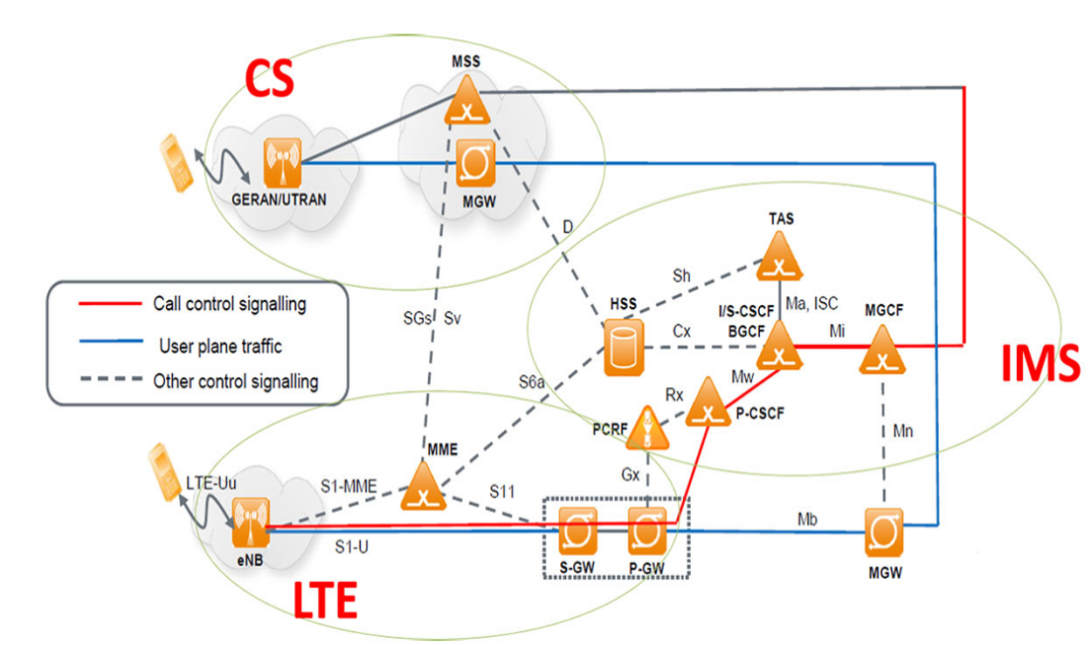

（TS23.002）

IP =   基于IP的传输       基于IP的会话控制       基于IP的业务实现

Multimedia =  语音、视频、图片、文本等多种媒体的组合 在多种接入基础之上具有不同能力的终端组合

Subsystem =  依赖于现有网络技术和网络设备发展的系统       
                      最大程度重用现有网络系统       
                      无线网络把PS/GPRS网络作为承载网络         
                      固定网络把基于固定接入IP系统作为承载网络

简言之：IMS在IP网络的基础上构建一个分层、开放、融合的核心网控制架构，是一个可运营、可管理、可计费的系统。

        从另外一个角度看，IMS实际上是IP网上的一个应用系统。IP网的相关技术标准主要由IETF制定，包括应用层（如Email（POP3、SMTP)、文件传输（FTP）、网页浏览（HTTP）等）的相关协议标准。IETF负责制定了与实时应用（Real-time Applications）相关的协议标准，包括SIP、RTP等。IMS使用的基本都是IETF相关的协议标准（SIP、Diameter等），不同的是，ISM在其基础上又进行了详细的操作性描述和增强，以便提供一种完整的、健壮的多媒体系统。这些操作性描述和增强为运营商控制、分责任、计费和安全提供了支持。

  IP多媒体的全套解决方案是由终端、GERAN（GSM EDGE Radio Access Network，GSM/ EDGE无线通信网络）或UTRAN（UMTS Terrestrial Radio Access Network，UMTS陆地无线接入网）、GPRS核心网和IP多媒体核心网子系统的一些特殊的功能单元来支持的。这些功能单元包括呼叫会话控制功能（CSCF）、媒体网关控制功能（MGCF）、IP多媒体网关功能（IM-MGW）、多媒体资源功能控制器（MRFC）、多媒体资源功能处理器（MRFP）、签约定位功能（SLF）、出口网关控制功能（BGCF）、应用服务器（AS）、信令网关功能（SGW）等。

IMS以其业务、控制、承载完全分离的水平架构，集中的用户属性和接入无关等特性，一方面解决了[软交换技术](https://baike.baidu.com/item/%E8%BD%AF%E4%BA%A4%E6%8D%A2%E6%8A%80%E6%9C%AF" \t "https://baike.baidu.com/item/IMS%E6%8A%80%E6%9C%AF/_blank)还无法解决的问题，如用户移动性支持、标准开放的业务接口、灵活的IP多媒体业务提供等；另一方面，其接入无关性，也使得IMS成为固定和[移动网络](https://baike.baidu.com/item/%E7%A7%BB%E5%8A%A8%E7%BD%91%E7%BB%9C/8777840" \t "https://baike.baidu.com/item/IMS%E6%8A%80%E6%9C%AF/_blank)融合演进的基础。

[IMS业务](https://baike.baidu.com/item/IMS%E4%B8%9A%E5%8A%A1/16687984" \t "https://baike.baidu.com/item/IMS%E6%8A%80%E6%9C%AF/_blank)架构如图所示，IMS的目的是建立与接入无关、能被移动网络与固定网络共用的融合[核心网](https://baike.baidu.com/item/%E6%A0%B8%E5%BF%83%E7%BD%91" \t "https://baike.baidu.com/item/IMS%E6%8A%80%E6%9C%AF/_blank)。

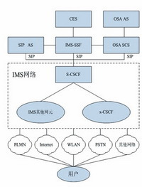

在[无线接入](https://baike.baidu.com/item/%E6%97%A0%E7%BA%BF%E6%8E%A5%E5%85%A5/4814870" \t "https://baike.baidu.com/item/IMS%E6%8A%80%E6%9C%AF/_blank)技术方面，IMS除了GSM/GPRS和WCDMA之外，WLAN通过SIPProxy也可以接入。此外，固定网络的LAN和[xDSL](https://baike.baidu.com/item/xDSL/10770830" \t "https://baike.baidu.com/item/IMS%E6%8A%80%E6%9C%AF/_blank)接入技术也可以接入到IMS。

IMS还提供了与[ISDN](https://baike.baidu.com/item/ISDN/587697" \t "https://baike.baidu.com/item/IMS%E6%8A%80%E6%9C%AF/_blank)/[PSTN](https://baike.baidu.com/item/PSTN/922760" \t "https://baike.baidu.com/item/IMS%E6%8A%80%E6%9C%AF/_blank)传统[电路交换网络](https://baike.baidu.com/item/%E7%94%B5%E8%B7%AF%E4%BA%A4%E6%8D%A2%E7%BD%91%E7%BB%9C/103393" \t "https://baike.baidu.com/item/IMS%E6%8A%80%E6%9C%AF/_blank)的互联机制。这样，IMS提供服务的终端除了[移动终端](https://baike.baidu.com/item/%E7%A7%BB%E5%8A%A8%E7%BB%88%E7%AB%AF" \t "https://baike.baidu.com/item/IMS%E6%8A%80%E6%9C%AF/_blank)之外，还包括固定的电话终端、多媒体智能终端、PC机的[软终端](https://baike.baidu.com/item/%E8%BD%AF%E7%BB%88%E7%AB%AF/12755230" \t "https://baike.baidu.com/item/IMS%E6%8A%80%E6%9C%AF/_blank)等。

## 网元介绍

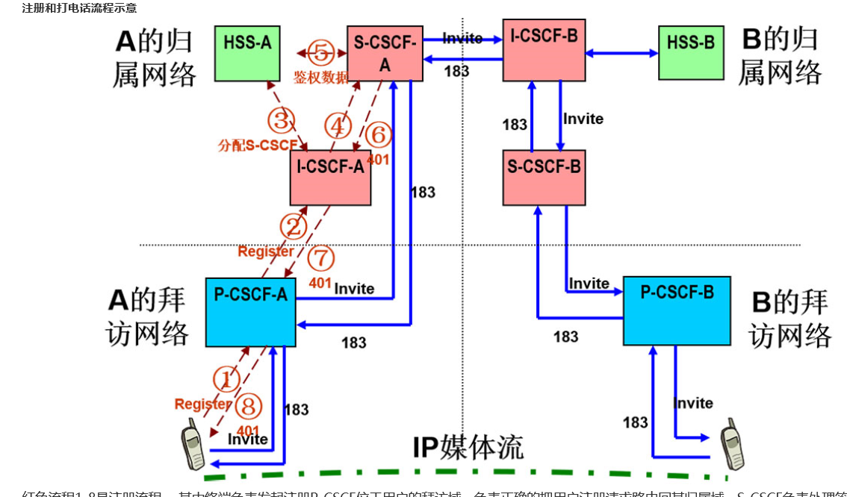

红色流程1-8是注册流程 ，其中终端负责发起注册P-CSCF位于用户的拜访域，负责正确的把用户注册请求路由回其归属域，S-CSCF负责处理签权，HSS提供用户的签权数据，蓝色流程是一个简化的打电话流程，其中终端发起电话邀请，P-CSCF根据用户的注册时保存的路由把用户的业务请求路由回S-CSCF，S-CSCF负责分析被叫路由，并正确的找到被叫。

1）CSCF

 CSCF（Call Session Control Function，呼叫会话控制功能）根据在网络中所处的位置的不同，承担的作用也不一样，它可以分为如下三种类型：

代理CSCF（P-CSCF）：它是IMS中与用户的第一个连接点，提供Proxy（代理）功能，即接受业务请求并转发它们。P-CSCF在某些情况下也可以提供UA（用户代理）功能。

问询CSCF（I-CSCF）：类似IMS的关口节点，分配S-CSCF、路由查询以及IMS域间拓扑隐藏。

服务CSCF（S-CSCF）：它在IMS核心网中处理核心控制地位，负责对UE的注册鉴权、会议控制以及用户数据管理等。

（2）MGCF

 MGCF（Media Gateway Control Function，媒体网关控制功能）一般用于以下场景：

控制IMS-MGW中的媒体信道的连接。与CSCF通信。根据路由号码，为从传统网络来的入局呼叫选择CSCF。执行ISUP协议和IMS呼叫控制协议间的转换。

（3）IM-MGW

 一个IM-MGW（IP Multimedia-Media Gateway Function，多媒体网关功能）可以终止来自电路交换网的承载信道和来自分组网的媒体流（如IP网中的RTP流）。IM-MGW可以支持媒体转换、承载控制和负荷处理（例如，多媒体信号编解码器、回声消除器、会议桥等）。它包含如下功能：

通过与MGCF交互来进行资源控制。拥有并维护回声消除器等资源。可能需要多媒体数字信号编、解码器。

IMS-MGW要提供必要的资源来支持UMTS/GSM媒体传输，还需要对H.248协议进行进一步的调整来支持额外的多媒体数字编、解码器等。

（4）MRF

MRF（Multimedia Resource Function，多媒体资源功能）分成两部分，包括MRFC（Multimedia Resource Function Controller，多媒体资源功能控制器）和MRFP（Multimedia Resource Function Processor，多媒体资源功能处理器）。

MRFC的主要功能：控制MFP中的媒体流资源；翻译来自AS和S-CSCF的信息（会话标志符等），并相应地对MRFP进行控制；产生计费记录。

MRFP的主要功能：控制Mb接口点的承载；提供MRFC需要的资源，混合输入媒体流（如用于多方会议），发出多媒体流（如用于多媒体广播），处理多媒体流（如语音编码转换、媒体分析）等。

（5）SLF

在会话建立期间，被I-CSCF查询，SLF（Subscription Locator Function，签约定位功能）向I-CSCF提供存储用户具体数据的HSS的名字；通过Dx接口来接入IMS。在单一的HSS环境中，并不需要SLF。

（6）HSS

 HSS（Home Subscriber Server，归属用户服务器功能）是一个数据库实体，它用于在归属网络中保存用户的签约信息，包括基本标志、路由信息及业务签约信息等。HSS中保存的主要信息包括：

IMS用户标识（包括公有及私有标志）：号码地址信息。

IMS用户安全上下文：用户网络接入认证密钥信息、漫游限制信息等。

IMS用户的路由信息：HSS支持用户注册，并且存储用户的位置信息。

IMS用户的业务签约信息：包括其他AS增值业务数据。

（7）BGCF

  BGCF（Breakout Gateway Control Function，出口网关控制功能）用于选择与[PSTN](http://www.dsliu.com/wenti/4835.html" \t "http://www.dsliu.com/wenti/_blank)（或CS域）接口点相连的网络。如果BGCF发现自己所在的网络与接口点相连，那么BGCF就选择一个MGCF，该MGCF负责与PSTN（或CS域）的交互。如果接口点在另一个网络，那么BGCF就把会话信令转发给另一个网络的BGCF。BGCF在选择与PSTN相连的网络的时候，会利用收到的其他协议的信息和管理信息。BGCF的主要功能如下：

收到 S-CSCF请求后，为呼叫选择一个适当的PSTN（或CS域）接口点。

选择一个与PSGN（或CS域）相连的网络。如果本网络没有与PSTN相连，那么BGCF就把SIP信令转发给与PSTN（或CS域）相连的网络的BGCF。

在与PSTN（或CS域）相连的网络中，选择一个MGCF，并把SIP信令转发给MGCF。

生成计费记录。

（8）SGW

 SGW（Singnalling Gateway Function，信令网关功能）完成传输层的信令转换，在基于SS7的信令与基于IP的信令之间转换（也就是在Sigtran SCTP/IP 和 SS7 MTP之间进行转换）。SGW不对应用层的消息进行解释，但必须对底层的SCCP或SCTP消息进行解释来保证信令的正确路由。

（9）AS

 在IMS系统中，实现了业务与控制的完全分离，所有的具体业务都是通过应用服务器（Application Server，AS）来提供的。应用服务器通过一种称为开放服务架构（Open Service Architecture，OSA）的方式引入了Internet上应用的开发模式，为IT应用与电信网的融合奠定了技术基础。AS与CSCF之间使用SIP协议通信。对于不同的服务，AS可以选择不同的SIP模式，如SIP代理模式、SIP用户代理（UA - User agent）模式和SIP B2BUA模式。AS可以设置在IMS本网内，也可以设置在外部的第三方网络中。如果位于本网，它还可以利用Sh或Si接口查询HSS。

一般来说，AS包含以下三类功能与实体：

SIP AS（Application Server）：基于SIP的应用服务器，负责提供IMS的具体服务。SIP AS和 S-CSCF 之间直接利用 SIP 及其扩展的呼叫信令协议，因此不需要进行呼叫信令协议之间的转换工作。另外由于基于 SIP 可以非常方便地实现语音、数据以及视频等多媒体类的会话，因此SIP AS可以高效率地提供各种新型的融合业务。

IM-SSF（IP Multimedia Service Switching Function）：IP多媒体交换功能实体，它作为SIP和智能网的CAP（CAMEL Application Part，CAMEL应用部分）之间的接口，为IMS用户提供增值业务。可以位于用户归属网，也可以由第三方提供，主要用于处理IMS发来的SIP会话、发起SIP请求、发送计费信息给CCF和OCS。

OSA-SCS（Open Service Access-Service Capability Server）：SIP和OSA框架之间的接口。SCS实际上是负责API具体实现的功能实体，它与核心网络元素（如HLR、MSC、SSP等）进行交互。这样，一个SCS服务程序就相当于一个进入核心网络的一个代理或一个网关。

IMS和软交换实际上是NGN的两个版本。和软交换当年把控制和承载分离开类似，IMS不过把业务和控制进一步分离，可以说IMS就是更标准的软交换，或者在移动网里更可说IMS是R6的软交换，理论上说IMS能实现的业务，软交换都可以实现，只不过都是基于各厂家私有的协议和标准，如果软交换进一步标准化这些业务和接口，就和IMS没有什么区别。

# SIP 协议

## SIP概述

SIP（Session Initiation Protocol，会话初始协议）是由IETF（Internet Engineering Task Force，因特网工程任务组）制定的多媒体通信协议。

它是一个基于文本的应用层控制协议，用于创建、修改和释放一个或多个参与者的会话。SIP 是一种源于互联网的IP 语音会话控制协议，具有灵活、易于实现、便于扩展等特 点。于 2002 年形成新标准 [RFC3261]

SIP 协议是基于超文本传输协议（HTTP）和简单邮件传送协议（SMTP）的信令协议，下图描述了 SIP 协议在协议栈中的位置：

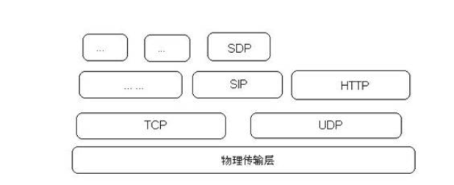

　 SIP 一种应用层的控制协议，它可以创建，修改和结束多媒体会话（会议），例如网络电话呼叫。SIP也可以邀请参与对象加入到已存在的会话，例如多方广播会议。它可以从当前存在的会话中再加入媒体也可以移除媒体。SIP可以透明支持名称映射，服务重新转发服务，这些服务功能支持个人移动能力-无论网络位置如何，用户可以在网络中保持一个对外单点可视的身份。

　　SIP支持创建和结束媒体通信的五个方面的功能：

* 用户定位： 端系统的决定来支持通信；
* 用户有效性： 决定被呼叫方是否有意愿决定加入通信；
* 用户能力： 决定用户可使用的媒体和其媒体参数；
* 会话创建： "ringing"，在呼叫方和被呼叫方之间创建会话参数；
* 会话管理： 包括转发，结束会话，修改会话参数和调用服务。

　　SIP 不是一个单一，垂直集成度通信系统。SIP而是一个模块，它可以用来和其他的IETF协议集成来构建一个完整的媒体架构。典型的架构如，和实时传输协议（RTP）配合，实现实时数据传输，提供QoS反馈，使用实时媒体协议（RTSP）来控制媒体流和媒体的发送控制，媒体网关控制协议

　　（MEGACO）（RFC 3015[30]） 来控制网关对PSTN网络的支持，和会话描述协议 （SDP） （RFC 2327[1]）来描述媒体会话。因此，SIP应该结合其他的协议一起使用对用户提供完整的服务。但是，基本的SIP功能和操作不会依赖于其他任何协议。

　　SIP 本身不提供服务。但是，SIP提供基本的操作，这些操作可以支持部署不同的服务。例如，SIP可以定位一个用户，并且对当前定位发送一个不透明的对象。如果此基本操作用来支持发送一个写入SDP的会话描述，终端可以同意会话中的参数。如果同样的操作用来传递一张呼叫方的图片和此会话描述，那么就可以在早期部署一个“caller ID”服务。就像这个例子所展示的，一个单个基本操作往往被用来提供不同的服务。

　　SIP 不提供会议控制服务例如发言权控制和发言，它不能对会议发出命令控制如何管理会议。SIP可以用来发起一个会话，这个会话可以用来支持一些会议控制协议。因为，SIP创建的消息和会话可以传递到完全不同的网络中，SIP不能也不会提供任何网络资源预设的支持能力。

　　SIP所提供的服务的本质使得安全性特别重要。对于对端来说，SIP提供了一个安全服务单元，这些服务单元包括拒绝攻击防止服务，认证（包括用户对用户，代理对用户），集成保护，加密和私有服务。

　　SIP 可以支持IPv4和IPv6两种网络环境。

## SIP 协议的体系结构

SIP 协议中的组成元素包含两个要素：SIP 用户代理（User Agent，UA）和 SIP 用户服务器（User Server，US）。用户代理是呼叫的终端要素，而用户服务器是处理与多个呼叫相关联信令的网络设备。在理想情况下，两个终端间的通信并不需要用户服务器的参与即可完成。但是现实总是比理想残酷，因为各个网络运营商、服务提供者希望对其网络的业务有所了解，固需要中间用户服务器的参与。

图 3 所示是典型的网络结构，称之为“SIP 梯形”。SIP 终端构成通信的端点，它们负责发送和接受 SIP 请求和响应，同时它们也是多媒体流的终点。UA 可能是终端上的一个应用或者是专门的硬件设备。

用户代理本身又可分为：客户机端（User Agent Client，用户代理客户机）和服务器端（User Agent Server，用户代理服务器）。用户代理客户机是发起请求的主叫应用；客户代理服务器是通话的被呼叫端，主要负责接受、重定向或者拒绝请求，给到来的请求发送响应。用户代理在发起呼叫的时候它是用户代理客户端，而当被呼叫的时候它是用户代理服务器端。

用户服务器是 SIP 消息在到达其最终目的地前所经过的逻辑节点，这些服务器用于对请求进行路由和重定向，既进行名字解析和用户定位。主要包括以下几种服务器：

有状态代理服务器（Proxy Server）：负责接收和转发 SIP 请求。可解析并重构 SIP 消息的部分信息。但是这些重构不会影响请求或会话的状态；

无状态代理服务器（Stateless Server）：其负责将上游的请求向下游转发和将下游的响应向上游转发，其不纪录请求或会话的状态；

重定向服务器（Redirect Server）：其负责将请求的地址映射为新地址；它对请求进行重定向但是不参与事务的处理；

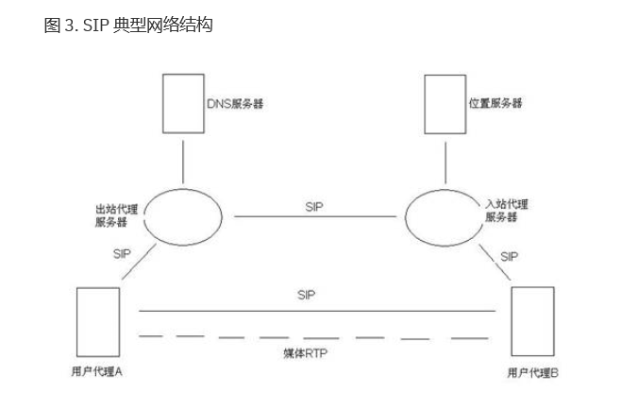

位置服务器（Location Server）：跟踪用户的位置；

注册服务器（Registrar Server）：负责接收和处理 REGISTER 请求的服务器；

## SIP 协议结构

SIP 协议是一个分层的结构。分层结构的好处就是各个层次之间保持相对独立，层与层之间仅存在松散耦合关系。参见下图：

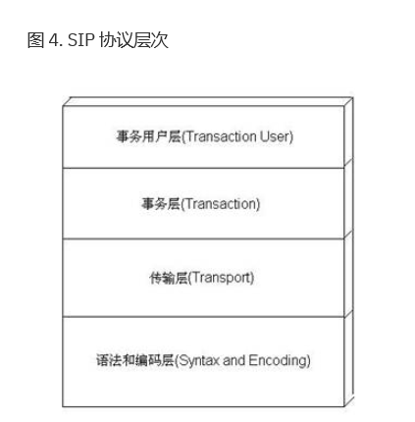

在 SIP 协议四层结构中，处于最底层的是采用 BNF 语法编码的语法和编码层；第二层是传输层用于控制终端如何发送请求和接收响应，以及控制服务端如何接受请求和发送响应；第三层是事务层，其用于控制请求和响应的匹配。SIP 协议中对事务的定义是：终端发送到服务器的一条请求和服务器端返回到终端的所有对该请求的响应（SIP 中存在一个请求对应多个响应，其中有多个临时响应但是最终响应只有一个，例如 INVITE）。该层还为上层提供事务的超时处理等。在 SIP 协议中定义了四种事务状态，每种状态都有自身的定时器、超时重发机制以及结束规则等。这四种事务状态为：INVITE 客户端事务、非 INVITE 客户端事务、INVITE 服务器端事务和非 INVITE 服务器端事务；最上层是事务用户层，用于创建客户端或服务器端事务。当需要发送 SIP 请求时，事务用户层创建一个客户端事务实例，将目的信息和传输协议等放在请求中发送。事务用户层包括上文提到的 SIP 两大要素之一 ---- 用户代理 UAC 和 UAS。其中 UAC 使用事务层创建和发送请求并接受响应；UAS 使用事务层接收请求并创建和发送响应。

UAC：用户代理客户端负责填写请求 URI，发送和接收地址 From 消息头、To 消息头，标识惟一呼叫的 Call-ID 消息头，其还可添加用于指示 UAC 要求的 SIP 扩展的 Require 消息头和用于指示 UAS 支持的扩展的 Supported 消息头，用来标识事务先后顺序的 CSeq 消息头，标识事务分支参数的 Via 消息头，用户代理客户端可以为发送的 SIP 请求预设置一个路由集，在 Route 消息头中指定到达目的地之前需要经过的中间节点集合。

## UAS：如果请求中存在路由信息，按照路由信息进行检查；如果没有包含路由信息，则负责检查请求中的 URI 和 To 消息头已确认该请求的目标地址，如果其中任意一个失败，则本请求认为无效而发送错误响应。其次检查请求是否存在扩展的要求，如果 UAS 端不能满足扩展要求则返回错误。如果能够满足扩展要求，则进一步处理请求内容。UAS 处理完请求后，就会创建响应。如上所述，响应可能是多个临时响应，但最终响应只有一个。在创建响应时，响应消息的 From 消息头、Call-ID 消息头、CSeq 消息头、Via 消息头以及 To 消息头都从请求消息中复制过来。

## SIP实例

　　此部分使用一个简单示例介绍了SIP的基本操作。它实际上是一个学习辅导，没有包含任何正式的说明。

　　第一个示例显示了SIP的基本功能：终端定位，希望通信的意愿，创建会话参数的协商和创建会话后会话拆线。

　　图表1 显示了一个典型的介于两个用户之间的SIP消息交互，两个用户分别是Alice和 Bob。（每个消息都通过一个带字母F的标签来标注，文本号码说明一个标注号码）。在这个例子中，Alice使用了一个在PC上运行的SIP应用程序（作为一个软电话）来呼叫Bob，Bob的电话是一个基于互联网的SIP电话。这个图例也同时显示了，这里有两个SIP 代理服务器介于Alice和BoB之间来支持会话管理工作。在图例1中，这种典型的设置方式我们通常称之为“SIP 拓扑图” "SIP 框架" 。

　　Alice使用自己的SIP身份 “呼叫”Bob，这种SIP身份是一种URL类型，我们这里称之为SIP URL。它的格式和邮件的格式非常相似，一般都包括一个用户名称和主机名称。在这个例子中，它就是 sip:bob@biloxi.com, 这里biloxi.com是一个Bob的SIP服务提供商。Alice可能也具有和Bob的URL同样的类型，或点击一个超链接后进入一个地址薄。SIP同样也提供一个安全的URL，被称之为SIPS URL。安全URL的示例为sips:bob@biloxi.com。通过SIPS URL发起的呼叫可以保证安全，加密的传输，它用来传输所有从呼叫方到被呼叫方域的所有SIP消息。 从这里，开始，SIP的请求消息安全地发送到被呼叫方，但是安全机制依赖于被呼叫方域的安全策略设置。

　　SIP 是基于一种类似于HTTP形式的请求/响应事务处理模式。每个事务处理包括一个启动了特别method方法的请求，或者一个功能，和至少一个来自于服务器端的响应构成。在这个例子中，事务处理是以Alice的软电话开始，软电话发送一个INVITE请求，携带了Bob SIP URL地址。这里，INVITE就是一个SIP method方法，它指定了一个执行命令，请求方（Alice）想让服务器方（Bob）接收这个请求。这个INVITE请求中包含了几个头域header fields。Header fields 被命名为属性值，这些属性值提供了关于消息的其他额外信息。在INVITE中的某些属性表示了呼叫的唯一身份，目的地地址，Alice的地址，和Alice和Bob之间创建会话所期望的会话类型的信息。INVITE （F1消息中）可能类似于这样的流程：

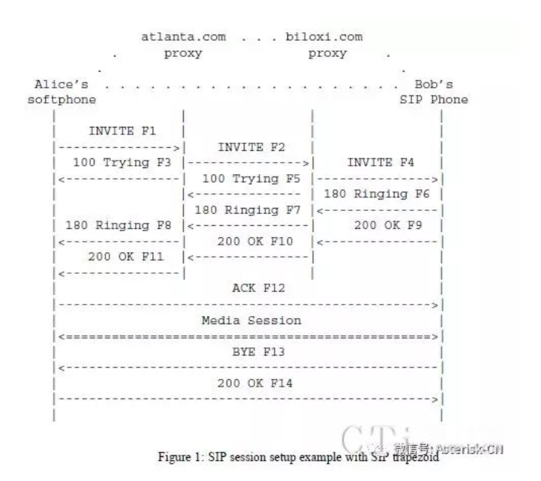

　Figure 1: SIP session setup example with SIP trapezoid

　　INVITE sip:bob@biloxi.com SIP/2.0

　　Via: SIP/2.0/UDP pc33.atlanta.com;branch=z9hG4bK776asdhds

　　Max-Forwards: 70

　　To: Bob <SIP:BOB@BILOXI.COM>

　　From: Alice <SIP:ALICE@ATLANTA.COM>;tag=1928301774

　　Call-ID: a84b4c76e66710@pc33.atlanta.com

　　CSeq: 314159 INVITE

　　Contact: <SIP:ALICE@PC33.ATLANTA.COM>

　　Content-Type: application/sdp

　　Content-Length: 142

　　（Alice的SDP 消息不显示）

　　文本消息的第一行包含了一个方法名称method（INVITE）。 紧接着的是几行包含一个header 值域的列表。在这个示例中，它们包含了最少的要求设置。这些头header简单描述如下：

　　Via 包含了一个地址（pc33.atlanta.com），Alice希望对这个请求获得响应的地址。它也包含了一个branch参数来确认这个事务处理。

　　To 包含了一个显示名称（Bob）和一个SIP或者SIPS URL（sip:bob@biloxi.com） 。Display names在RFC 2822[3]有介绍。

　　From 也包含一个显示名称（Alice）和一个SIP或SIPS URI （sip:alice@atlanta.com），它表示这个请求的发起方。这个header同时还有一个一个标签tag参数，此标签包含了一个任意字符串（1928301774），这个字符串被添加到了软电话的URL。此标签也是为了确认身份的目的。

　　Call-ID 包含一个对这个呼叫的全局唯一确认信息，它是由一个任意字符串和软电话主机名称或IP地址组合而成。To tag的组合，From tag的组合，和Call-ID完整定义了一个Alice和BoB两者之间的点对点的SIP关系，这种关系可以看作一个dialog对话。

　　CSeq 或Command Sequence包含一个整数和一个method名称。这个CSeq是一个增长的数值，它是支持每一个在dialog里新的请求，并且是一个普通的序列号码。

　　Contact 包含一个SIP或者SIPS URI，它用来表示一个直接的路由去联系Alice，通常情况下，它由一个用户名称以及它所在的全限定域名构成（FQDN）。 如果使用了全限定域名（FQDN）的话，许多终端系统没有已注册的域名，因此，这里IP地址是允许的。Via头告诉其他参数往哪里发送响应消息，Contact告诉其他参数往哪里发送将来的请求消息。

　　Max-Forwards 最大前转来限定一个请求到达目的地的最大跳跃（hop）数量。它是由一个整数数值构成，在经过一个跳转时会降低一个数值。

　　Content-Type 包含一个信息体的描述，这里忽略。

　　Content-Length contains an octet （byte） count of the message body.

　　会话的细节，例如媒体类型，编码，采样率等没有在SIP中进行描述。 这些细节而是包含在了SIP消息体中，它们通过编码以后以各种协议的格式出现。其中一种协议格式就是 会话描述协议-Session Description Protocol （SDP） （RFC 2327[1]）。这个SDP消息（没有在这里显示）示例是通过SIP消息来传输，传输的方式类似于电子邮件中的附件方式来传输，或类似于通过HTTP消息传输网页页面内容的方式。

　　因为软电话不知道Bob的地址或biloxi.com域名中的SIP服务器地址，软电话发送一个INVITE 到SIP 服务器端，这个SIP服务器支持Alice的域，atlanta.com。 atlanta.com SIP 服务器已经配置了Alice的软电话，或者通过DHCP发现了软电话地址信息。

　　这个atlanta.com SIP 服务器是一个代理服务器。代理服务器接收请求，然后作为一个请求者转发这些请求。在这个实例中，代理服务器接收到了INVITE请求，然后发送了一个100 （Trying） 响应给Alice的软电话。这个100 （Trying） 响应表示这个INVITE已经被收到，代理正在通过路由设置路由这个INVITE到其目的地。

　　在SIP中，响应消息使用一个三位数的码和描述短语作为回复消息。这个响应消息在Via中包括同样的To， From， Call-ID， CSeq 和 branch参数 parameter，这些参数和INVITE中的一样，这些参数允许Alice的软电话关联响应消息来发送INVITE消息。这个atlanta.com代理服务器定位到这个代理服务器在biloxi.com，它可能执行一个特别的DNS查询来找到服务biloxi.com 域的SIP 服务器。 因此，它获得biloxi.com 代理服务器的IP地址，然后转发或者在这里代理其INVITE请求。在转发这个请求之前，这个 atlanta.com 代理服务器添加另外一个Via头域，这个头域包含自己的地址（这个INVITE已经在第一个Via包含了Alice的地址）。biloxi.com 代理服务器收到这个 INVITE消息后，然后回复一个带100 （Trying） 响应消息到atlanta.com 代理服务器，表示它已经收到了这个INVITE消息，正在处理这个请求。代理服务器会查询一个定位服务器，我们称之为定位服务，定位服务包含当前Bob的IP地址。biloxi.com 代理服务器会添加另外一个Via header ，并且携带自己的IP地址，这个地址是对这个INVITE请求的，代理转发这个请求到Bob的SIP软电话。

　　Bob的软电话收到这个INVITE 消息后，对 Bob 发出提示，告诉他有从Alice来的电话呼叫，Bob决定是否应答这个呼叫，这里Bob的软电话会产生振铃提示。Bob的软电话提示180振铃，这个响应消息会路由根据相反的方向回到两个代理服务器。每个代理使用Via header 域值来决定发送响应的地址方向，并且从顶部路由记录中删除自己的地址。因此，尽管要求DNS和定位服务查询 路由这个初始的INVITE请求，180（Ringing）响应返回到呼叫方时可以没有查询消息或没有代理服务器中所保持的状态。

　　这样也获得了一个合理的响应属性，每个看到INVITE消息的代理服务器也可以看到所有对INVITE的响应消息。

当Alice的软电话收到这个180 （Ringing）响应后，它会传递这个信息给Alice，传递过来的信息方式可以使用一个回铃音（ringback tone）或或者在Alice终端屏幕显示一个消息。

在这个示例中，Bob决定应答这个呼叫。当他拿起电话听筒时，他的SIP电话会发送一个 200 （OK） 响应消息来表示这个呼叫已经应答。这个200 （OK） 包含了一个消息体，这个消息体带了这个呼叫会话的媒体描述类型，这个媒体描述中说明了Bob希望和Alice创建会话。因此，这里有一个两阶段的SDP消息交互过程：Alice发送一个交互消息给Bob，Bob然后发送了一个交互消息给Alice。这个两阶段的交互提供基本的协商能力，它是基于一个简单的offer/answer SDP交互模式来进行的。如果Bob不希望应答这个呼叫或者Bob电话可能被占线，他此时和其他人进行通话，那么Bob终端则会发送一个错误响应消息而不是200（ok），这样就会导致没有媒体创建的情况。完整的SIP响应码在在Section21中列出。Bob发送的200 （OK） （图例1中的消息F9）可能类似于这样：

SIP/2.0200 OK

Via: SIP/2.0/UDPserver10.biloxi.com ;branch=z9hG4bKnashds8;received=192.0.2.3

Via: SIP/2.0/UDPbigbox3.site3.atlanta.com ;branch=z9hG4bK77ef4c2312983.1;received=192.0.2.2

Via: SIP/2.0/UDPpc33.atlanta.com ;branch=z9hG4bK776asdhds ;received=192.0.2.1

To:Bob <sip:bob@biloxi.com>;tag=a6c85cf

From:Alice <sip:alice@atlanta.com>;tag=1928301774

Call-ID:a84b4c76e66710@pc33.atlanta.com

CSeq:314159 INVITE

Contact:<sip:bob@192.0.2.4>

Content-Type:application/sdp

Content-Length:131

（Bob'sSDP not shown）

　　响应消息的第一行包含了响应码（200）和响应原因短语习语（OK）。其余其他行消息包含 header值域消息。Via，To， From，Call-ID，和 CSeq header 值域都是从 INVITE请求中拷贝过来的。（注意，这里有三个Via 头值–一个是Alice软电话添加的，另外一个是atlanta.com代理服务器添加到，还有一个是biloxi.com代理添加的）。Bob的软电话已经在header中添加了一个taq标签参数To。这个标签将会在两个终端的dialog中使用，也将会在此呼叫将来的请求和响应使用。

　　Contact头包含了一个URL地址，这个URL就是Bob可以直接访问的软电话地址。 Content-Type 和 Content-Length参考消息体（这里没有列出），这个消息包含了BobSDP 媒体的信息。

　　另外，在 这个示例中，DNS和定位查询显示代理服务器可以做一个灵活的路由决定，它可以决定往哪里发送请求。例如，如果Bob软电话返回一个486 （Busy，忙状态）响应的话，biloxi.com 代理服务器可以代理这个INVITE到Bob的语音邮箱服务器。代理服务器也可以同时发送一个INVITE到多个地址。这种类型的并行查询方式称之为forking（分支）处理方式。

　　在这个示例中，200 （OK） 消息通过两个代理服务器返回到Alice，Alice软电话收到响应消息，软电话停止回铃音，表示呼叫已应答。最后，Alice软电话发送一个确认消息ACK，这个消息发送到Bob软电话来确认最终响应 （200 （OK））已收到。在这个示例中，这个ACK是通过Alice软电话直接被发送到了Bob软电话，发送过程绕开了两个代理服务器。这样处理的原因就是因为两个终端已经通过互相学习知道对方的地址，双方地址是通过INVITE/200（OK）交互时的Contact头获得，当然这个地址在初始时的INVITE是双方都不知道的。两个代理服务器的查询服务也不需要。因此，代理服务器则会退出这个呼叫流程。这个处理过程成功实现了 INVITE/200/ACK 三方握手，并且创建了SIP会话。

Alice和Bob之间的媒体会话启动，他们之间的软电话开始发送媒体数据包，媒体数据包的格式是他们之间的SDP交互互相同意支持的格式。一般来说，端对端的媒体数据通过不同的路径发送，而不是使用SIP信令消息的路径。

在这个会话过程中，Alice或Bob任何一方都可以有权决定修改媒体会话的属性。修改会话属性是通过发送一个re-INVITE消息，在此消息中包含一个新的媒体描述来实现。这个re-INVITE涉及到了已存在的dialog,因此其他的参与方知道这个消息是修改了现在的会话，而不是重新建立的新会话。其他方发送一个200（ok）接受这个修改。请求方对200（ok）发送一个ACK。如果其他方不能接受这个修改的话，它会发生一个错误响应，例如488 （Not Acceptable Here），同样也接收一个ACK确认消息。但是，这个re-INVITE失败不会导致目前的呼叫失败-这个会话仍然会继续使用以前协商的属性。

在呼叫结束后，Bob首先挂机（hangs up），并且生成一个BYE消息。这个BYE会直接路由返回到Alice的软电话，这里仍然绕过了代理。Alice确认了BYE接收，发送一个200（ok），结束这个会话和BYE消息事务。这里没有ACK发送-ACK发送仅发生在对INVITE请求的响应中。这里涉及了SIP中的可靠性机制问题，振铃应答的时间程度和分叉处理等因素。因为这个原因，SIP中的请求处理经常被划分为INVITE或者non-INVITE两个层面，除了INVITE method以外，还涉及其他的所有methods

　　在某些案例中，对于代理来说可能非常有用，在整个会话期间可以看到两个终端之间在SIP信令路径上的所有消息。例如，如果 biloxi.com 代理服务器希望保持除了初始INVITE以外的SIP消息，它对INVITE添加一个要求的路由header值，这个值我们称之为Record-Route，用来解析主机或者代理的IP地址。因为Bob软电话（这个消息会通过200（ok）传送会Bob）和Alice软电话将会收到这个消息，在整个dialog过程中保存这个消息。biloxi.com 代理服务器将收到和对BYE代理转发这个ACK，BYE和200（OK）。每个代理可以独立决定收到的后续的消息，消息将被通过所有选择接收的代理发送，这些代理来接收这个消息。这个能力经常被代理使用，代理通过这个能力可以提供mid-call 功能或者呼叫期间的控制功能。

注册是另外一个SIP常用的操作。注册是一种方法，它可以使得biloxi.com服务器获知当前Bob的位置。Bob软电话基于初始化处理，在一定周期内Bob软电话对在biloxi.com的服务器发送REGISTER消息，我们称之为SIP registrar或者SIP注册。REGISTER 消息关联Bob的SIP软电话或者SIPS URI （sip:bob@biloxi.com），这个机器是当前Bob写入记录的地址（它在Contact头中传输SIP或者SIPURL）。这个注册会写入此关联，也被称之为在数据库中的绑定或者定位服务，此定位服务可以使用在biloxi.com 域的代理中。经常，对于一个域的注册服务器需要和这个域的代理协同工作。这里一定要注意，区分不同类型的SIP服务器功能概念是非常重要的，它们区别是在于逻辑处理的不同，而不是物理上，形体上的不同。

　 Bob不仅仅局限于从一台设备注册。例如，Bob的两个终端设备，一台在家里面，另外一台在办公室都发送注册消息。两台设备的消息都保存在定位服务中，允许代理执行各种对Bob 终端的定位查询。

同样的道理，同一时间，多个用户可以注册到一台单个设备上。

定位服务仅是一个抽象概念。通常情况下，它包括一些必要的信息，它支持代理输入一个URL，并且接收零个或多个URL，这些URL告诉代理往什么地址发送请求。注册是一种方式来创建这些信息，但也不仅仅是这一种方式。任意映射功能可以通过管理员自行决定。

最后，一定要注意，在SIP中注册是用来路由入局的SIP请求的，它不能充当出局的授权请求的角色。在SIP中，签权和身份认证的处理可以基于逐一请求的方式，使用 challenge/response 机制的方式来处理，或使用更低一层的方案来处理，其他的SIP操作，例如查询SIP服务器的能力或终端使用OPTIONS，或使用CANCEL取消正在进行的请求等流程将会在后续之间进行讨论。

详细解释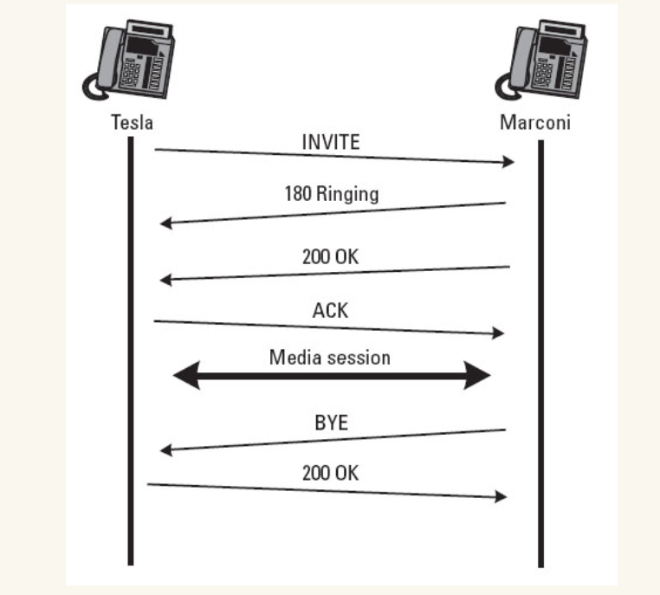

**INVITE**

主叫方Tesla首先发起 INVITE 消息到被叫方Marconi。INVITE 消息包含会话类型和一些呼叫所必须的参数。会话类型可能是单纯的语音，也可能是网络会议所用的多媒体视频，还可能是游戏会话。下面是消息体范例，我们来详细分析各个字段的意义。

INVITE sip:marconi@radio.org SIP/2.0  
    <＝ 请求方法、请求地址（Request－URI）、SIP 版本号（目前都是 SIP/2.0）  
        <＝ 请求地址一般就是被叫方地址，跟 MSN 中好友 eMail 地址类似

Via: SIP/2.0/UDP lab.high-voltage.org:5060;branch=z9hG4bKfw19b  
    <＝SIP 版本号（2.0）、传输类型（UDP）、呼叫地址、  
        <＝branch是一随机码，它被看作**传输标识**        <＝Via 字段中地址是消息发送方或代理转发方设备地址，一般由主机地址和端口号组成  
        <＝传输类型可以为 UDP、TCP、TLS、SCTP

Max-Forwards: 70  
    <＝最大跳跃数，就是经过 SIP 服务器的跳跃次数，主要是防止循环跳跃  
    <＝每尽管一台代理服务器，该整数减一

To: G. Marconi <sip:marconi@radio.org>  
From: Nikola Tesla <sip:n.tesla@high-voltage.org>;tag=76341  
    <＝表示请求消息的发送方和目标方  
        <＝如果里面有用户名标签，地址要求用尖括号包起来  
        <＝对于 INVITE 消息，可以在 From 字段中包含 tag，它也是个随机码

Call-ID: [123456789@lab.high-voltage.org](mailto:123456789@lab.high-voltage.org)  
    <＝呼叫ID是由本地设备生成的，全局唯一值。每次呼叫该值唯一不变  
        <＝对于用户代理发送 INVITE 消息，本地将生成 From tag 和 Call-ID 全局唯一码，被叫方代理则生成 To tag 全局唯一码。这三个随机码做为整个对话中**对话标识**（dialog indentifier）在通话双方使用。

CSeq: 1 INVITE  
    <＝CSeq，又叫**命令队列**（Command Seqence），每发送一个新的请求，该数自动加1  
* 以上几个字段是所有 SIP 消息体所必须的，其它头字段有些是可选的，有些在特定请求也是必须

Subject: About That Power Outage...  
Contact: <sip:n.tesla@lab.high-voltage.org>  
    <＝Contact 是 INVITE 消息所必须的，它用来路由到被叫设备地址，也称为用户代理（UA）  
Content-Type: application/sdp  
Content-Length: 158  
    <＝最后两位附属字段说明消息体类型以及字段长度

v=0    <＝SDP版本号，目前都是 0  
o=Tesla 2890844526 2890844526 IN IP4 lab.high-voltage.org    <＝主叫源地址，类型等  
s=Phone Call    <＝主题  
c=IN IP4 100.101.102.103    <＝连接  
t=0 0    <＝ 时间戳  
m=audio 49170 RTP/AVP 0   <＝媒体  
a=rtpmap:0 PCMU/8000    <＝媒体属性

    <＝从上面 SDP 消息体我们可以得出下面信息  
        <＝连接 IP 地址：100.101.102.103  
        <＝媒体格式：audio  
        <＝端口号：49170  
        <＝媒体传输类型：RTP  
        <＝媒体编码：PCM u Law  
        <＝采样率：8000 Hz

**180 Ringing**

当被叫方接收到 INVITE 请求消息后，将回复 180 Ringing。顾名思义，就是发回铃音，提示主叫方电话已连接上了，正等待被叫应答。被叫方接收到 INVITE 消息后也会发生响铃或者其它有呼入提示，这由被叫方设定（我们可以把它想象成我们自己设定手机铃声）。对于 180 响应又被称为“**消息及时响应**”，它是一种用来测试被叫状态的一种响应。因此它所包含的信息不多，具体 180 响应消息如下：

SIP/2.0 180 Ringing  
Via: SIP/2.0/UDP lab.high-voltage.org:5060;branch=z9hG4bKfw19b  
;received=100.101.102.103    <＝这里增加一个 received 参数，标识接收方 IP 地址  
To: G. Marconi <sip:marconi@radio.org>;tag=a53e42    <＝上已提到，To tag 做为被叫方标识  
From: Nikola Tesla <sip:n.tesla@high-voltage.org>;tag=76341  <＝要求很发送方 From tag 一致  
Call-ID: [123456789@lab.high-voltage.org](mailto:123456789@lab.high-voltage.org)  
CSeq: 1 INVITE  
Contact: <sip:marconi@tower.radio.org>  
Content-Length: 0  
    <＝对于 180 Ringing 响应，基本上就是将 INVITE 的 Via、To、From、Call-ID 和 CSeq 内容复制过来，对于首行标出 SIP 版本号，响应代码（180）和动作原因（reason phrase）  
    <＝注意这里 From 和 To 地址，因为它们用来指定呼叫方向，因此这里的 200 OK 响应并没有将地址对调，仍然保持原样。一点不同的是 To 头字段添加了由被叫方 Marconi 生成的 tag 标识

**200 Ok**

被叫响铃后，如果被叫用户 Marconi 接起电话，则发出 200 OK 响应。这个响应除了做为接通指示之外，还有一个功能是用来指定被叫允许的连接媒体格式，让主叫方确认是否可以接收该媒体。  
消息体如下

SIP/2.0 200 OK  
Via: SIP/2.0/UDP lab.high-voltage.org:5060;branch=z9hG4bKfw19b  
;received=100.101.102.103  
To: G. Marconi <sip:marconi@radio.org>;tag=a53e42  
From: Nikola Tesla <sip:n.tesla@high-voltage.org>;tag=76341  
Call-ID: [123456789@lab.high-voltage.org](mailto:123456789@lab.high-voltage.org)  
CSeq: 1 INVITE  
Contact: <sip:marconi@tower.radio.org>  
Content-Type: application/sdp  
Content-Length: 155  
    <＝头字段部分基本同上  
  
v=0  
o=Marconi 2890844528 2890844528 IN IP4 tower.radio.org  
s=Phone Call  
c=IN IP4 200.201.202.203  
t=0 0  
m=audio 60000 RTP/AVP 0  
a=rtpmap:0 PCMU/8000

    <＝从上面 SDP 消息体我们可以得出下面信息  
        <＝终端 IP 地址：200.201.202.203  
        <＝媒体格式：audio  
        <＝端口号：60000  
        <＝媒体传输类型：RTP  
        <＝媒体编码：PCM u Law  
        <＝采样率：8000 Hz

**ACK**

通话前最后一步是主叫方确认 200 OK响应。该项确认证明连接被允许，即将使用另一种协议开始媒体连接。这另一种协议是上面在 SDP 消息段中所协商好的 RTP 格式。该 ACK 响应内容如下：

ACK sip:marconi@tower.radio.org SIP/2.0  
Via: SIP/2.0/UDP lab.high-voltage.org:5060;branch=z9hG4bK321g  
Max-Forwards: 70  
To: G. Marconi <sip:marconi@radio.org>;tag=a53e42  
From: Nikola Tesla <sip:n.tesla@high-voltage.org>;tag=76341  
Call-ID: [123456789@lab.high-voltage.org](mailto:123456789@lab.high-voltage.org)  
CSeq: 1 ACK  
Content-Length: 0

**BYE**

通话完毕后，由被叫方 Marconi 首先挂机，发送 BYE 请求命令。注意这回由 Marconi 做为主叫方了，因此 Via 字段和 From、To 与 INVITE 字段有所不同。其实也就是倒置。

BYE sip:n.tesla@lab.high-voltage.org SIP/2.0  
Via: SIP/2.0/UDP tower.radio.org:5060;branch=z9hG4bK392kf  
Max-Forwards: 70  
To: Nikola Tesla <sip:n.tesla@high-voltage.org>;tag=76341  
From: G. Marconi <sip:marconi@radio.org>;tag=a53e42  
Call-ID: [123456789@lab.high-voltage.org](mailto:123456789@lab.high-voltage.org)  
CSeq: 1 BYE  
Content-Length: 0

**200 OK**

BYE 之后，要求被叫方发 200 Ok 确认，也就是让主叫知道被叫已经知道你挂断了。（注意这里所说的主被叫角色已经倒过来了）打个比方，通话之后，有一方要求挂机，另一方需要知道它已经挂机了。

SIP/2.0 200 OK  
Via: SIP/2.0/UDP tower.radio.org:5060;branch=z9hG4bK392kf  
;received=200.201.202.203  
To: Nikola Tesla <sip:n.tesla@high-voltage.org>;tag=76341  
From: G. Marconi <sip:marconi@radio.org>;tag=a53e42  
Call-ID: [123456789@lab.high-voltage.org](mailto:123456789@lab.high-voltage.org)  
CSeq: 1 BYE  
Content-Length: 0

到此，就是最简单的呼叫过程。该过程简单在于两个终端之间没有其它设备，完全的点对点连接，它们之间只需要知道对方 IP 地址即可。现实生活中这种呼叫形式是很少见的。

# SDP协议介绍

SDP全称是Session Description Protocol，翻译过来就是描述会话的协议。主要用于两个会话实体之间的媒体协商。

什么叫会话呢，比如一次网络电话、一次电话会议、一次视频聊天，这些都可以称之为一次会话。

那为什么要去发这个描述文本呢，主要是为了解决参与会话的各成员之间能力不对等的问题，如果参加本次通话的成员都支持高质量的通话，但是我们没有去进行协议，为了兼容性，使用的都是普通质量的通话格式，这样就很浪费资源了。所以SDP的作用还是很有必要的。RFC2327

# SDP协议结构

SDP描述由许多文本行组成，文本行的格式为<类型>=<值>，<类型>是一个字母，<值>是结构化的文本串，其格式依<类型>而定。

SDP的 文本信息包括：

* 会话名称和意图
* 会话持续时间
* 构成会话的媒体
* 有关接收媒体的信息

##### 会话名称和意图描述

v = （协议版本）  
o = （所有者/创建者和会话标识符）  
s = （会话名称）  
i = * （会话信息）  
u = * （URI 描述）  
e = * （Email 地址）  
p = * （电话号码）  
c = * （连接信息 ― 如果包含在所有媒体中，则不需要该字段）  
b = * （带宽信息）

##### 时间描述

t = （会话活动时间）  
r = * （0或多次重复次数）

##### 媒体描述

m = （媒体名称和传输地址）  
i = * （媒体标题）  
c = * （连接信息 — 如果包含在会话层则该字段可选）  
b = * （带宽信息）  
k = * （加密密钥）  
a = * （0 个或多个会话属性行）

SDP协商利用的是里请求和响应这两个模型（offer、answer）,Offerer发给Answerer的请求消息称为请求offer，内容包括媒体流类型、各个媒体流使用的编码集，以及将要用于接收媒体流的IP和端口。  
Answerer收到offer之后，回复给Offerer的消息称为响应，内容包括要使用的媒体编码，是否接收该媒体流以及告诉Offerer其用于接收媒体流的IP和端口。

Offer/Answer模型包括两个实体，一个是请求主体Offerer，另外一个是响应实体Answerer，两个实体只是在逻辑上进行区分，在一定条件可以转换。

SDP协议例子：

消息正文格式：

v=0    // 该行指示协议的版本

o=mhandley 2890844526 2890842807 IN IP4 126.16.64.4   //o 行中包含与会话所有者有关的参数

l 第一个参数表明会话发起者的名称，该参数可不填写，如填写和 SIP 消息中， from 消息头的内容一致。

l 第二个参数为主叫方的会话标识符。

l 第三个参数为主叫方会话的版本，会话数据有改变时，版本号递增。

l 第四个参数定义了网络类型， IN 表示 Internet 网络类型，目前仅定义该网络类型。

l 第五个参数为地址类型，目前支持 IPV4 和 IPV6 两种地址类型。

l 第六个参数为地址：表明会话发起者的 IP 地址，该地址为信令面的 IP 地址，信令 PDP 激活时为手机分配。

s=SDP Seminar // 表明本次会话的标题，或会话的名称

i=A Seminar on the session description protocol // 会话的描述

u=http://www.cs.ucl.ac.uk/staff/M.Handley/sdp.03.ps // 会话的 URI ，通过该地址可以查阅到会话的更多内容

e=mjh@isi.edu (Mark Handley) //会话责任人的EMIAL地址

c=IN IP4 224.2.17.12/127 //C 行包含为多媒体会话而建立的连接的信息，其中指出了真正的媒体流使用的 IP 地址

l 第一个参数为网络类型，目前仅定义 INTERNET 网络类型。用“ IN ”表示。

l 第二个参数为地址类型，目前支持两种地址类型： IPV4 和 IPV6 。

l 第三个参数为地址，该地址为多媒体流使用的 IP 地址。

t=2873397496 2873404696 // 表示会话的开始时间和结束时间

l 第一个参数表明会话的开始时间，数字表明从 1900 年 1 月 1 日 00 ： 00 以来所经过的秒数。

l 第二个参数表明会话的结束时间，数字表明从 1900 年 1 月 1 日 00 ： 00 以来所经过的秒数。

m=audio 3458  RTP/AVP  0   96   97   // m 行又称媒体行，描述了发送方所支持的媒体类型等信息

l   第一个参数为媒体名称：表明支持音频类型。

l   第二个参数为端口号，表明 UE 在本地端口为 3458 上发送音频流。

l   第三个参数为传输协议，一般为 RTP/AVP 协议。

l  四 - 七参数为所支持的四种净荷类型编号

a=rtpmap:0   PCMU //a行为媒体的属性行，以属性的名称：属性值的方式表示。

    格式为： a=rtpmap:< 净荷类型 >< 编码名称 >

l 净荷类型0固定分配给了PCMU，

l 净荷类型96对应的编码方案为G.726,为动态分配的。

l 净荷类型97对应的编码方式为自适应多速率宽带编码（AMR-WB），为动态分配的。

a=rtpmap:96  G726-32/8000

a=rtpmap:97  AMR-WB

m=video 3400 RTP/AVP 98  99 //m 行又称媒体行，描述了发送方所支持的媒体类型等信息

l   第一个参数为媒体名称：表明支持视频类型。

l   第二个参数为端口号，表明 UE 在本地端口为 3400 上发送视频流。

l   第三个参数为传输协议，一般为 RTP/AVP 协议。

l   四、五参数给出了两种净荷类型编号

   格式为： a=rtpmap:< 净荷类型 >< 编码名称 >

      a=rtpmap:98  MPV

      a=rtpmap:99  H.261

l 净荷类型98对应的编码方案为MPV,为动态分配的。

l 净荷类型97对应的编码方式为H.261，为动态分配的。

a=rtpmap:98  MPV

a=rtpmap:99  H.261

下面是一个helix 流媒体服务器的RTSP协议中的SDP协议：

v=0 //SDP version

// o field定义的源的一些信息。其格式为：o=<username> <sess-id> <sess-version> <nettype> <addrtype> <unicast-address>

o=- 1271659412 1271659412 IN IP4 10.56.136.37 s=<No title>

i=<No author> <No copyright>  //session的信息

c=IN IP4 0.0.0.0 //connect 的信息，分别描述了：网络协议，地址的类型，连接地址。

c=IN IP4 0.0.0.0

t=0 0 //时间信息，分别表示开始的时间和结束的时间，一般在流媒体的直播的时移中见的比较多。

a=SdpplinVersion:1610641560 //描述性的信息

a=StreamCount:integer;2 //用来描述媒体流的信息，表示有两个媒体流。integer表示信息的格式为整数。

a=control:*

a=DefaultLicenseValue:integer;0 //License信息

a=FileType:string;"MPEG4" 用来描述媒体流的信息说明当前协商的文件是mpeg4格式的文件

a=LicenseKey:string;"license.Summary.Datatypes.RealMPEG4.Enabled"

a=range:npt=0-72.080000  //用来表示媒体流的长度

m=audio 0  RTP /AVP 96 //做为媒体描述信息的重要组成部分描述了媒体信息的详细内容：表示session的audio是通过 RTP 来格式传送的，其payload值为96传送的端口还没有定。

b=as:24 //audio 的bitrate

b=RR:1800

b=RS:600

a=control:streamid=1  //通过媒体流1来发送音频

a=range:npt=0-72.080000 //说明媒体流的长度。

a=length:npt=72.080000

a=rtpmap:96 MPEG4-GENERIC/32000/2 //rtpmap的信息，表示音频为AAC的其sample为32000

a=fmtp:96 profile-level-id=15;mode=AAC-hbr;sizelength=13;indexlength=3;indexdeltalength=3;config=1210 //config为AAC的详细格式信息

a=mimetype:string;"audio/MPEG4-GENERIC"

a=Helix-Adaptation-Support:1

a=AvgBitRate:integer;48000

a=HasOutOfOrderTS:integer;1

a=MaxBitRate:integer;48000

a=Preroll:integer;1000

a=OpaqueData:buffer;"A4CAgCIAAAAEgICAFEAVABgAAAC7gAAAu4AFgICAAhKIBoCAgAEC"

a=StreamName:string;"Audio Track"

下面是video的信息基本和audio的信息相对称，这里就不再说了。

m=video 0  RTP /AVP 97

b=as:150

b=RR:11250

b=RS:3750

a=control:streamid=2

a=range:npt=0-72.080000

a=length:npt=72.080000

a=rtpmap:97 MP4V-ES/2500

a=fmtp:97 profile-level-id=1;

a=mimetype:string;"video/MP4V-ES"

a=Helix-Adaptation-Support:1

a=AvgBitRate:integer;300000

a=HasOutOfOrderTS:integer;1

a=Height:integer;240 //影片的长度

a=MaxBitRate:integer;300000

a=MaxPacketSize:integer;1400

a=Preroll:integer;1000

a=Width:integer;320  //影片的宽度

a=OpaqueData:buffer;"AzcAAB8ELyARAbd0AAST4AAEk+AFIAAAAbDzAAABtQ7gQMDPAAABAAAAASAAhED6KFAg8KIfBgEC"

a=StreamName:string;"Video Track"

# EPS 概述

EPS（Evolved Packet System，演进的分组系统）是3GPP标准委员会在第4代移动通信中出现的概念。可以认为EPS=UE（User Equipment，用户设备）+LTE（4G接入网部分）+EPC（Evolved Packet Core，演进的分组核心网）。

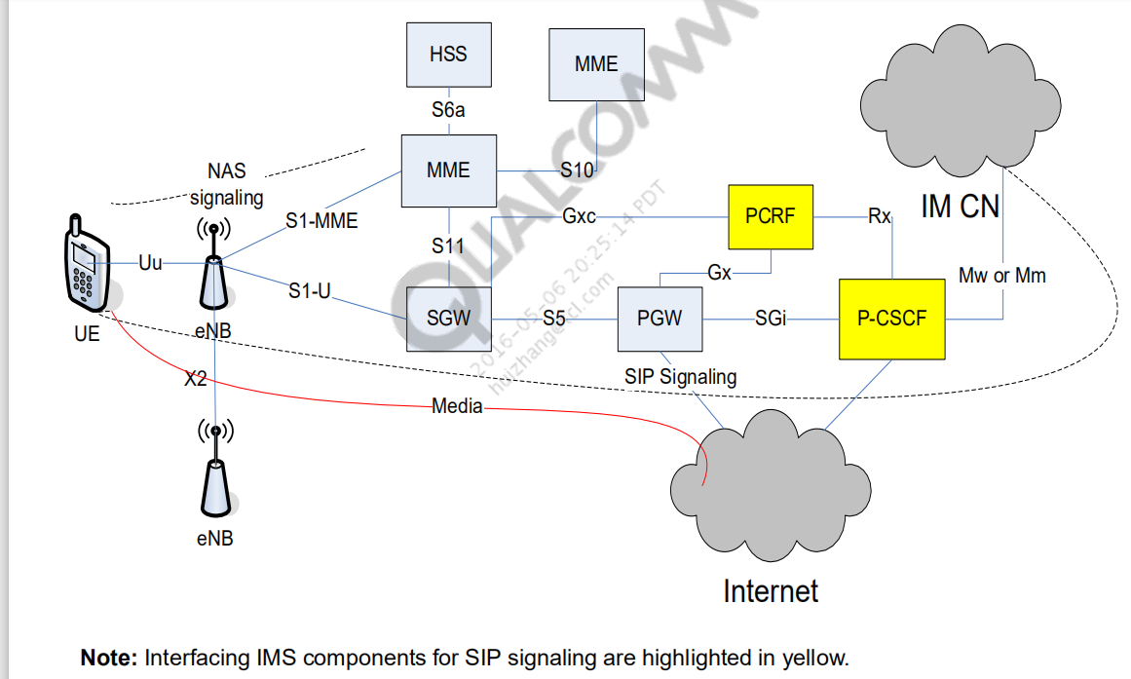

E-UTRA：LTE空中接口

E-UTRAN：LTE接入网=UE+eNB

EPC=MME+SGW+PGW

EPS=E-UTRAN+EPC

EPC：Evolved Packet Core 4G核心网，3GPP的演进分组核心网，主要包括无线接口长期演进（Long Term Evolution，LTE）和系统结构演进（System Architecture Evolution，SAE），由MME+SGW+PGW组成

****eNodeB****（evolved Node B，演进的节点B）。eNodeB是LTE网络中的基站，是LTE网络E-UTRAN的主要网元，负责无线资源管理、上下行数据分类和QoS执行、空口的数据压缩和加密。eNodeB同MME完成信令处理，与S-GW一起完成用户面数据转发。eNodeB相当于面向终端的一个汇聚节点。

MME（Mobility Management Entity，移动性管理实体）。MME负责控制面的移动性管理、用户上下文和移动状态管理、分配用户临时身份标识等。MME相当于LTE网络总的管家，所有的内部事务（Intra System切换）和外部事务（InterSystem互操作）均由MME总体协调完成。

# PDN

PDN（Packet Data Network分组数据网络），严格意义上讲可以分为内部 PDN 和外部 PDN：内部 PDN 即 EPS 系统中的分组数据网络，是 EPS 系统实体（e.g. MME、HSS、SGW、PGW、PCRF）之间的网络通信；而外部 PDN 即 EPS 系统之外的分组数据网络，例如：3GPP 网络 CDMA1X、Internet（互联网）、IoT（Internet of Things，物联网）、IMS（VoLTE 业务）、行业应用（e.g. 银行专线、证券专线），以及非 3GPP 网络 WiMAX 等。内、外 PDN 通过 PGW 作为网关。

为了方便描述，在普遍的语境中，“PDN” 一般指代的都是外部 PDN，所以我们也常常简要的将 PGW 阐述为 EPS 和 PDN 之间的网关。若将 EPS 作为一个整体，那么从 PDN 的角度来看，EPS 就可以抽象的理解为是 UE 到 PDN 之间的接入网。

需要注意的是，UE 是可以与多个不同 PDN 建立 PDN Connection 的，这就要求不同的 PDN 之间具有隔离性。在 EPS 中，PDN 的隔离性由 PGW 的（物理/逻辑）隔离性来完成。例如：PLMN 中具有有多个 PGW，每个 PGW 对接一个 PDN，UE 想访问哪个 PDN 就连接对应的 PGW，想访问多个 PDN 就连接到多个 PGW。

NOTE：PGW 并非一定连接到某个 PDN，即 SGi 接口配置是可以为空的，此时 PGW 的 APN 则作为停机 APN（e.g. bosstjft.xx、dummy.xx）。当用户欠费时，运营商会将用户接入的 APN 修改为停机 APN，此时 UE 就会进入 “有信号，但无法上网” 的状态。待用户补缴费用后，网络侧会主动让 UE 完成去附着（Detach）并重新附着（Re-attach）的流程，与现网可用的 APN 再次建立 PDN Connection。

PDN Connection

由于 EPS 使用 PGW 来对接不同的 PDN，所以 UE 到 PGW 之间的逻辑数据通路称为 PDN Connection，或者 EPS 业务隧道。UE 发送的上行 IP 报文沿隧道发送到 PGW，PGW 发送的下行 IP 报文沿隧道发送到 UE。EPS 业务隧道的实际路径为 UE => eNB => SGW => PGW => PD。

PDN Connection 的关键属性为：APN、PDN Type、UE IP（又称为 PDN Address）和 UE DNS。首先简单总结一下这些参数与 PDN Connection 之间复杂的关系：

由于 PGW 不适合作为高度抽象的操作对象，所以使用 APN 来表示 UE 希望接入的 PDN。1 个 UE 可以同时连接到多个 APN，建立多个不同的 PDN Connection。

由于 PDN 具有特征属性参数，所以在同一个 APN 内可以根据 PDN Type 的不同建立多个不同的 PDN Connection。

虽然很少见，但实际上 EPS 允许为 UE 在同一个 APN 内使用同一个 PDN Type 建立多个不同的 PDN Connection。

这般设计，目的是为了在复杂的现网环境中，尽力地保障 UE 与 PDN 之间的 IP 连通性。后面内容中，我们主要对这些属性进行介绍以及分析其功能。

# LTE注册流程

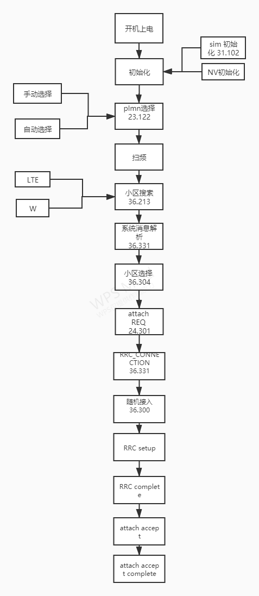

## UE 初始化

UE初始化(网络相关)主要包括SIM初始化 和nv初始化

SIM相关信息主要包括以内的几个内容：

1 。PLMN 相关

HPLMN selector with Access Technology

OPLMNwACT

PLMNwACT

FPLMN

EHPLMN

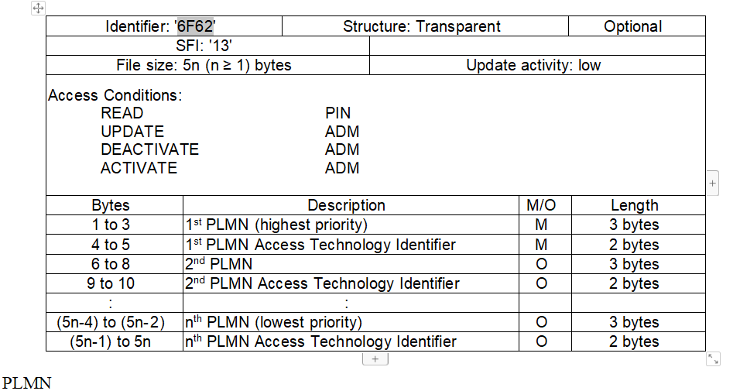

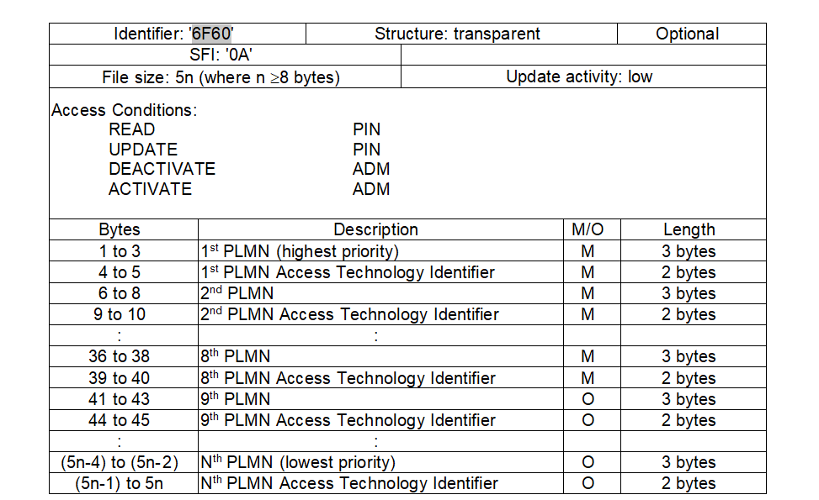

2.PLMN 选择包括自动搜网 和手动搜网

自动搜网 优先级 RPLMN>HPLMN>UPLMN>OPLMN

手动搜网 RPLMN默认注册， 其他列出可选plmn

没有找到合适plmn， 发起受限注册，可以进行紧急拨号

1. 扫频

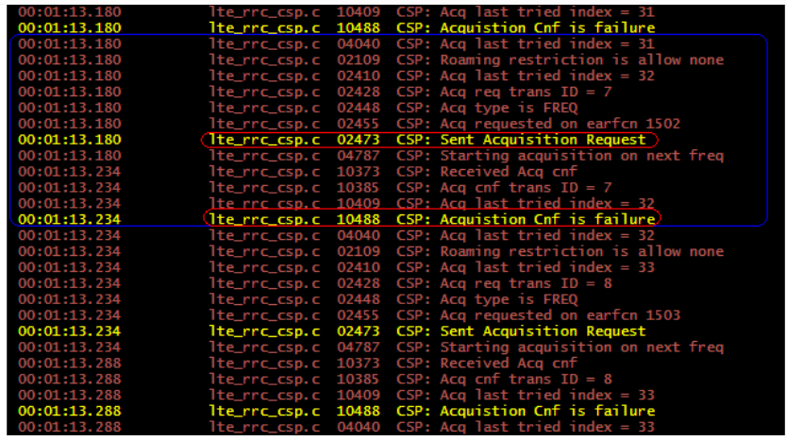

1. 小区搜索

LTE的小区搜索实质是通过对PSS(主同步信号)和SSS(辅同步信号)的解调 ，也就是UE对小区的识别和对下行的同步。这样就可以接受MIB和SIB消息。

W下面会有时隙同步 帧同步 主扰码解析等

1. 系统消息解析

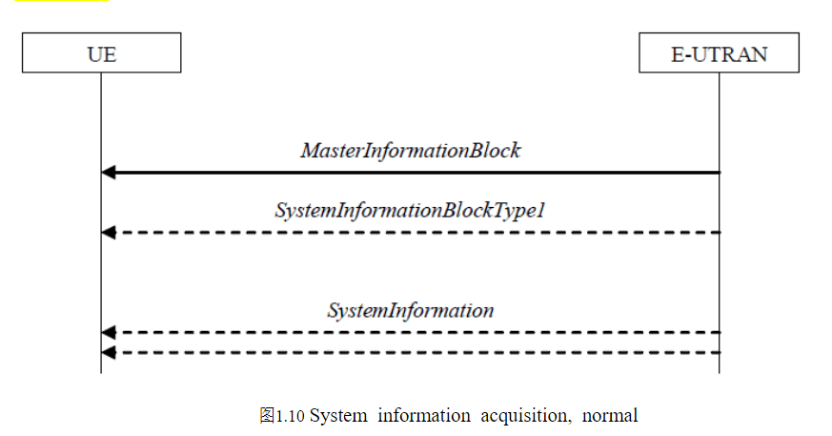

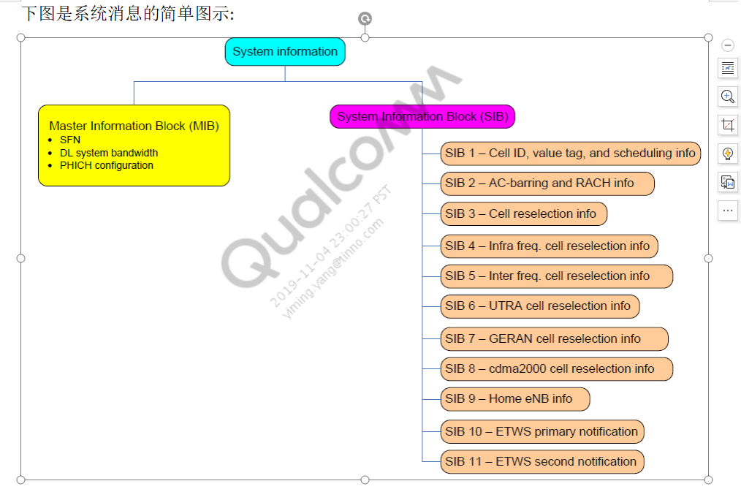

MIB 中携带 天线数 下行带宽 小区id，注册频点等信息

-- ASN1START

MasterInformationBlock ::= SEQUENCE {

dl-Bandwidth ENUMERATED {

n6, n15, n25, n50, n75, n100},

phich-Config PHICH-Config,

systemFrameNumber BIT STRING (SIZE (8)),

schedulingInfoSIB1-BR-r13 INTEGER (0..31),

spare BIT STRING (SIZE (5))

}

OTA message

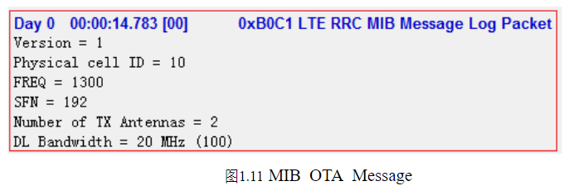

DL_Bandwidth：系统带宽，取值范围(1.4M(6RB，0)，3M(15RB,1)，5M(25RB,2)，10M(50RB,3)，15M(75RB,4)，

20M(100RB,5))，上图为n100，对应的系统带宽为20M（100RB，带宽索引号为5）。

Phich_Duration：当该参数设置为normal时，PDCCH占用的OFDM符号数可以自适应调整；当该参数设置为extended时，若带宽为1.4M，则PDCCH占用的OFDM符号数可以取3或4，对于其他系统带宽下，PDCCH占用的符号数只能为3。

SystemFrameNumber:系统帧号。系统帧号，用于UE获取系统时钟。实际SFN位长为10bit，也就是取值从0-1023循环。在PBCH的MIB广播中只广播前8位，剩下的两位根据该帧在PBCH 40ms周期窗口的位置确定，第一个10ms帧为00，第二帧为01，第三帧为10，第四帧为11。PBCH的40ms窗口UE可以通过盲检来确定。

SIB消息中携带plmn 小区id，s准则的参数等，需要在sib消息携带的plmn跟前面的plmn一致的时候，才会有下一步。否在扫下一个频点。

SIB1:

SystemInformationBlockType1-BR-r13 ::= SystemInformationBlockType1

SystemInformationBlockType1 ::= SEQUENCE {

cellAccessRelatedInfo SEQUENCE {

plmn-IdentityList PLMN-IdentityList,

trackingAreaCode TrackingAreaCode,

cellIdentity CellIdentity,

cellBarred ENUMERATED {barred, notBarred},

intraFreqReselection ENUMERATED {allowed, notAllowed},

csg-Indication BOOLEAN,

csg-Identity CSG-Identity OPTIONAL -- Need OR

},

cellSelectionInfo SEQUENCE {

q-RxLevMin Q-RxLevMin,

q-RxLevMinOffset INTEGER (1..8) OPTIONAL -- Need OP

},

p-Max P-Max OPTIONAL, -- Need OP

freqBandIndicator FreqBandIndicator,

schedulingInfoList SchedulingInfoList,

tdd-Config TDD-Config OPTIONAL, -- Cond TDD

si-WindowLength ENUMERATED {

ms1, ms2, ms5, ms10, ms15, ms20,

ms40},

systemInfoValueTag INTEGER (0..31),

nonCriticalExtension SystemInformationBlockType1-v890-IEs OPTIONAL

}

SystemInformationBlockType1-v890-IEs::= SEQUENCE {

lateNonCriticalExtension OCTET STRING (CONTAINING SystemInformationBlockType1-v8h0-IEs) OPTIONAL,

nonCriticalExtension SystemInformationBlockType1-v920-IEs OPTIONAL

}

/ SIB1 接收后, 如果PLMN匹配, 并且未被barred, 则可以进行S准则判定是否属于suitable小区了. 适合驻留的小区称之为suitable小区，能够提供正常的服务。它需要满足以下条件：

* 小区属于注册的PLMN或者是等效PLMN 列表中的一个 ( EPLMN)
* 小区没被阻塞禁止
* 小区不属于forbidden tracking areas for roaming的TA (Tracking Area)
* 如果是CSG 的小区，其CSG ID应该包含在UE允许的CSG列表中
* 满足小区择的S-Criterion准则

与之相对，只能提供受限服务的小区被称之为acceptable小区，它需要满足以下条件：

* 小区没被阻塞禁止
* 满足小区择的S-Criterion准则

此外，协议中还定义了其他种类的小区：

* 禁止小区，UE不允许驻留的小区
* 保留小区，只某些特定种类的UE(AC 11 和 AC15) 在HPLMN能够驻留的小区
* CSG(Closed Subscriber Group)小区，只有属于CSG Group 的UE才可以驻留

小区择的S准则是指：

Srxlev = Qrxlevmeas – (Qrxlevmin + Qrxlevminoffset) – Pcompensation

需满足Srxlev>0

Qrxlevmeas: 实际测得的小区接收信号功率值，这里主要是指UE测量到的RSRP。

Qrxlevminoffset: 该值的作用是减少PLMN之间的乒乓选择，此参数仅在UE注册到VPLMN后进行周期性PLMN搜索，进行高优先级PLMN小区评估时使用，其他情况下该值为0。

Qrxlevmin: 信号强度要求的最小值, -140～-44 dBm .

Pcompensation: 大于0dB的补偿值，在某个小区内如果最大可以使用的上行发射功率大于UE所能发射的最大功率，那么这个小区的选择门限要被提高。Pcompensation取值为max(PEMAX – PUMAX, 0)，其中PEMAX表示UE进行上行传输时的最大发射功率等级，PUMAX表示UE的射频最大输出功率值

|  |  |
| --- | --- |
| Srxlev | Cell Selection RX level value (dB) |
| Qrxlevmeas | Measured cell RX level value (RSRP). |
| Qrxlevmin | Minimum required RX level in the cell (dBm) |
| Qrxlevminoffset | Offset to the signalled Qrxlevmin taken into account in the Srxlev evaluation as a result of a periodic search for a higher priority PLMN while camped normally in a VPLMN [5] |
| Pcompensation | max(PEMAX – PUMAX, 0) (dB) |
| PEMAX | Maximum TX power level an UE may use when transmitting on the uplink in the cell (dBm) defined as PEMAX in [TS 36.101] |
| PUMAX | Maximum RF output power of the UE (dBm) according to the UE power class as defined in [TS 36.101] |

如果满足S准则, UE则认为此小区为一个suitable cell并驻留下来, 读取其他所需要的系统消息, 进行后续流程. 如不满足, 继续选择其他小区.

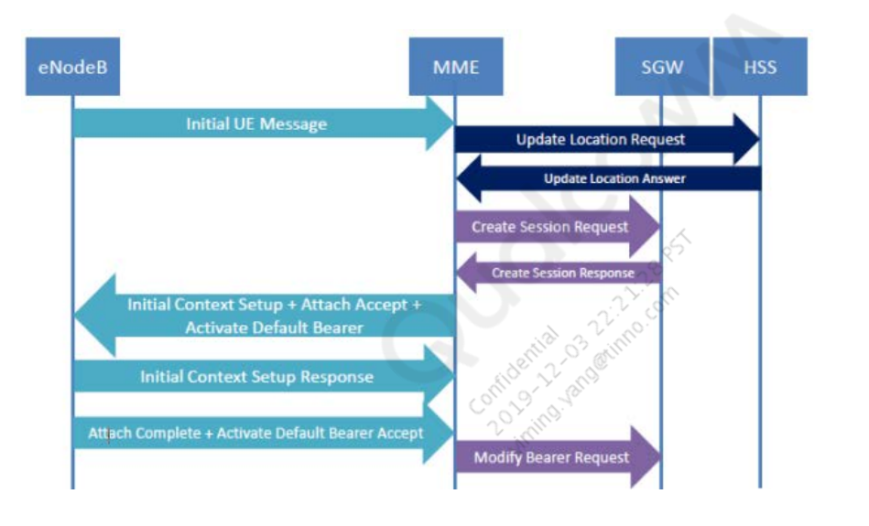

// LTE ATTACH 流程中OTA信令具体含义可以从3GPP TS24.301中查询, 下面简单介绍下

// Attach Request, MS->NW, 手机发起, 携带了UE 的各种参数

62487, 199607, 311796, 11:45:25:220 2019/01/03, MOD_EMM_NASMSG, , TRACE_PEER, [MS->NW] EMM_Attach_Request(cipher="KAL_FALSE", EPS attach type="EMM_ATTACH_TYPE_COMBINED_ATTACH")

.... .010 = EPS attach type: Combined EPS/IMSI attach (2) // attach 的类型, 有combined/EPS only类型

EPS mobile identity // UE 的id, 可以是GUTI, 或者IMSI

.... .110 = Type of identity: GUTI (6)

Mobile Country Code (MCC): Unknown (1)

Mobile Network Code (MNC): Unknown (01)

MME Group ID: 1

MME Code: 2

M-TMSI: 0x66431122

UE network capability // UE支持的加密/完整性保护算法, CSFB 等feature

1... .... = EEA0: Supported

.1.. .... = 128-EEA1: Supported

..0. .... = H.245 After SRVCC Handover: Not supported

...1 .... = Access class control for CSFB: Supported

.... 1... = LTE Positioning Protocol: Supported

.... .1.. = Location services (LCS) notification mechanisms: Supported

.... ..0. = SRVCC from E-UTRAN to cdma2000 1xCS: Not supported

ESM message container // attach 流程中包含的 PDN connectivity request 信令, 但这里面不包含APN参数.

NAS EPS session management messages: PDN connectivity request (0xd0)

0011 .... = PDN type: IPv4v6 (3)

.... 0001 = Request type: Initial request (1)

.... ...1 = EIT (ESM information transfer): Security protected ESM information transfer required

Tracking area identity - Last visited registered TAI // last TAI

DRX Parameter // 手机指定的 DRX 周期

SPLIT PG CYCLE CODE: 8 (8)

0000 .... = CN Specific DRX cycle length coefficient: CN Specific DRX cycle length coefficient / value not specified by the MS (0)

.... 0... = SPLIT on CCCH: Split pg cycle on CCCH is not supported by the mobile station

.... .010 = Non-DRX timer: max. 2 sec non-DRX mode after transfer state (2)

MS Network Capability // 2/3G 相关的能力

.... 1... = SRVCC to GERAN/UTRAN capability: SRVCC from UTRAN HSPA or E-UTRAN to GERAN/UTRAN supported

Location area identification - Old location area identification // 上次注册的 LAI

Mobile station classmark 2 // 2/3G 相关能力

Mobile station classmark 3 // 2/3G 相关能力

Supported Codec List - Supported Codecs // 语音codec (2/3G) AMR/WB之类的支持能力

Voice Domain Preference and UE's Usage Setting // UE usage 以及 voice domain 配置

.... .0.. = UE's usage setting: Voice centric

.... ..11 = Voice domain preference for E-UTRAN: IMS PS voice preferred, CS Voice as secondary (3)

// 网络受到attach 请求后, 可能会发起 Identity以及鉴权的流程

// IDENTITY request, 网络可能会请求手机的 IMSI/IMEI

63040, 199982, 312171, 11:45:25:220 2019/01/03, MOD_EMM_NASMSG, , TRACE_PEER, [NW->MS] EMM_Identity_Request(cipher="KAL_FALSE", identity type="D_EMM_ID_TYPE_IMSI")

.... 0001 = Identity type 2: IMSI (1)

63086, 199996, 312185, 11:45:25:220 2019/01/03, MOD_EMM_NASMSG, , TRACE_PEER, [MS->NW] EMM_Identity_Response(cipher="KAL_FALSE")

IMSI: 001010123456789

Mobile Country Code (MCC): Unknown (1)

Mobile Network Code (MNC): Unknown (010)

// 鉴权过程, 一般第一次入网会要求, 也看运营商的需求, 进行AKA双向校验. 鉴权都是由网络发起, 携带一个 RAND 随机数以及 AUTN

63428, 200388, 312577, 11:45:25:220 2019/01/03, MOD_EMM_NASMSG, , TRACE_PEER, [NW->MS] EMM_Authentication_Request(cipher="KAL_FALSE")

Authentication Parameter RAND - EPS challenge

RAND value: 55555555555555555555555555555555

Authentication Parameter AUTN (UMTS and EPS authentication challenge) - EPS challenge

AUTN value: 56515053525cd5555554575651518607

SQN xor AK: 56515053525c

AMF: d555

MAC: 5554575651518607

// 手机收到后, 会先校验 AUTN, 校验通过后, 再把随机数和AUTN发送给SIM卡, 通过卡中的CK/IK密匙以及传入的RAND随机数, 计算出一个RES值, 返回给网络.

// 网络比较RES, 确认是否跟网络侧计算出的结果一致, 如果一致, 继续后续的流程, 不一致, 可以重新发起AUTH流程, 或者拒绝attach.

// 鉴权通过后, 网络启动安全模式, 激活OTA信令的加密和完整性保护, 之后的OTA信令会进行完整性和加密的校验

// 在Attach request中包含了PDN请求, 未携带APN, 但是可以设定一个标志, 要求网络通过ESM info request流程来查询UE 的APN, UE提供attach APN.

// 之后网络会要求RRC同时启动安全模式, 分配srb/drb资源(LTE attach就默认激活了一个PDN), 随后下发Attach accept, 包含了attach结果, 网络的支持能力以及默认承载建立请求

72310, 204598, 316787, 11:45:25:621 2019/01/03, MOD_EMM_NASMSG, , TRACE_PEER, [NW->MS] EMM_Attach_Accept(cipher="KAL_TRUE", EPS attach result="EMM_ATTACH_RESULT_COMBINED_ATTACHED")

.... .010 = Attach result: Combined EPS/IMSI attach (2)

GPRS Timer - T3412 value // 周期性 TAU 定时器

Tracking area identity list - TAI list // 目前小区所在 TAI list

ESM message container // 打包的PDN 默认承载建立请求, 里面携带了分配的ip类型, ip地址, apn名字, 聚合速率等参数, PCSCF地址(当被请求时)

EPS mobile identity - GUTI // 网络分配的GUTI

Location area identification // LAI, Combined attach时从UMTS核心网获取的

Mobile identity - MS identity - TMSI/P-TMSI (0x0000) // TMSI, Combined attach时从UMTS核心网获取的

EPS network feature support // 网络支持的能力

1... .... = Control plane CIoT EPS optimization: Supported

.0.. .... = EMM-REGISTERED w/o PDN connectivity: Not supported

..0. .... = Support of EXTENDED SERVICE REQUEST for packet services: Not supported

...0 0... = CS-LCS: no information about support of location services via CS domain is available (0)

.... .0.. = Location services via EPC: Not supported

.... ..1. = Emergency bearer services in S1 mode: Supported //紧急号码支持

.... ...1 = IMS voice over PS session in S1 mode: Supported // volte 支持

// 在信令log中还会看到这两个信令, 在attach流程中不是单独存在的, 是打包在attach accept以及attach complete中. LTE下无线资源是以承载(bearer)来标志的, EBI是bearer id, 可以通过这个跟踪建立释放的具体是哪个.

// 手机收到attach accept后, 会根据配置建立对应的承载(RRC层需要建立相应的srb/drb), 同时也会检查apn的名字(高通平台会检查), 如果跟手机上报的apn不一致, attach可能会失败. 如果没有问题后, 手机回Attach Complete, 完成attach流程.

73047, 204740, 316929, 11:45:25:621 2019/01/03, MOD_EMM_NASMSG, , TRACE_PEER, [MS->NW] EMM_Attach_Complete(cipher="KAL_TRUE")

ESM message container contents: 5200c2

0101 .... = EPS bearer identity: EPS bearer identity value 5 (5)

.... 0010 = Protocol discriminator: EPS session management messages (0x2)

NAS EPS session management messages: Activate default EPS bearer context accept (0xc2)

至此, 一个完整的Attach流程已经结束, 手机在这之后获取到Normal service, 如果Attach APN是internet类型, 就可以进行数据业务了. 如果要进行语音业务, 需要先进行IMS注册, 或者执行CSFB流程到2/3G上发起.

## OTA 消息

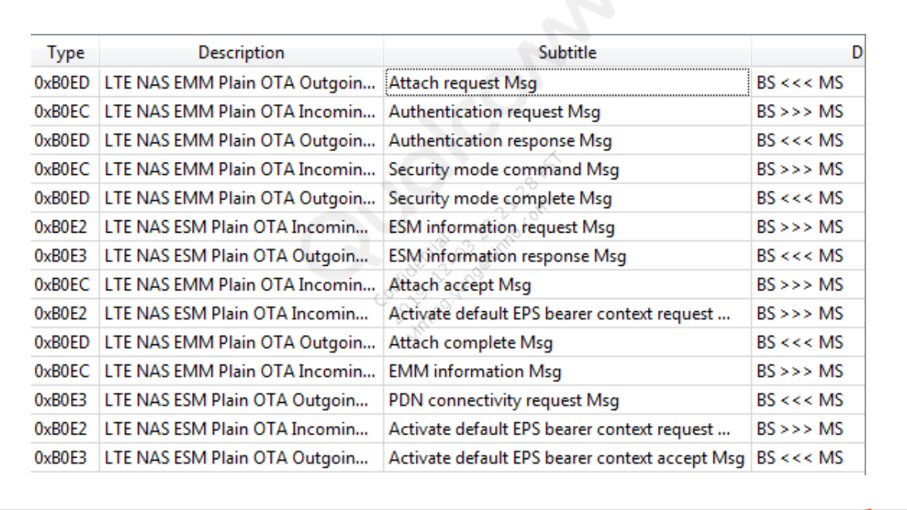

## Attach Request Message

LTE device with voice as preference, sends attach request as “voice

centric” and IMS PS as “voice preferred”

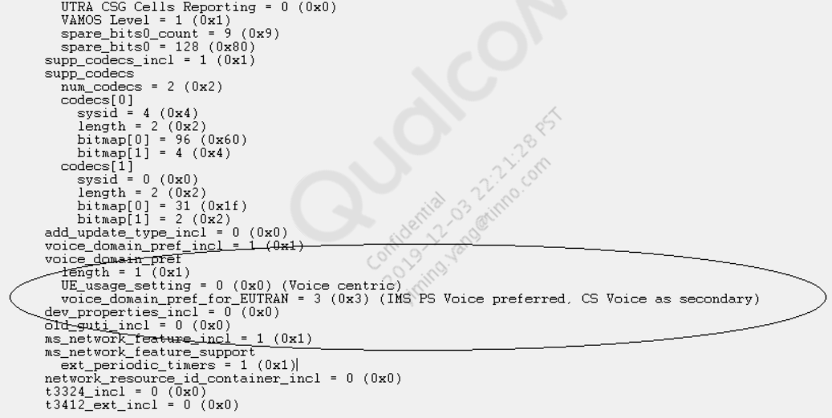

Check APN Name for Default Bearer

Look in ESM information response for access_point_name.

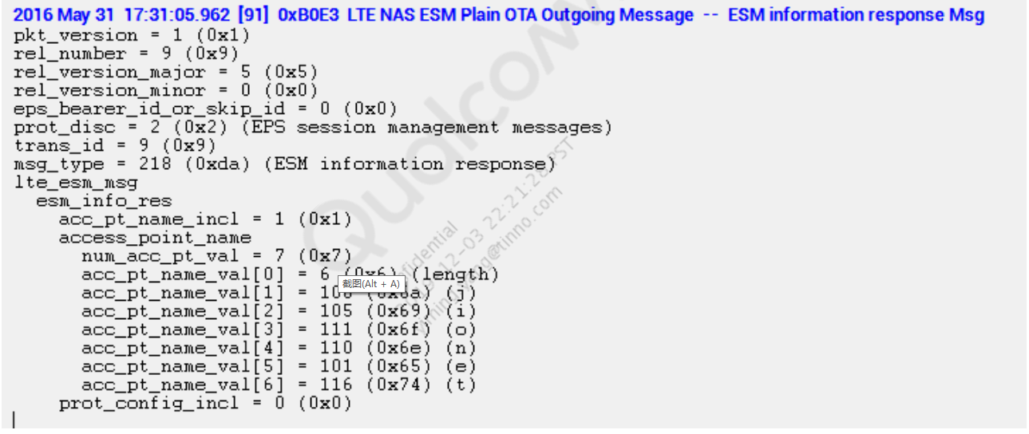

Default Bearer Activation on QC9 for LTE

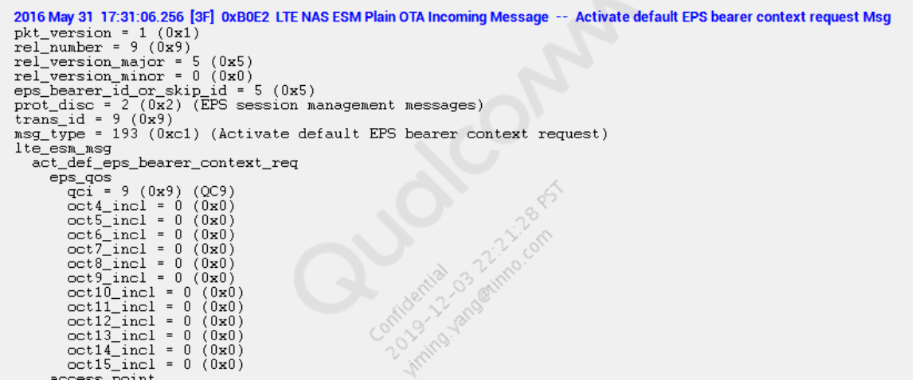

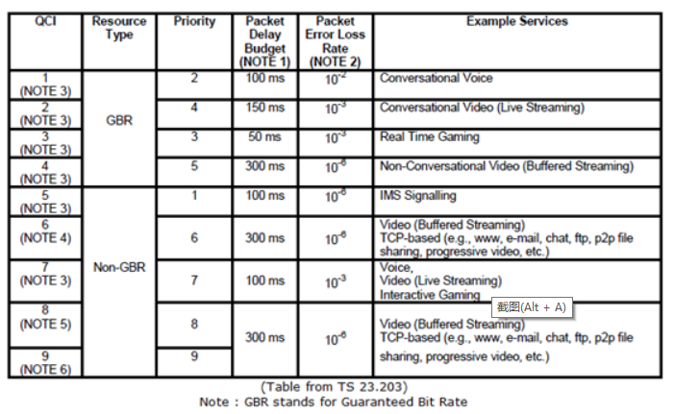

Check PDN connectivity with APN name “ims”, after the attach procedure

is complete.

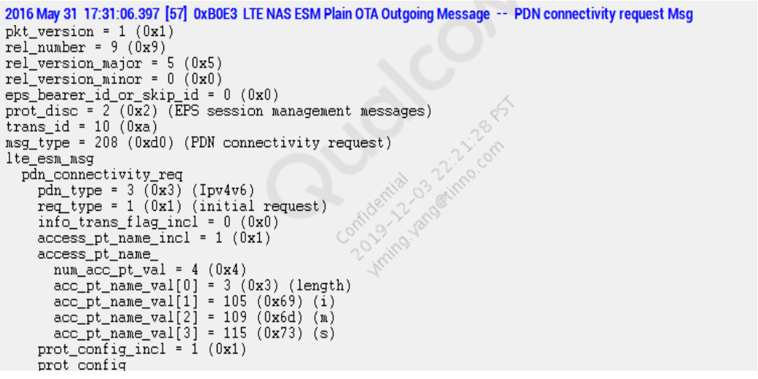

IMS signaling default bearer is established on QCI 5

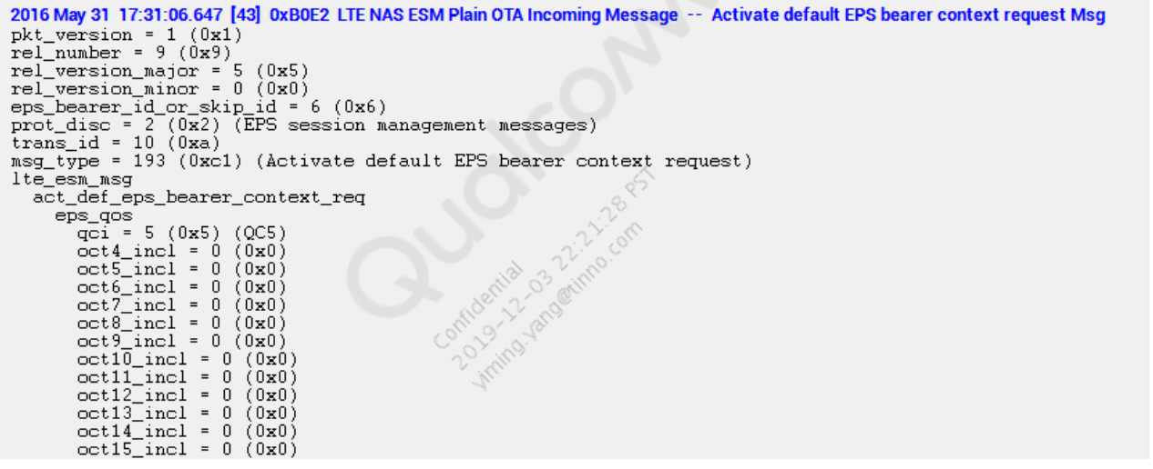

Prerequisites for IMS registration:

▪ LTE attach is successful

▪ Bearer is established to carry data (QCI=9)

▪ PDN connectivity request is sent to IMS

▪ Bearer for IMS signaling is established (QCI = 5)

## LTE Advanced Carrier Aggregation

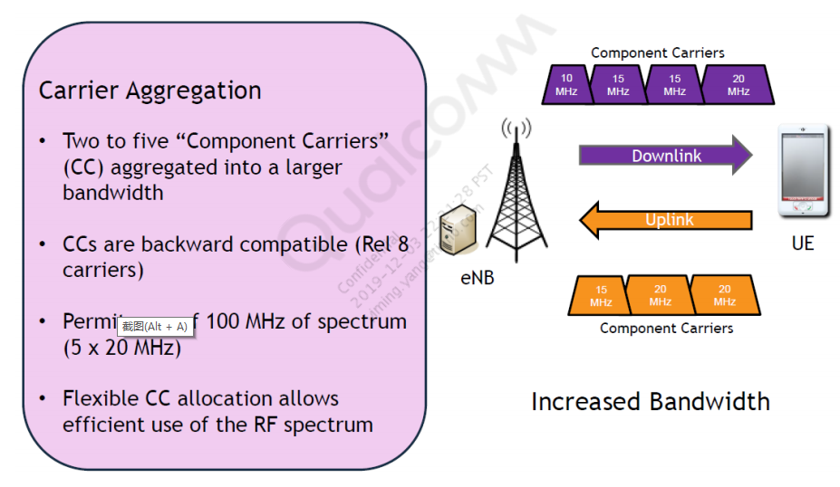

CA Serving Cell Set

▪ A UE configured for CA connects to one Primary (serving) Cell (PCell) and

up to four Secondary (serving) Cells (SCells)

▪ Both primary and secondary cells are categorized as serving cells

Primary Component Carrier (PCC) – CC corresponding to the PCell.

▪ The cell on which the UE performs initial connection establishment

▪ The primary cell can be changed during the hand over procedure

▪ Each connection has a single primary cell

▪ A PDCCH order to initiate the random access procedure can only be

received on the primary cell

▪ PRACH preambles can only be sent on the primary cell

▪ The primary cell is used to generate inputs during security procedures

▪ The primary cell is used to define NAS mobility information, for example,

Tracking Area Identity

▪ LTE Idle

▪ No CA in Idle mode

▪ LTE Connected Single Carrier

▪ No SCells added

▪ No carrier aggregation-related operations

▪ CA, SCell added via RRC (Deactivated)

▪ No monitoring of PDCCH for SCell

▪ No CQI reports for SCell

▪ Periodic measurements for SCell

▪ CA, SCell Activated via MAC CE

▪ Monitoring PDCCH for DL SCell

▪

During UE Attach procedure, the eNB inquires about UE Capabilities, by

sending UE Capability Enquiry Message

▪ All UE supported capabilities are provided in UE Capability Information

Message

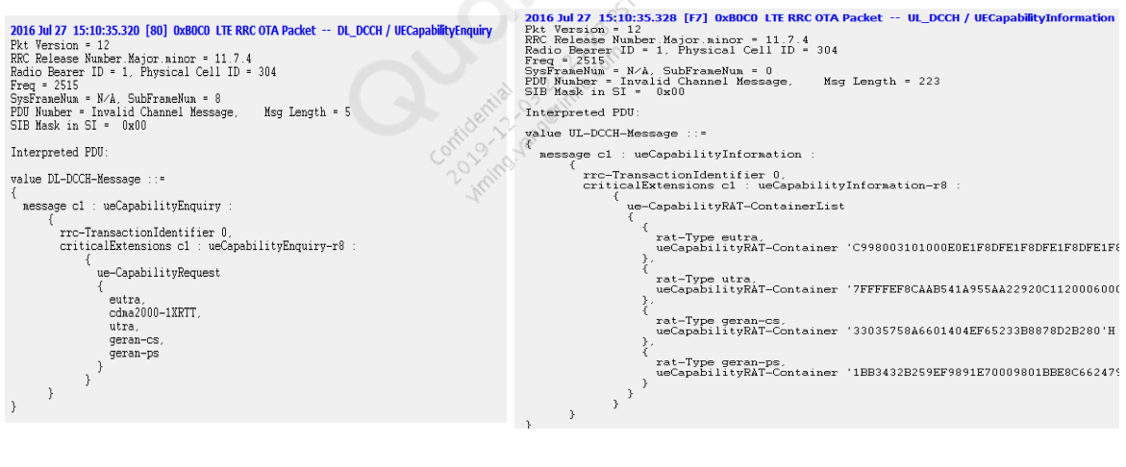

▪ In the snapshot UE supports B5 +B3 combination

▪ Bandwidth call supported is A for both band 5 and band 3 in both UL and DL

▪ supportedMIMO-CapabilityDL-r10 “two layers” indicates that UE supports DL 2 x 2 MIMO

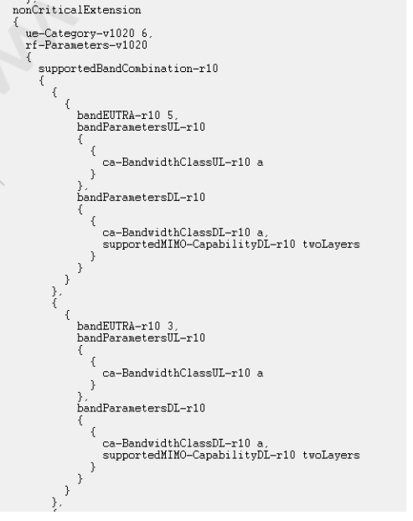

▪ featureGroupIndRel10-r10 specifies R10 LTE Adv. Access Stratum

Features supported by UE.

▪ FGI Bit 111: Measurement reporting trigger Event A6

▪ This bit can be set to 1 only if the UE supports carrier aggregation.

▪ Event A6: Neighbor becomes offset better than Secondary Cell

▪ Rel 10 FGI Bit Index start from 101, which is the leftmost bit in the field

featureGroupIndRel10.

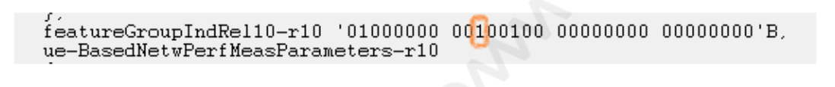

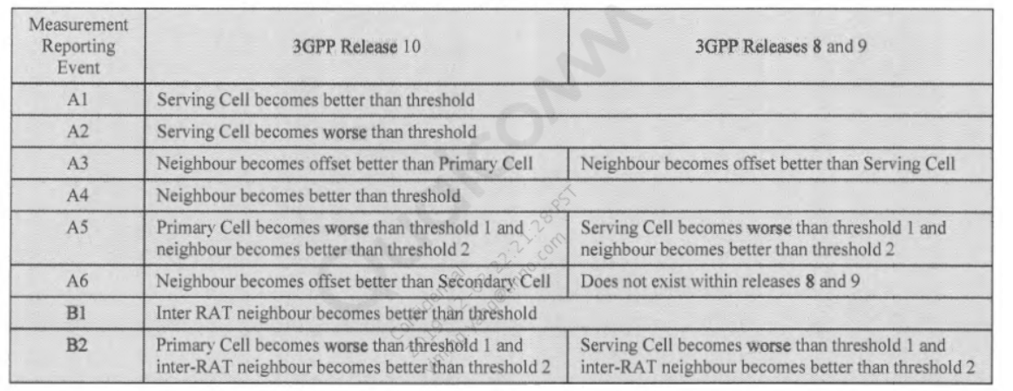

The secondary cell [SCell] Addition, Release, and modification are RRC’s

responsibility. RRC configures SCell for CA capable UE only.

▪ For the UE to receive data (PDSCH/PDCCH) on SCell, it has to be

activated. This is different from configuring the SCell. The activation is

done through the MAC Control Element.

▪ After configuring/adding the SCell, the SCell is initially in the deactivated

state. When SCell is modified, the UE does not change the activation

status of the concerned SCell

▪ During HO, if the same SCell is in use in the target PCell (that is, SCell is

not released during HO), the SCell in the target cell is initially in the

deactivated state.

▪ SCells cannot be added/configured at the time of RRC Connection

establishment. There is no provision for SCell addition in the RRC

Connection Setup message.

▪ On completion of AS security, the SCell may be added either blindly or

after receiving the measurement report from the UE indicating that the cell

on the carrier frequency used for the SCell is above a certain threshold.

▪ SCell is added to the PCell, or to a set of serving cells through the ‘RRC

Connection Reconfiguration’ procedure

▪ During HO, if the same SCell is in use in the target PCell (that is, SCell is

not released during HO), the SCell in the target cell is initially in the

deactivated state

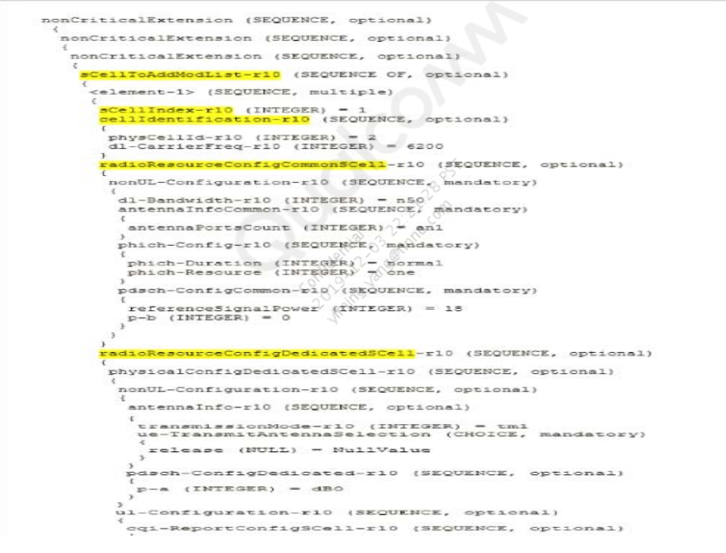

E-UTRAN uses

IE sCellToReleaseList in RRCConnectionReconfiguration message to

remove or release an already configured SCell

▪ UE should release all the configured SCells if RRC Connection

Re-establishment procedure is initiated (obviously on PCell).

▪ SCell can be released when SCell is either in activated or deactivated

state.

▪ Typically, when SCell is deactivated and SCell Channel conditions

reported by UE are poor, then eNB can release the SCell

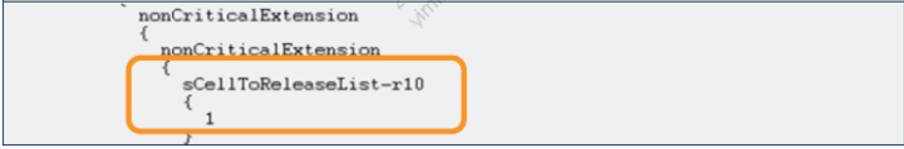

▪ Purpose and actions

▪ Save UE battery power

▪ Start/Stop SCell activities

▪ Applicability

▪ SCells only (SCells need to be configured by RRC)

▪ PCell is never de-activated

▪ The UE (and the network) can deactivate the activated SCell without

explicit signaling that is based on sCellDeactivationTimer. This is the

amount of time (in radio frames) the UE has not received any data on the

SCell.

▪ SCell activation is done through the MAC Control Element whereas the

deactivation mechanism is either by using MAC control element or by the

expiry of the sCellDeactivationTimer.

## LTE ←→ 3GPP (UMTS/GERAN) Inter-RAT Mobility

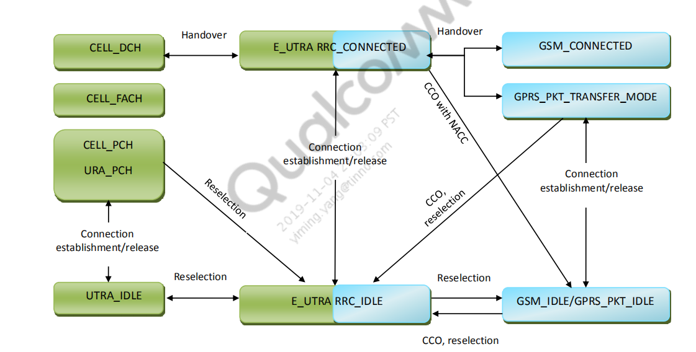

## UTRAN Inter-RAT Cell Reselection

* UE in RRC_IDLE performs cell reselection to identify a cell for UE to camp on
* Cell reselection criteria involves measurement of the serving and neighbor

cells

* Absolute priority-based cell reselection
  + Inter-RAT cell reselection evaluation will be performed only on those cells for
  + which prioirity has been assigned
  + Only given by RPLMN and only valid within RPLMN
  + Equal priority between RATs is not supported
  + Priorities of different Inter-RAT can be given by:
    - System information of serving cell
    - Dedicated signaling (RRCConnectionRelease) with validity timer (optional)

(T320 in EUTRA, T322 in UTRA, and T3230 in GERAN)

* Cell reselection parameters are applicable to all UEs in a cell, but it is possible

to configure specific reselection parameters per UE group or per UE

## Measurement Rule for Cell Reselection

Perform cell reselection measurement based on the priority

For the higher-priority Inter-RAT neighbor cell

– UE shall always perform cell reselection measurement for higher priority cell

For the lower-priority Inter-RAT neighbor cell

– If Snonintrasearch is sent in the serving cell and SServingCell > Snonintrasearch, UE may not perform cell reselection measurement

– If SServingCell ≤ Snonintrasearch or Snonintrasearch is not sent in the serving cell, UE shall perform cell reselection measurement

SServingCell is Srxlev value of serving cell where:

– Srxlev = Qrxlevmeas – (Qrxlevmin + Qrxlevminoffset) – Pcompensation

Note: QrxlevminOffset is only applied when a cell is evaluated for cell selection as a result of a periodic search for a higher-priority PLMN while camped normally in a VPLMN.

(Qrxlevmeas为小区RSRP值；Qrxlevmin为小区最小接入门限值；Qrxlevminoffset为最小电平偏移值，仅当周期搜索高优先级PLMN时的小区时配置，一般配置为0；Pcompensation=MAX（PEMax-PPowerClass，0），PEMax为允许UE在小区中最大上行发射功率，该参数为可选配置，一般不进行配置，PPowerClass为UE自身的最大上行发射功率。)

## Cell Reselection Criteria

SnonServingCell,x

For GERAN and UTRAN cell

– SnonServingCell.x is the Srxlev value of an evaluated cell

– For UTRAN FDD, Squal > 0

For cdma2000 RATs

–

SnonServingCell,x = FLOOR(-2 x 10 x log10 Ec/Io) in units of 0.5 dB

Scaling TreselectionRAT

Decides High-mobility state or Medium-mobility state based on number of

reselection

Scaling TreselectionRAT using Speed-dependent ScalingFactor

– sf-medium for Medium-mobility state

– sf-high for High-mobility state

– Multiply TreselectionRAT by sf-medium or sf-high in Medium-mobility state or High-mobility state respectively

Criteria 1



SnonServingCell,x > Threshx,high during TreselectionRAT



For the higher-priority Inter-RAT neighbor cell, the cell reselection shall be

performed if:



Fulfills criteria 1



More than 1 sec has elapsed since the UE camped on the current serving cell



For the lower-priority Inter-RAT neighbor cell, the cell reselection shall be

performed if:



None of serving frequency, equal/higher-priority (Inter-RAT) frequency fulfills

criteria 1



SServingCell < Threshserving,low



SnonServingCell,x of lower-priority IRAT cell > Threshx,low during TreselectionRAT



More than 1 sec has elapsed since the UE camped on the current serving cell

Note: For cell reselection to cdma2000 HPRD NW, pre-registration should be

performed by the UE

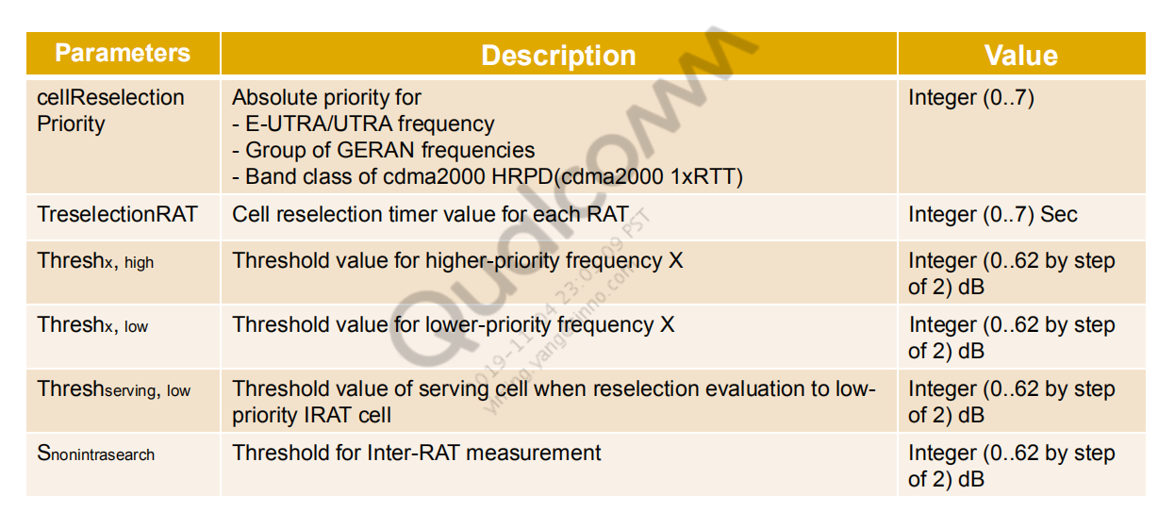

# Inter-RAT Handover from E-UTRAN

Inter-RAT HO is network controlled through source access system



Blind HO is also supported



In RRC_CONNECTED state, a UE shall follow the measurement parameters

specified by RRC directed from the E-UTRAN (IE. measConfig)



UE performs Inter-RAT neighbor cell measurements during DL/UL idle

periods that are provided by the network through suitable DRX/DTX period or

packet scheduling if necessary



During HO, eNB forwards all remaining or unacknowledged Downlink PDCP

SDUs, and successfully received uplink PDCP SDU to target RAT, but eNB

does not forward any downlink and uplink RLC context

## Measurement Gap

E-UTRAN provides measurement Gap to UE in order to provide idle period to

measure neighbor Inter-RAT cells.



During the measurement gap



UE shall not transmit any data



Is not expected to tune its receiver on the serving E-UTRAN carrier frequency



E-UTRAN provides the measurement configuration with

RRCConnectionReconfiguration message. (IE.measconfig)

## Inter-RAT Measurement Report

Depends on the measurement gap pattern and UE measurement capability,

measurement requirement for neighbor RAT cell can be different



CPICH measurement for UTRAN



GSM carrier RSSI and BSIC verification measurement for GERAN



BSIC verification measurement consists of BSIC identification and BSIC

reconfirmation



Measurement reporting type



Periodic reporting



Event-triggered periodic reporting



Event-triggered reporting (event B1 and B2)

## 1615344792(1)

MobilityFromEUTRACommand message can be used to move UE from

E-UTRAN to a cell using another RAT (UTRAN or GERAN)



Handover – MobilityFromEUTRACommand message includes radio resources that

have been allocated for the UE in the target cell



Cell Change Order – MobilityFromEUTRACommand message may include

information facilitating access of connection establishment in the target cell, e.g.,

SI; CCO is applicable only to GERAN



With failure of MobilityfromE-UTRA, UE needs to perform connection

reestablishment procedure

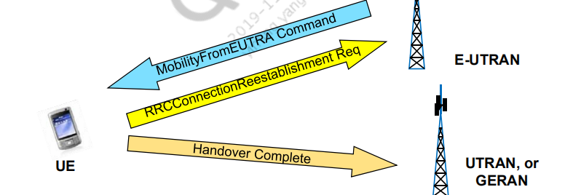

# UTRAN to E-UTRAN Cell Reselection

## Measurement Rule for E-UTRA in IDLE or PCH state

Absolute priority can be given by BCCH (SIB 19) or Dedicated signaling

message (UTRAN MOBILITY INFORMATION)



Absolute priority for Inter-RAT is not used (when HCS is not used)



If Squal > SsearchRAT, and Srxlev > SHCSRAT if SHCSRAT is signaled, UE may choose to

not perform measurements on cells of E-UTRAN



If Squal ≤ SsearchRAT, or Srxlev ≤ SHCS,RAT if SHCS,RAT is signaled, perform

measurements on cells of E-UTRAN



If SsearchRAT is not sent for serving cell, perform measurements on cells of

E-UTRAN



Absolute priority for Inter-RAT is used



E-UTRA cell is higher-priority cell

–

Perform cell reselection measurement for higher priority cell



E-UTRA cell is lower-priority cell

–

SrxlevServingCell > Sprioritysearch1 and SqualServingCell > Sprioritysearch2, UE may not perform

cell reselection measurement.

–

Otherwise, UE shall perform Inter-RAT cell reselection measurement.

Cell Reselection Criteria without Absolute Pri**ority**

Cell reselection based on ranking criteria



For E-UTRA cells Srxlev>0

Information

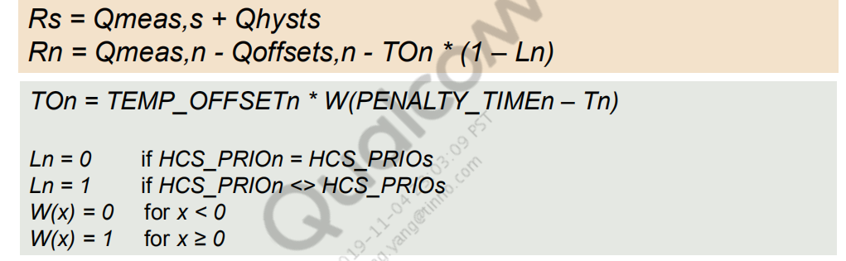

Needed to fulfill criteria for Treselection



Treselections,PCH and Treselections,FACH will be applied (if provided in SIB4) for

(URA)CELL_PCH and CELL_FACH



Scalable Treselection



Multiply Treselection by IE “Speed dependent ScalingFactor for Treselection” for

high mobility State



Multiply Treselection by IE “Inter-RAT ScalingFactor forreselection,” if available

## Cell Reselection Criteria with Absolute Priority

Criterion 1: E-UTRA cell has higher priority



The SrxlevnonServingCell,x of E-UTRA cell > Threshx,high for Treselection



Criterion 3: E-UTRA cell has lower priority



SrxlevServingCell < Threshserving,low or SqualServingCell < 0 and



The SrxlevnonServingCell,x of E-UTRA cell > Threshx,low for Treselection

Note: Criterion 2 is used for same priority of UTRA interfrequency cell reselection

case.



UE shall reselect the cell that has the highest SrxlevnonServingCell,x, if multiple

E-UTRA cells meet cell reselection Criteria on highest absolute priority



Treselections,PCH and Treselections,FACH will be applied if provided in SIB4 for

CELL_PCH/URA_PCH and CELL_FACH



Scalable Treselection



Multiply Treselection by IE “Speed dependent ScalingFactor for Treselection” for

high mobility State



Multiply Treselection by IE “Inter-RAT ScalingFactor forreselection”, if available

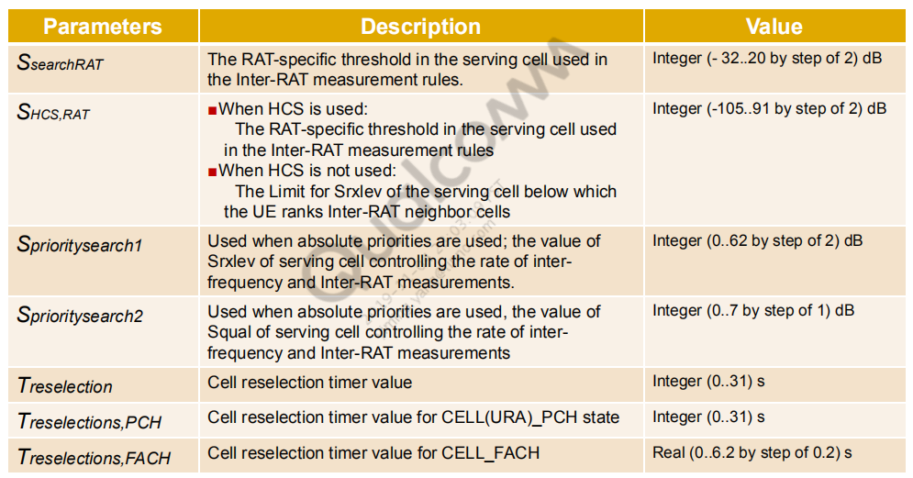

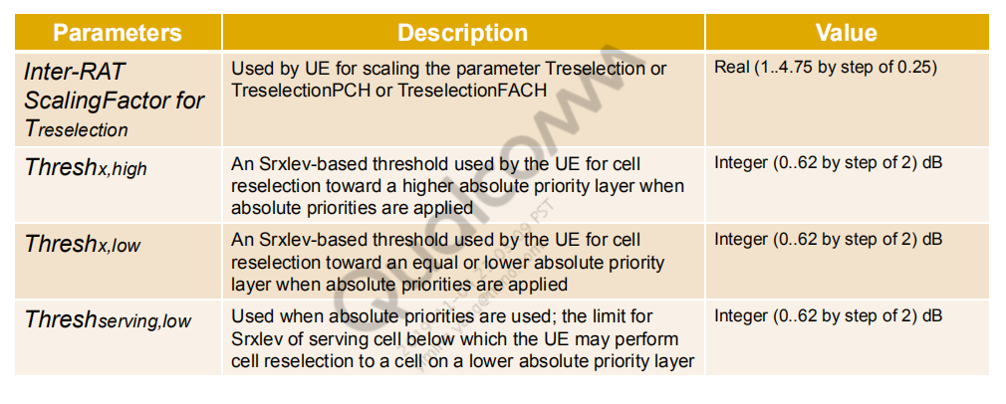

## UTRAN to E-UTRAN Handover

UTRAN configures Inter-RAT measurement using MeasurementControl

message



E-UTRAN RSRP or RSRQ measurements are scheduled during Compressed

mode gaps



Compressed mode pattern is configured by UTRAN using:



PhysicalchannelReconfiguration message



MeasurementControl message



Event 3A and 3B are used to report Inter-RAT measurement

Based on UE’s Measurement, UTRAN sends

HandoverFromUTRANCommand message to UE



With receiving HandoverFromUTRANCommand message, UE starts to

establish connection to E-UTRAN



Success – UE sends RRCConnectionReconfigurationComplete to E-UTRAN



Failure – UE sends HandoverFromUTRANFailure message after reverting back

to UTRAN configuration

E-UTRAN frequencies may be included in the E-UTRAN Neighbor Cell list

(refer to [S9])



THRESH_priority_search



Controls measurement for reselection of E-UTRA cells



Threshold value of RSSI level for UE to trigger priority-based Cell reselection



Priority value for serving GERAN cell and neighbor E-UTRAN cell can

be given by system information, or CHANNEL_RELEASE message in

individual priorities IE



If individual priorities are assigned, MS shall ignore all priorities provided

in system information



Monitor cells of higher-priority Inter-RAT frequencies once every

(60*Nhpf) sec.



Nhpf is the number of Inter-RAT frequencies of higher priority

## Cell Reselection Criteria

S_non-serving_EUTRAN is defined by



The measured RSRP - E-UTRAN_QRXLEVMIN



For higher-priority E-UTRA cell, cell reselection criteria is:



S_non-serving_EUTRAN > THRESH_EUTRAN_high for Treselection



For lower-priority E-UTRA cell, cell reselection criteria is:



S_serving < THRESH_serving_low and S value from all the other GSM cells

–

Any E-UTRA cell S_non-serving_EUTRAN > THRESH_EUTRAN_low for

T_reselection

–

S_nonserving_EUTRAN > S_serving + H_PRIO



If Multiple E-UTRA cell meets the cell reselection criteria, neighbor E-UTRA

cell shall be ranked by S_non-serving_EUTRA value

UE shall not perform Inter-RAT cell reselection within 5 sec after selecting

GSM cell from other RAT



If priority information is available only for some Inter-RAT frequencies, UE

should only consider the cells that have priority information for Cell

reselection



If no priority is available in serving cell, UE in camped normally state (see

[S12]) shall consider any GSM cell to have lowest priority.



UE in any cell state (see [S12]) shall apply priorities only from system

information of the serving cell

## GERAN to E-UTRAN Packet Cell Cha**nge Order**

Network-Controlled Cell reselection



Network may request measurement reports from UE and control its cell

reselection



NETWORK_CONTROL_ORDER indicates different NC mode



NC0 – Normal MS control



NC1 – MS control with measurement report



NC2 – NW control



When ordered to send measurement report, UE shall report a new best

E-UTRAN cell in GPRS E-UTRAN Neighbor Cell list with PACKET

MEASUREMENT REPORT

NW may send PACKET CELL CHANGE ORDER to UE in Packet IDLE mode

via CCCH, or PCCH



With receiving PCCO for E-UTRAN cell, UE needs to acquire specified cell

and initiate RRC Connection establishment procedure



If UE fails to complete PCCO, UE shall send a PACKET CELL CHANGE

FAILURE message with the appropriate cause value to the network in the old

cell

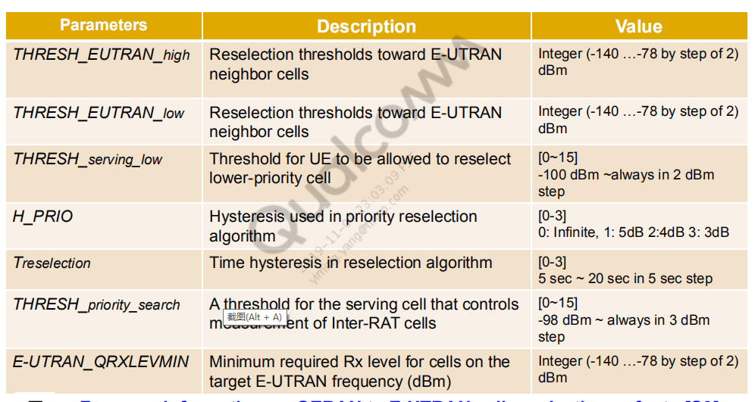

## GERAN to E-UTRAN Handover

Measurement of E-UTRAN Cell in Ded**icat**

E may use search/idle frame to perform E-UTRAN cell measurement in

Dedicated mode



Qsearch_C_E-UTRAN on SACCH, or Qsearch_C_E-UTRAN_Initial on

BCCH (if Qsearch_C_E-UTRAN is not available) controls the threshold when

measurement shall be performed



Qsearch_P controls E-UTRAN cell measurement in Packet Transfer mode



EUTRAN_MULTIRAT_REPORTING which is on (P)BCCH or SACCH

indicates the number of cells to be reported in Measurement Report



E-UTRAN FDD (TDD) cell in neighbor cell list can be on up to 3 FDD (TDD)

frequencies

**ed Mod**

## PS Handover from GERAN to E-UTRAN

PS Handover procedure is initiated by source BSS based on the various

trigger conditions, e.g., measurement report from UE



For UE that is not in NC2, BSS may order UE to enter NC2 before initiating

PS Handover



For PS Handover, source BSS will receive DL-DCCH message including an

RRCConnectionReconfiguration and send it to UE via PS HANDOVER

COMMAND



With receiving PSHandoverCommand message, UE starts to establish

connection to E-UTRAN



Success – UE sends RRCConnectionReconfigurationComplete to E-UTRAN



Failure – UE sends PacketCellChangeFailure message on PACCH to GERAN

Note

NC0：一般的MS控制。MS自行执行小区重选。NC1：MS控制，并有测量报告。MS向网络发送测量报告并自行执行的小区重选。NC2：网络控制重选。MS向网络发送测量报告但不自行执行小区重选。当该参数设置为NC2，并且在SET GCELLGPRS命令里支持NC2设置为“支持”时，才能能够实现网络控制重选。

## Inter-RAT Redirection and CS Fallback

LTE RRC CONNECTED mode to other RAT



redirectedCarrierInfo in RRCConnectionrelease is used to redirect UE from

E-UTRA RRC_CONNECTED to GERAN, UTRAN, and cdma2000 (HRPD

Idle/1xRTT Dormant mode)



WCDMA CONNECTING state and CONNECTED state to LTE using

RRCConnectionReject and RRCConnectionRelease



If E-UTRA frequency list is available with UE, UE includes IE “Pre-Redirection

info” and sets IE “Support of E-UTRA FDD(TDD)” to TRUE in

RRCConnectionReq



IE “Redirection info” in RRCConnectionReject and RRCConnectionRelease is

used



GERAN GSM_CONNECTED to LTE using CHANNEL RELEASE



IE “Cell selection indicator after release of all TCH and SDCCH” is used

## CS Fallback to GERAN or UTRAN

The CS fallback in EPS enables the voice and other CS-domain services

(e.g., CS UDI video/ SMS/LCS/ USSD) by reuse of CS infrastructure when

the UE is served by E-UTRAN.



CS Fallback is only available in case E-UTRAN coverage is overlapped by

either GERAN coverage or UTRAN coverage.

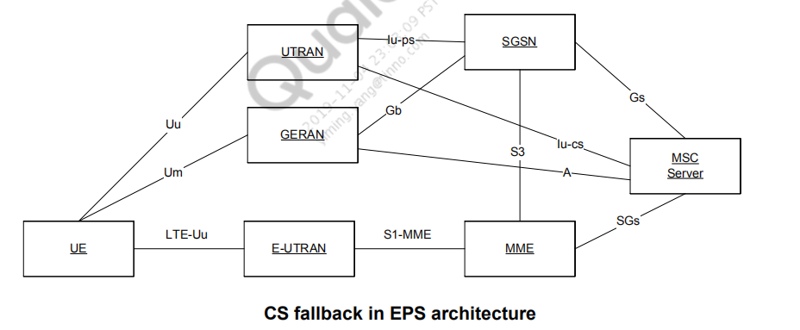

Cell selection flow

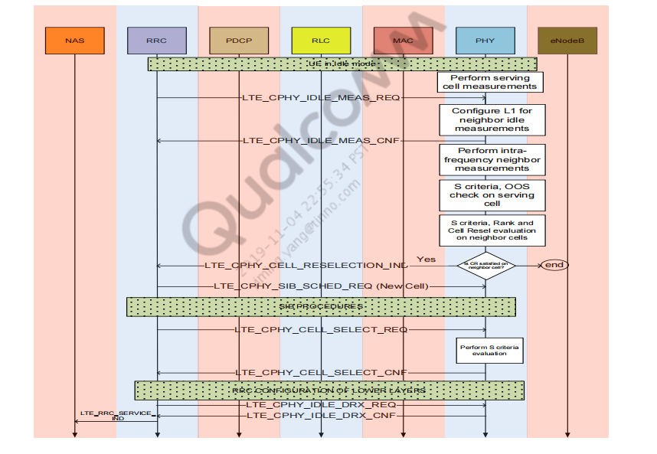

Log

//IMP state in IDLE (after receiving CPHY_IDLE_DRX_CFG_REQ)

329370 27:21:08:16.351 496.351 lte_ml1_imp_stm.c

H 720

IMP Paging DRX: entering IDLE

//ML1 instructs to start measurements on serving and neighbor cells in DRX wake up

21:08:23.851

503.851 lte_ml1_mgr_task.c

H 1015

L1M->IMP message id: 4240200

time: absolute time in milli secs from powerup]

21:08:23.851

503.851 lte_ml1_imp.c

H 1116

Start cell resel eval, time 22089

//Serving cell measurement request

[req 3: Serving cell measurement]

21:08:23.851

503.851 lte_ml1_imp_stm.c

H 1989

IMP obj start: entering SRCH MEAS: req 3

21:08:23.851

503.851 lte_ml1_sm_idle.c

H 516

SM_Idle: Config req add 3, new config 3

21:08:23.851

503.851 lte_ml1_sm_sd_if.c

H 264

SM: Sent Serving Cell Measurement Req; id: 0x0408020d

//S > 0

422035 26:21:08:23.913

503.913 lte_ml1_mdb_idle.c

H 2178

Serv meas upd new rsrp -71 avg -73 S 27

//Measurement rules

[C: Previous measurement rules. 0 means no neighbors]

N: Current measurement rules. 0 means no neighbors

Serv S: Serving cell DRX

Drx S fail: Number of consecutive DRX S fail

Nserv: Number of consecutive DRX cycles where S failed after which UE should measure all neighbors]

422036 26:21:08:23.913

503.913 lte_ml1_mdb_idle.c

H 2743

Meas Rules: C=0 N=0: serv S 27 # drx S fail 24 Nserv 2

Intra cfg 0 Sintra 0 Non-intra cfg 0 Snonintra 0

422039 26:21:08:23.913

503.913 lte_ml1_mdb_idle.c

H 3505

Serv cell S 27 rsrp -73 Mob 1 Qhyst 0 rank -73

422041 27:21:08:23.913

503.913 lte_ml1_imp_stm.c

H 2233

IMP check resel/oos: entering IDLE

//Here serving cell is degraded

21:08:27.757

507.757 lte_ml1_sm_idle_st

H 1399

SM Idle: Entering lte, config reqs 3

21:08:27.757

507.757 lte_ml1_sm_sd_if.c

H 264

SM: Sent Serving Cell Measurement Req; id: 0x0408020d

//S failed

21:08:27.773

507.773 lte_ml1_mdb_idle.c

H 2178

Serv meas upd new rsrp -120 avg -114 S -14

21:08:27.773

507.773 lte_ml1_mdb_idle.c

H 2743

Meas Rules: C=0 N=1: serv S -14 # drx S fail 1 Nserv 2 Intra

cfg 1 Sintra 40 Non-intra cfg 2 Snonintra 10

463152 26:21:08:27.773

507.773 lte_ml1_mdb_idle.c

H 1988

Meas possible: cur_time 0x0604b last_meas 0x047a0 drx_idx 3

meas_prd 2560

//Start measuring neighbor cells

[Ngbr meas req (freq,Physical cell ID)

CP: Cyclic prefix

Num tx: Number of tx antennas used for neighbor cell measurements

Ttl_ref_time: Reference time to be applied to antennas

Ftl_off: Reference frequency offset]

463154 32:21:08:27.773

507.773 lte_ml1_md.c

H 453

Ngbr meas req (100,278) cp 0 num tx 2 ttl_ref_time ant0

154100 ant1 154100 ftl_off -13108

463156 32:21:08:27.773

507.773 lte_ml1_md.c

H 453

Ngbr meas req (100,1) cp 0 num tx 0 ttl_ref_time ant0 0 ant1 0

ftl_off -13108

463158 32:21:08:27.773

507.773 lte_ml1_md.c

H 453

Ngbr meas req (100,100) cp 0 num tx 0 ttl_ref_time ant0 1200

ant1 1200 ftl_off -13108

63160 32:21:08:27.773

507.773 lte_ml1_md.c

H 453

Ngbr meas req (100,125) cp 0 num tx 2 ttl_ref_time ant0 12000

ant1 12000 ftl_off -13108

463162 32:21:08:27.773

507.773 lte_ml1_md.c

H 477

Sent Neighbor meas req cmd to LL, num_cells 4

//Neighbor cell measurements returned from LL

463215 32:21:08:27.773 507.773 lte_ml1_md.c

H

664

Ngbr meas upd (100,278) rsrp rx0 70 rx1 70 total 70 rsrq rx0

54070435 rx1 54070435 total 54070435

21:08:27.773

507.773 lte_ml1_md.c

H

664

Ngbr meas upd (100,278) rsrp rx0 70 rx1 70 total 70 rsrq rx0

54070435 rx1 54070435 total 54070435

21:08:27.773

507.773 lte_ml1_md.c

H 718

Ngbr meas upd (100,278) new rsrp -120 avg -120 S -20

ant0_samp_off 154100 ant1_samp_off 154100

21:08:27.773

507.773 lte_ml1_md.c

H 664

Ngbr meas upd (100,1) rsrp rx0 4439968 rx1 4439968 total

4439968 rsrq rx0 -2142384518 rx1 -2142384518 total -

2142384518

21:08:27.773

507.773 lte_ml1_md.c

H 718

Ngbr meas upd (100,1) new rsrp -72 avg -72 S 28

ant0_samp_off 0 ant1_samp_off 0

21:08:27.773

507.773 lte_ml1_md.c

H 664

Ngbr meas upd (100,100) rsrp rx0 14040 rx1 14040 total 14040

rsrq rx0 54070435 rx1

54070435 total 54070435

21:08:27.773

507.773 lte_ml1_md.c

H 718

Ngbr meas upd (100,100) new rsrp -97 avg -96 S 4

ant0_samp_off 1200 ant1_samp_off 1200

21:08:27.773

507.773 lte_ml1_md.c

H

664

Ngbr meas upd (100,125) rsrp rx0 8859 rx1 8859 total 8859

rsrq rx0 54070435 rx1 54070435 total 54070435

21:08:27.773

507.773 lte_ml1_md.c

H

718

Ngbr meas upd (100,125) new rsrp -99 avg -98 S 2

ant0_samp_off 12000 ant1_samp_off 12000

//Reselection evaluations

[Mob: UE mobility state. 1 means normal]

21:08:27.773

507.773 lte_ml1_mdb_idle.c

H 3505

Serv cell S -14 rsrp -114 Mob 1 Qhyst 4 rank -255

21:08:27.773

507.773 lte_ml1_mdb_idle.c

H 3579

LTE freq 100 FreqQoff 0 Mob 1 Tresel 0

21:08:27.773

507.773 lte_ml1_mdb_idle.c

H 3652

pci 1 S 28 rsrp -72 Qoff 0 rank -72 Tresel 8237

21:08:27.773

507.773 lte_ml1_mdb_idle.c

H 3652

pci 100 S 4 rsrp -96 Qoff 0 rank -96 Tresel 8237

21:08:27.773

507.773 lte_ml1_mdb_idle.c

H 3652

pci 278 S -20 rsrp -120 Qoff 0 rank -255 Tresel 255

21:08:27.773

507.773 lte_ml1_mdb_idle.c

H 3652

pci 125 S 2 rsrp -98 Qoff 0 rank -98 Tresel 8237

//Cell Reselection indication to ML1/upper layers

21:08:27.773

507.773 lte_ml1_imp.c

H 1175

ML1 CELL RESEL IND, rat 0 freq 100 id 1

//Sent reselection indication to RRC, entered into RRC_RESP state

21:08:27.773

507.773 lte_ml1_imp_stm.c

H 2226

IMP check resel/oos: entering RRC_RESP

//RRC sends SIB schedule request. IMP moves to SUSPEND state

21:09:53.335

593.335 lte_ml1_mgr_task.c

H 760

RRC->L1M message id: 40c0212

21:09:53.335

593.335 lte_ml1_mgr_stm.c

H 7028

L1M:LTE_CPHY_SIB_SCHED_REQ

21:09:53.335

593.335 lte_ml1_imp_stm.c

H 1770

IMP resel honor: entering SUSPENDED

//MIB/SIBs decode on the new cell

21:09:53.335

593.335 lte_ml1_sm_sd_if.c

H 623

SM: Sent Normal PBCH Decode Req; id: 0x04070204

21:09:53.351

593.351 lte_ml1_mdb.c M 1298

LTE ML1 SEARCHER MIB Decoded SFN 928 DL BW 50

21:09:53.351

593.351 lte_ml1_sm_idle_lt

H 2311

MIB cell (100,1), BW 50 # ant 2 pHICH res 2 dur 1 sfn 928

//RRC sends IDLE DRX request on the new cell

21:09:53.680

593.680 lte_ml1_mgr_stm.c

H 7081

L1M:LTE_CPHY_IDLE_DRX_CFG_REQ

[Paging cycle: in ms. 320 means 320 ms

Nb: used to derive number of paging groups

Ueid: IMSI mod 1024

T: Paging cycle in number of frames (=Paging cycle/10)

N: min(T,Nb)

Ns: max(1, Nb/T)

21:09:53.680

593.680 lte_ml1_common_pag H 401

Paging Config: cycle 320 Nb 1 UEid 10 T 32 N 32 Ns 2 i_s

0 sfn_off 10 subfn_off 4

21:09:53.680

593.680 lte_ml1_common_pag H 303

Paging DRX info: cell (100,1) cycle 320 Nb 1 UE id 10 cycle

idx 0

//IMP moves IDLE state

21:09:53.680

593.680 lte_ml1_imp_stm.c

H 720

IMP Paging DRX: entering IDLE

Scenario: Cell Reselection: To a barred cell

//Cell Reselection to PCI: 499 / EARFCN: 1

13:02:14.225

lte_rrc_csp.c

CSP: Reselection indication received

13:02:14.225

lte_rrc_csp.c

CSP: Reselecting to physical cell ID 499 on earfcn 1

13:02:14.225

lte_rrc_csp.c

CSP: Sent Reselection started Ind

//Abort SIB collection on current serving cell

13:02:14.225

lte_rrc_csp.c

CSP: Sent Reselection started Ind

13:02:14.225

lte_rrc_sib.c

Received SIB abort req

//Issue SIB collection request on the target cell

13:02:14.226

lte_rrc_sib.c

Received get_sibs_req with phy_cell_id = 499, freq = 1, cause = 1, proc_id = 0

13:02:14.226

lte_rrc_sib.c

get_sibs_reqi: Event NOT already active for the cell

13:02:14.226

lte_rrc_sib.c

Sent cphy_sib_sched_req for phy_cell_id = 499 freq = 1; curr_mask = 0x3 next_mask = 0x0 mod_bnd = 65535

//Start SIB wait timer

13:02:14.226 EVENT_LTE_RRC_TIMER_STATUS

Timer Name = SIB Event1 WT, Timer Value = 30000, Timer State = Start

//MIB on target cell

13:02:14.226

lte_rrc_sib.c

MIB received for phy_cell_id = 499 & freq = 1 at SFN 1

13:02:14.226

lte_rrc_sib.c

Sent cphy_sib_sched_req for phy_cell_id = 499 freq = 1; curr_mask = 0x2 next_mask = 0x3 mod_bnd = 64

13:02:14.226

lte_rrc_sib.c MAC_DL_DATA (SIB1 or SI message) received for phy_cell_id = 499 & freq = 1 at SFN 2

13:02:14.229

EVENT_LTE_RRC_DL_MSG

DL Channel Type = DL BCCH, Message Type = System Information Block Type 1

//Cell barred as per SIB

13:02:14.229

lte_rrc_csp.c

CSP: Received get SIBs cnfi

13:02:14.229

lte_rrc_csp.c

CSP: Reselection - getting bw from MIB

13:02:14.229

lte_rrc_csp.c

CSP: Num PLMNs = 1

13:02:14.229

lte_rrc_csp.c

CSP: cell_barred is barred

13:02:14.229

lte_rrc_csp.c

CSP: Cell is barred

//Reselection failed. Bar the cell

13:02:14.230

lte_rrc_sib.c

Received SIB abort req

13:02:14.230

lte_rrc_sib.c

abort_reqi: Event active for the cell, clearing it

13:02:14.230

lte_rrc_sib.c

Sent cphy_sib_sched_req for phy_cell_id = 499 freq = 1; curr_mask = 0x0 next_mask = 0x0 mod_bnd = 128

13:02:14.230

EVENT_LTE_RRC_TIMER_STATUS

Timer Name = SIB Event1 WT, Timer Value = 30000, Timer State = Stop

13:02:14.230

lte_rrc_stm.c

(RRC -> LTE_RRC_SIB_SM) (ACTIVE/LTE_RRC_SIB_ABORT_REQI) -> ACTIVE

13:02:14.230

lte_rrc_csp.c

CSP: Sent SIB Abort message

13:02:14.230

lte_rrc_csp.c

CSP: Sent Cell Bar Request

//Reselection cancel request to lower layers

13:02:14.230

lte_rrc_csp.c

CSP: Sent Reselection cancel request

13:02:14.230

lte_rrc_csp.c

CSP: Sent Reselection canceled Ind

## Connected Mode

Measurements

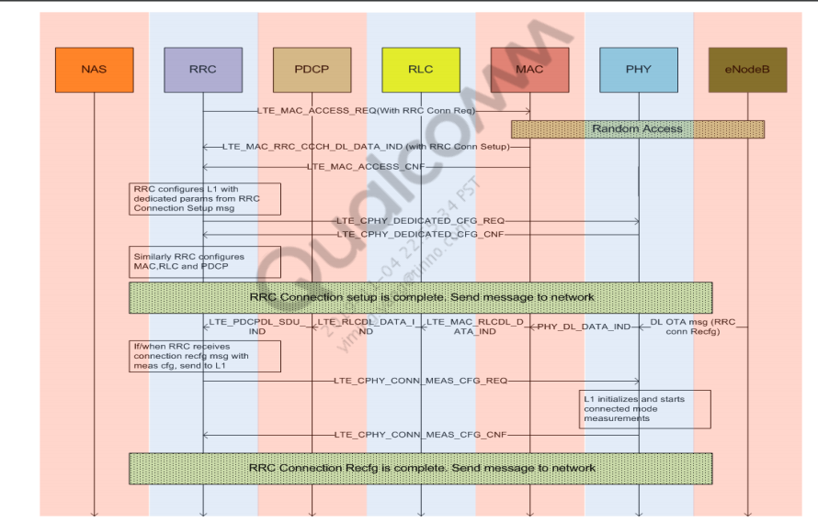

Handover

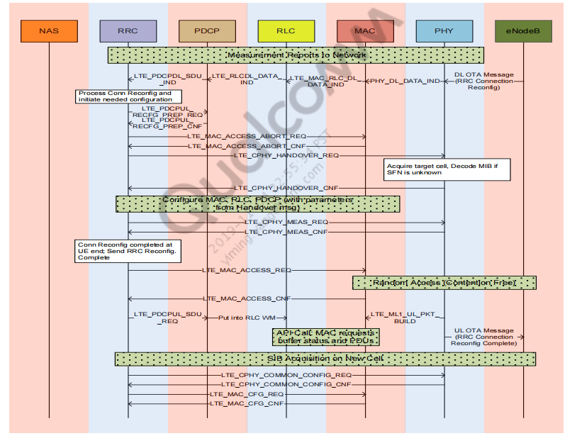

//Reconfiguration message with Handover request

61803 121:00:11:02.641

EVENT_LTE_RRC_DL_MSG

DL Channel Type = DL DCCH, Message Type = RRC Connection

Reconfiguration

61805 113:00:11:02.643

EVENT_LTE_RRC_TIMER_STATUS

Timer Name = T304, Timer Value = 2000, Timer State = Start

//Handover Cswitch initialised

61811 81:00:11:02.647

modem/lte/ML1/dlm/src/lte_ml1_dlm_schd.c

1104

H Handover CSWITCH PROC Init...

61812 105:00:11:02.647

modem/lte/ML1/manager/src/lte_ml1_mgr_stm.c 10228

H CSWITCH Block cause 3 →

Reason: Handover

//Lower layers are configured

61823 129:00:11:02.650

modem/lte/ML1/schdlr/src/lte_ml1_schdlr_main.c

455

H Received

LTE_LL1_SYS_CONFIG_SERVING_CELL_

CNF

61824 121:00:11:02.650

modem/lte/ML1/schdlr/src/lte_ml1_schdlr_main.c

468

H Received LTE_LL1_SYS_SLAM_TIMING_CNF

//Handover from Serving Cell 397 to Cell 116

61826 129:00:11:02.651

modem/lte/ML1/schdlr/src/lte_ml1_schdlr_stm.c

1436

H Switch from Cell116 to Cell116 with SrvCell397

//Received timing on the new cell

61831 129:00:11:02.651

modem/lte/ML1/schdlr/src/lte_ml1_schdlr_procs.c

782

H Rxed the 1st tick on the nbrcell with sf=4999

//Cell switch confirmation

61832 105:00:11:02.651

modem/lte/ML1/manager/src/lte_ml1_mgr_task.c

890

H ML1: cell switch ind

61833 121:00:11:02.651

modem/lte/ML1/dlm/src/lte_ml1_dlm_stm.c

4261

H DLM<-SCDLR: CSWITCH STATE: Cell switch

cnf Recd

//Send Common/Dedicated configuration of the new cell, received in RRC Reconfig message

61852 93:00:11:02.652

modem/lte/ML1/ulm/src/lte_ml1_ulm_l1m.c

1439 H

ULM<-L1M : Received Handover

CFG Req

61857 113:00:11:02.653

modem/lte/ML1/manager/src/lte_ml1_mgr_stm.c 10257 H

CSWITCH Unblock cause 3

//Configuring lower layers with the new cell information

61860 129:00:11:02.653

modem/lte/ML1/schdlr/src/lte_ml1_schdlr_main.c 455 H

Received

LTE_LL1_SYS_CONFIG_

SERVING_CELL_CNF

61866 121:00:11:02.654

modem/lte/ML1/dlm/src/lte_ml1_dlm_cfg.c

1639 H

DLM<-DL FW:

Config Serving Cell Cnf Recd

61870 129:00:11:02.654

modem/lte/ML1/ulm/src/lte_ml1_ulm_cfg.c

2199 H

ULM <- LL:

LTE_LL1_UL_PHYCHAN_

CONFIG_CNF RECEIVED

//Target cell SFN not known. Need to decode PBCH (MIB)

61873 137:00:11:02.654

modem/lte/ML1/dlm/src/lte_ml1_dlm_rach.c 520 H

DLM RACH: RACH MIGHT

PROCEED WITH LL SFN

UNKNOWN

//SIB decoding and paging currently suspended since target cell SFN is not known

61874 121:00:11:02.654

modem/lte/ML1/dlm/src/lte_ml1_dlm_sib.c

2169 H

DLM SIB: SIB

SUSPENDED AS LL SFN

UNKNOWN

61875 121:00:11:02.654

modem/lte/ML1/dlm/src/lte_ml1_dlm_stm.c

3253 E

DLM STM: PAGING SUSPENDED

LL SFN UNKNOWN

//PBCH decoding request on the new cell

61878 169:00:11:02.654

modem/lte/ML1/search/src/lte_ml1_sm_sd_if.c 613 H

SM: pBCH_DEC_REQ:

(21250,116) cp 0 freq_off 0 init 0

max_frm 20 #ant 0 ref_time

02E767

61879 129:00:11:02.654

modem/lte/ML1/search/src/lte_ml1_sm_sd_if.c 624 H

SM: Sent Normal PBCH Decode

Req; id: 0x04070204

61886 161:00:11:02.654

modem/lte/ML1/l1_common/src/lte_ml1_common_uemob.c 710 H

Serv cell change: old (2100,397)

new (2100,116) time 7358

UE mob 1

//Handover confirmation sent to RRC

61888 90:00:11:02.654

modem/lte/ML1/manager/src/lte_ml1_mgr_stm.c 4095 H LTE_CPHY_HANDOVER_CNF

Status: 0

61891 74:00:11:02.654

modem/lte/RRC/src/lte_rrc_llc.c

1361 H LTE_CPHY_HANDOVER_CNF

received with success

//RRC sends RACH config of new cell to L1

61894 113:00:11:02.655

modem/lte/ML1/manager/src/lte_ml1_mgr_stm.c 4801 H ML1: LTE_CPHY_RACH_CFG_REQ

rcvd

61896 113:00:11:02.655

modem/lte/ML1/ulm/src/lte_ml1_ulm_l1m.c

396 H ULM<-L1M : Received

PRACH Cfg Req

61898 129:00:11:02.655

modem/lte/ML1/manager/src/lte_ml1_mgr_stm.c 4319 H ML1: LTE_CPHY_RACH_CFG_CNF

sent, status 0

//RRC reconfig complete to be sent on new cell

61904 129:00:11:02.657

EVENT_LTE_RRC_UL_MSG

UL Channel Type = UL DCCH, Message Type = RRC

Connection Reconfiguration Complete

//Contention free access on the new cell.

61905 105:00:11:02.657

EVENT_LTE_RACH_ACCESS_START

RACH Cause = 4, RACH Contention = Contention Free

//Adjust the timing on new cell

61924 121:00:11:02.674

modem/lte/ML1/schdlr/src/lte_ml1_schdlr_main.c 468

H Received

LTE_LL1_SYS_SLAM_TIMING_CNF

//Trigger SFN update procedure, since SFN is not yet known

61926 113:00:11:02.676

modem/lte/ML1/manager/src/lte_ml1_mgr_stm.c 1180 H L1M: HO SFN UPDATE TRIGGER...

//MIB decoded, PBCH decode confirmation from lower layers

61929 145:00:11:02.676

modem/lte/ML1/manager/src/lte_ml1_mgr_modules.c 762

H SM->L1M HO PBCH decode cnf rcvd:

stm error flag status: 0

61933 137:00:11:02.675

modem/lte/ML1/schdlr/src/lte_ml1_schdlr_procs.c 748

H Rxed the 1st tick on the serving cell

with sf=5026

//MIB on the new cell

61943 169:00:11:02.677

modem/lte/ML1/search/src/lte_ml1_sm_sd_if.c 613 H SM: pBCH_DEC_REQ: (21250,116) cp

0 freq_off 0 init 0 max_frm 20 #ant 1

ref_time 02E767

//SFN update completed

61947 113:00:11:02.677

modem/lte/ML1/manager/src/lte_ml1_mgr_stm.c 8286 H L1M: DLM HO SFN UPDATE DONE

61958 129:00:11:02.677

modem/lte/ML1/manager/src/lte_ml1_mgr_stm.c 8379 H L1M: ****HO SFN UPDATE

PROCEDURE DONE****

//Resume SIB procedure on the new cell

61978 113:00:11:02.694

EVENT_LTE_RRC_DL_MSG

DL Channel Type = DL BCCH, Message Type =

Master Information Block

61989 121:00:11:02.698

EVENT_LTE_RRC_DL_MSG

DL Channel Type = DL BCCH, Message Type =

System Information Block Type 1

61991 177:00:11:02.698

modem/lte/RRC/src/lte_rrc_sib.c

555 H Sent cphy_sib_sched_req for

phy_cell_id = 116 freq = 2100;

curr_mask = 0x4 next_mask = 0x7

mod_bnd = 512

61997 113:00:11:02.699

modem/lte/ML1/manager/src/lte_ml1_mgr_stm.c 6998 H L1M:LTE_CPHY_SIB_SCHED_REQ

62190 57:00:11:02.787

EVENT_LTE_RRC_NEW_CELL_IND

Cause = handover, Frequency = 2100, Cell ID = 116

Scenario: UE switched to the new cell but fails to get response for the Random access request, for the initial few attempts

//Reconfiguration message with Handover request

EVENT_LTE_RRC_DL_MSG

DL Channel Type = DL DCCH, Message Type = RRC Connection Reconfiguration

28283 81:00:03:24.124

modem/lte/ML1/dlm/src/lte_ml1_dlm_schd.c

1104

H Handover CSWITCH PROC Init...

28284 117:00:03:24.124

modem/lte/ML1/manager/src/lte_ml1_mgr_stm.c 10228

H CSWITCH Block cause 3 -->

HANDOVER

//Lower layer configurations

28299 129:00:03:24.127

modem/lte/ML1/schdlr/src/lte_ml1_schdlr_main.c 455

H Received

LTE_LL1_SYS_CONFIG_SERVING_CELL_CNF

28300 121:00:03:24.127

modem/lte/ML1/schdlr/src/lte_ml1_schdlr_main.c 468

H Received

LTE_LL1_SYS_SLAM_TIMING_CNF

//Switch from Serving Cell 397 to Cell 116

28305 129:00:03:24.129

modem/lte/ML1/schdlr/src/lte_ml1_schdlr_stm.c 1436

H Switch from Cell116 to Cell116 with

SrvCell397

//Received 1st tick on the target cell

28309 129:00:03:24.129

modem/lte/ML1/schdlr/src/lte_ml1_schdlr_procs.c 782

H Rxed the 1st tick on the nbrcell with

sf=9235

28329 169:00:03:24.130

modem/lte/ML1/dlm/src/lte_ml1_dlm_rach.c 1844

H channel config updating C-RNTI

Current: C-RNTI vaild = 0 val = 14New:

C-RNTI val = 2016

//Channel configurations on target cell

28330 113:00:03:24.130

modem/lte/ML1/dlm/src/lte_ml1_dlm_cfg.c

1346

H DLM->DL FW: DL CH Config schdl

Req Sent

28332 113:00:03:24.130

modem/lte/ML1/dlm/src/lte_ml1_dlm_cfg.c

1545

H DLM->SCDLR: Serving cell cfg req

sent

28334 93:00:03:24.130

modem/lte/ML1/ulm/src/lte_ml1_ulm_l1m.c

1439

H ULM<-L1M : Received Handover CFG

Req

28336 121:00:03:24.130

modem/lte/ML1/ulm/src/lte_ml1_ulm_cfg.c

1723

H ULM -> LL: LTE_LL1_UL_PHYCHAN_

CONFIG_REQ SENT

28339 129:00:03:24.131

modem/lte/ML1/schdlr/src/lte_ml1_schdlr_main.c 455

H Received LTE_LL1_SYS_CONFIG_

SERVING_CELL_CNF

28343 129:00:03:24.131

modem/lte/ML1/ulm/src/lte_ml1_ulm_cfg.c

2199

H ULM <- LL: LTE_LL1_UL_PHYCHAN_

CONFIG_CNF RECEIVED

28349 105:00:03:24.133

modem/lte/ML1/manager/src/lte_ml1_mgr_task.c 890

H ML1: cell switch ind

// Target SFN not known.. need to decode PBCH for SFN

28354 137:00:03:24.133

modem/lte/ML1/dlm/src/lte_ml1_dlm_rach.c 520

H DLM RACH: RACH MIGHT PROCEED

WITH LL SFN UNKNOWN

28355 121:00:03:24.133

modem/lte/ML1/dlm/src/lte_ml1_dlm_sib.c

2169

H DLM SIB: SIB SUSPENDED AS LL SFN

UNKNOWN

28356 121:00:03:24.133

modem/lte/ML1/dlm/src/lte_ml1_dlm_stm.c

3253

E DLM STM: PAGING SUSPENDED LL

SFN UNKNOWN

28357 93:00:03:24.133

modem/lte/ML1/ulm/src/lte_ml1_ulm_l1m.c

1372

H ULM<-L1M : Received Handover Resume

Req

28357 113:00:03:24.133

modem/lte/ML1/ulm/src/lte_ml1_ulm_l1m.c

1372

H ULM<-L1M : Received Handover Resume

Req

28358 99:00:03:24.133

modem/lte/ML1/gm/src/lte_ml1_gm_stm.c

2151

H GM: Processing

LTE_ML1_GM_HANDOVER_

RESUME_REQ

//PBCH decode request

28359 169:00:03:24.133

modem/lte/ML1/search/src/lte_ml1_sm_sd_if.c 613

H SM: pBCH_DEC_REQ: (21250,116) cp 0

freq_off 0 init 0 max_frm 20 #ant 0

ref_time 033427

28360 129:00:03:24.133

modem/lte/ML1/search/src/lte_ml1_sm_sd_if.c 624

H SM: Sent Normal PBCH Decode Req; id:

0x04070204

28368 90:00:03:24.133

modem/lte/ML1/manager/src/lte_ml1_mgr_stm.c 4095

H LTE_CPHY_HANDOVER_CNF Status: 0

28371 74:00:03:24.133

modem/lte/RRC/src/lte_rrc_llc.c

1361

H LTE_CPHY_HANDOVER_CNF

received with success

//CF Random access to send RRC reconfiguration complete on target cell

28373 65:00:03:24.134

EVENT_LTE_RACH_ACCESS_START

RACH Cause = 4, RACH Contention = Contention Free

28375 129:00:03:24.136

EVENT_LTE_RRC_UL_MSG

UL Channel Type = UL DCCH, Message Type = RRC

Connection Reconfiguration Complete

//RACH failed. No Msg2 from network

28377 161:00:03:24.148

modem/lte/ML1/dlm/src/lte_ml1_dlm_schd.c

155

H DLM->LL: PDCCH RNTI CHANGE

REQ RNTI MASK: 1 C-RNTI

VAL: 2016 clear harq buf: 0

28396 121:00:03:24.154

modem/lte/ML1/ulm/src/lte_ml1_ulm_dlm.c

129

H ULM <- DLM : RA TIMER EXPIRY IND

RECEIVED

28398 105:00:03:24.154

modem/lte/ML1/ulm/src/lte_ml1_ulm_stm.c

603

H ULM: PRACH MSG1 STATE EXIT

28399 78:00:03:24.154

modem/lte/ML1/ulm/src/lte_ml1_ulm_stm.c

1797

H ULM: RAR TIMER EXPIRED STATE

ENTER

28405 97:00:03:24.154

modem/lte/ML1/gm/src/lte_ml1_gm_stm.c

925

H GM: Leaving PRACH State

28406 105:00:03:24.154

modem/lte/ML1/gm/src/lte_ml1_gm_stm.c

2326

H GM: Entering OUT_SYNC State

//2nd attempt on MAC Seq#1

28413 73:00:03:24.154

modem/lte/L2/mac/src/lte_mac_rach.c

564

X rach_send_preamble

cur_raid=62,pwr_lvl=-100,attempt

#=2,seq #=1

28415 121:00:03:24.154

modem/lte/ML1/manager/src/lte_ml1_mgr_stm.c 4890

H ML1:

LTE_CPHY_START_RACH_REQ rcvd

28417 78:00:03:24.154

modem/lte/ML1/ulm/src/lte_ml1_ulm_stm.c

1842

H ULM: RAR TIMER EXPIRED STATE

EXIT

28418 105:00:03:24.154

modem/lte/ML1/ulm/src/lte_ml1_ulm_stm.c

552

H ULM: PRACH MSG1 STATE ENTER

28422 110:00:03:24.154

modem/lte/ML1/ulm/src/lte_ml1_prach.c

881

H ULM : Prach Rsp SFN : 926, sub-fn : 8

28424 113:00:03:24.154

modem/lte/ML1/dlm/src/lte_ml1_dlm_rach.c

615

H DLM RACH STM: MSG2 STATE

ENTRY

28436 129:00:03:24.154

modem/lte/ML1/manager/src/lte_ml1_mgr_stm.c 4362

H ML1: LTE_CPHY_START_RACH_CNF

sent, status 1

…

//Max attempts reached. MAC sends Random access problem ind to RRC

28914 129:00:03:24.331

modem/lte/L2/mac/src/lte_mac_rach.c

1573

X Send

RANDOM_ACCESS_PROBLEM_IND

to RRC, attempt_number=10

28956 78:00:03:24.350

modem/lte/ML1/ulm/src/lte_ml1_ulm_stm.c

1797

H ULM: RAR TIMER EXPIRED STATE

ENTER

//MAC re-initiates random access on Seq#2

28970 73:00:03:24.351

modem/lte/L2/mac/src/lte_mac_rach.c

564

X rach_send_preamble

cur_raid=62,pwr_lvl=-100,attempt

#=2,seq #=2

28970 137:00:03:24.351

modem/lte/L2/mac/src/lte_mac_rach.c

564

X rach_send_preamble

cur_raid=62,pwr_lvl=-100,attempt

#=2,seq #=2

28974 78:00:03:24.351

modem/lte/ML1/ulm/src/lte_ml1_ulm_stm.c

1842

H ULM: RAR TIMER EXPIRED STATE

EXIT

29003 73:00:03:24.353

modem/lte/L2/mac/src/lte_mac_rach.c

709

X rach_send_preamble_state_

handler mce=0,crnti=0

//Failed again

29047 78:00:03:24.371

modem/lte/ML1/ulm/src/lte_ml1_ulm_stm.c

1797

H ULM: RAR TIMER EXPIRED STATE

ENTER

//Repeat RACH attempts

31640 73:00:03:25.160

modem/lte/L2/mac/src/lte_mac_rach.c

564

X rach_send_preamble

cur_raid=62,pwr_lvl=-96,

attempt #=3,seq #=6

31644 78:00:03:25.160

modem/lte/ML1/ulm/src/lte_ml1_ulm_stm.c

1842

H ULM: RAR TIMER EXPIRED STATE

EXIT

31676 73:00:03:25.160

modem/lte/L2/mac/src/lte_mac_rach.c

709

X rach_send_preamble_state_handler

mce=0,crnti=0

/Finally success on RACH procedure

31741 73:00:03:25.190

modem/lte/RRC/src/lte_rrc_config.c

1938

H Successful RACH in the target cell

//Handover completed ind sent to RRC

31766 70:00:03:25.191

modem/lte/RRC/src/lte_rrc_csp.c

9080

X CSP: Handover Completed indication

received

31767 70:00:03:25.191

modem/lte/RRC/src/lte_rrc_csp.c

9093

X CSP: Handover to physical cell ID 116

on earfcn 2100

31775 73:00:03:25.190

modem/lte/RRC/src/lte_rrc_llc.c

1145

H LTE_RRC_HANDOVER_

COMPLETED_IND received

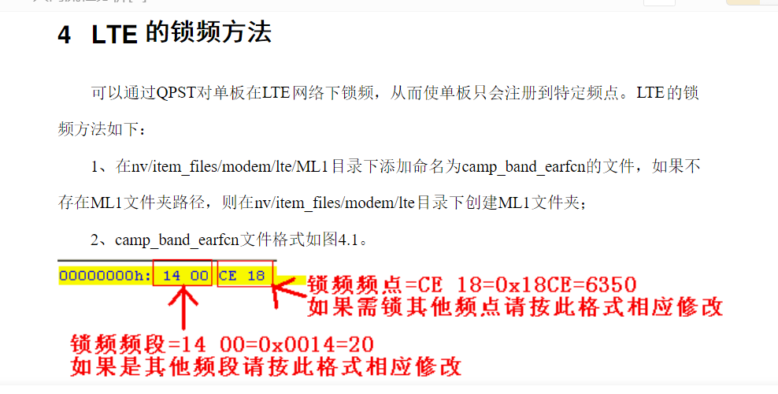

IMS注册

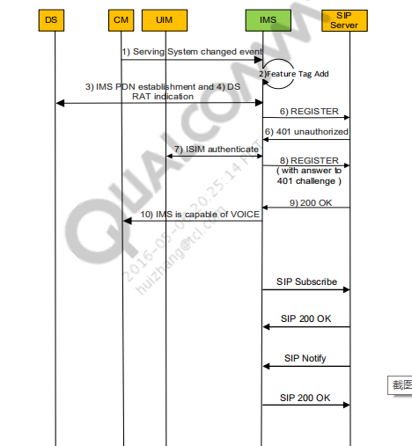

Search/Filter → MSG 0x156E

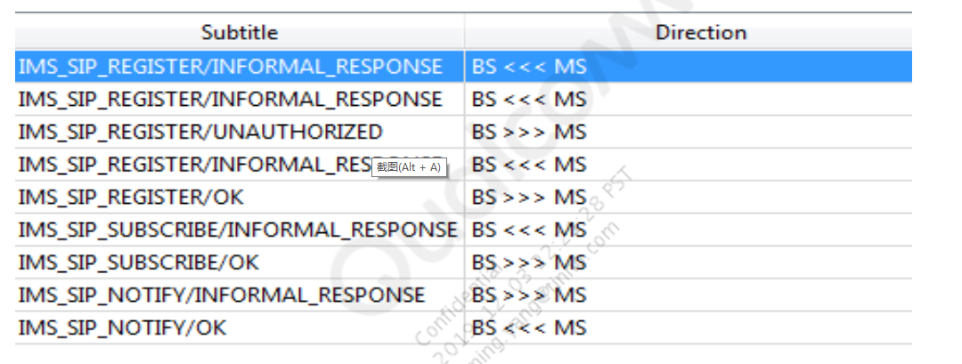

IMS Registration Call Flows

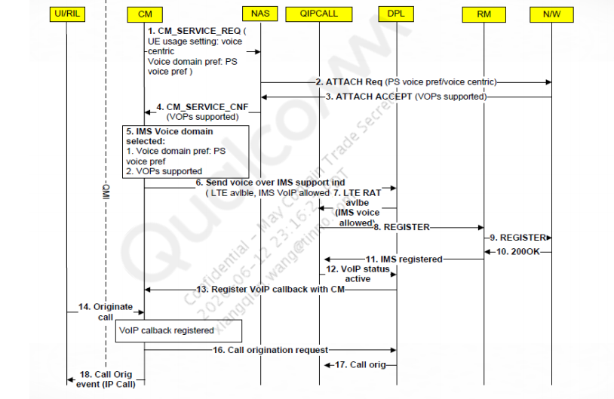

## IMS registration call flow process

1. Attach Accept indication received by NAS with indication of Voice over Packet Switch

(VoPS) or no VoPS support.

a. Attach request

OTA LOG [0xB0ED] LTE NAS EMM Plain OTA Outgoing Message Attach

request Msg

msg_type = 208 (0xd0) (PDN connectivity request)

sm_container[1]

container_id = 1 (0x1) (P-CSCF IPv6 Address Request)

UE_usage_setting = 0 (0x0) (Voice centric)

voice_domain_pref_for_EUTRAN = 3 (0x3) (IMS PS Voice preferred,

CS Voice as secondary)

b. Attach accept for the default APN.

OTA LOG [0xB0EC] LTE NAS EMM Plain OTA Incoming Message Attach accept

Msg

attach_result = 2 (0x2) (comb EPS/IMSI attach)

msg_type = 193 (0xc1) (Activate default EPS bearer context request)

pdn_type = 2 (0x2) (IPv6)

ipv6_interface_id = 0x8f23272c001c8b0

(8f2:3272:c001:c8b0)

sm_container[1]

container_id = 1 (0x1) (P-CSCF IPV6 Address)

address = 0x2002c0239c17c03db6b52ffffebfb3d6

(2002:c023:9c17:c03d:b6b5:2fff:febf:b3d6)

IMSVoPS = 1 (0x1) (IMS Vo PS Session in S1 Mode supported

2. CM and DS inform IMS DPL regarding service availability. (Here IMS module is triggered)

[0051/0002] MSG IMS/High [qpDcm.c 7804] qpDcmGetServingSystem: DS Sys

Info Avail Sys:3, GLOBAL RAT Mask 1104, Num of Avail apns 5 , pOOSPtr-

>eLastOOSReason 1 , pRatParam->InstID 1

[0051/0002] MSG IMS/High [qpDcm.c 8282] qpDplProcessDSSysEvent:

Iterating DS Sys Info, pDSSysEvStruct->avail_sys[0].tech = 0, rat_value

= 3, so_mask = 1000

[0051/0002] MSG IMS/High [qpDcm.c 8282] qpDplProcessDSSysEvent:

Iterating DS Sys Info, pDSSysEvStruct->avail_sys[2].tech = 0, rat_value

= 5, so_mask = 400

// DS rat_value = 3(LTE), 1(WCDMA), 5(IWLAN)

Filter: ds sys info

3. Device portability layer (DPL) informs all IMS registered clients about the availability of

Radio access technology (RAT) (Register Manager (RM), Policy manager(PM), QIPcall, and

so on) and RM decides if RAT is valid for IMS registration.

MSG IMS/High [PDPManager.cpp 1395] EventChangeRat -Current RAT 0 New Rat

10 ProceedIfRatsSame 1,ServiceOnRatMask = 0x0000644e, new RAT mask =

0x00000400

MSG IMS/High [PDPManager.cpp 1421] EventChangeRat - New RAT is 10 and is

valid: 1

// new rat = 10 (LTE), 3 (WCDMA), 9 (eHRPD), 6 (IWLAN)

RAT is valid: 1

// New RAT is Valid:1 indicated Rat is valid for IMS. If this is 0 no

IMS Registration is performed

//new RAT mask is a combination of all RATs available in RAT mask

format-

0x400- LTE,

0x50- WLAN +IWLAN,

0x450- LTE+WLAN+IWLAN

// RAT mask in NV 73835 (AllowedRATMask)

Filter: new rat

4.PM/RM informs DPL about the APN to be used.

MSG IMS/Medium [qpIMSPolicyManager.cpp 1932] GetRATAPNAttributes RAT =

10 APNType = 1 RegActionMask 0

MSG IMS/Medium [qpIMSPolicyManager.cpp 1055] GetIMSAPNPriority

n_pInputParam = 10 eAPNType[0] = 1 eAPNType[1] = 0 eAPNType[2] = 0

MSG IMS/Medium [qpIMSPolicyManager.cpp 3310] GetSupportedRcsSrvMask:

PM+Network services[7]

MSG IMS/High [ RegisterManager.cpp 5112] EventChangeRat: NewRat = 10,

RegType[0]

MSG IMS/High [qpIMSPolicyManager.cpp 1270] GetIMSAPNParams IP FB = 1

iFBStatus 1 iAPNIndex = 0

MSG IMS FW/High [ qpIMSPolicyManager 1281] GetIMSAPNParams APN Name =

ims

5. IMS clients request to create DCM profile with DPL (3GPP/ 3GPP2)

[0051/0002] MSG IMS/High [qpDcm.c 3437] qpDcmCreateProfile - New

profile[b7d74c10] -> RAT:10 -> APN:5 shareable:1

[6052/0002] MSG IMS DPL/High [qpDcm.c 4037] SearchDSProfiles:

pApnName=tmus

[0051/0002] MSG IMS/High [qpDcm.c 4199] SearchDSProfiles: Got a

matching profile 4 with PCSCF bit NOT SET

[0051/0002] MSG IMS/High [PDPHandler.cpp 231]

CPDPHandler::CreateProfile - Profile created

[0051/0002] MSG IMS/High [PDPRATHandlerVoLTE.cpp 876] InitPDP - DCM

create Profile Succeeded

6. RM decides if registration is needed using PM, if present.

[0051/0001] MSG IMS/Medium [RegisterManager.cpp 5612]

CheckRegistrationNeeded: RegType[0]

[0051/0001] MSG IMS/Medium [RegisterManager.cpp 5558] CheckValidSim:

RegType[0]

[0051/0001] MSG IMS/Medium [RegistrationHandlerVoLTE.cpp 1872]

IsRegParametersReady Called: RegType[0]

[0051/0001] MSG IMS/Medium [RegisterManager.cpp 5784]

CheckRegistrationNeeded - Active:1, Valid Rat:1

[0051/0002] MSG IMS/High [PDPManager.cpp 2702] RatMask changed in

GetUpdatedRatMaskBasedOnAPNPreference to [1024]

[0051/0002] MSG IMS/High [PDPManager.cpp 2747] Initial GetPreferredRAT

preferredRAT[10], n_eRATMaskNew[1024] OperatorMode[9] WFC[1]

Callmodepref[1]

7. If PDP is not already active, RM asks DPL for establishing PDP connection.

[0051/0002] MSG IMS/High [PDPRATHandlerVoLTE.cpp 2530] PdpActivate

enter, pdp state:0 RegType[0]

[6055/0002] MSG IMS REGMGR/High [PDPRATHandlerVoLTE 2236]

UpdateHOSysPrefInfo Comparing APN Name ims against ims

[6053/0002] MSG IMS FW/High [qpIMSPolicyManager 1281] GetIMSAPNParams

APN Name = ims

[0051/0002] MSG IMS/High [qpDcm.c 7526] qpDcmEstablishPDPConnection -

3GPP ProfileNumber --> 2 | 3GPP2 ProfileNumber --> -1 | IPType --> 2

[6052/0002] MSG IMS DPL/High [qpDcm.c 7524] qpDcmEstablishPDPConnection

- APNName --> ims, Resolved APN -->

[0051/0002] MSG IMS/High [qpDcm.c 7501] qpDcmEstablishPDPConnection |

pDcmProfile=b7d39cf0 dsAppID=369

[0051/0002] MSG IMS/High [qpDcm.c 7533]

DPL_M#$$#0#qpDcmEstablishPDPConnection - DS_EWOULDBLOCK on dsnet_start

a. If IMS APN is the additional PDN, it is requested from NAS.

[0xB0E3] LTE NAS ESM Plain OTA Outgoing Message -- PDN connectivity

request Msg

pdn_type = 3 (0x3) (Ipv4v6)

access_pt_name_

[0xB0E2] LTE NAS ESM Plain OTA Incoming Message -- Activate

default EPS bearer context request Msg

pdn_type = 3 (0x3) (IPv4v6)

b. PDP activation on applications is requested.

[6052/0002] MSG [[IMS_DataD] imsdatad.c 1653] | 1063

|QCSI#>>#DATAD#6# QMI_IMS_DCM_PDP_ACTIVATE_REQ_V01--->

[6052/0003] MSG [[IMS_DataD] imsdatad.c 1665] | 1063

|ims_qmi_dcm_pdp_activate_handler | Valid IP Address Family Type.

[0051/0002] MSG [qpdpl_qmi_handler.c 1869] qpDplProcessQcciEvent |

QMI_IMS_DCM_PDP_ACTIVATE_IND_V01 | ims_qmi_dcm_client_ind_cb | inst

1

[0051/0002] MSG [qpDcm.c 10583]

[6052/0002] MSG IMS DPL/High [qpDcm.c 10527]

qpDcmProcessQCCIPdpActIndEvent - HYBRID IP

Address=2002:c023:9c17:ba3c:a34c:6ae0:a9ea:3ce0

// APPS DPL informs Modem DPL of PDP activation and IP address to use

DPL_M#>>#IMS_APP#1#qpDcmProcessQCCIPdpActIndEvent-DS_ENETISCONN

HYBRID event for AppId (368)

[0051/0002] MSG [PDPRATHandlerVoLTE.cpp 1339] EventPdpActivated

raise QPE_RM_PDP_ACTIVATED_EV RegType[0]

[0051/0002] MSG [PDPRATHandler.cpp 378] PDPStateUpdate new state (2):

RegType[0] bRetVal[0]

[0051/0002] MSG [RegisterManager.cpp 2595] EventPdpActivated:

RegType[0]

[0051/0002] MSG [RegisterManager.cpp 2652] EventPdpActivated: call

EventPdpSuccess for RegType[0]

// RM informed of successful PDP activation

8. RM decides the PCSCF address to be used for registration.

[0051/0002] MSG IMS/High [PCSCFListHandler.cpp 258] Init

[0051/0002] MSG IMS/High [PCSCFListHandler.cpp 278] Init - P-CSCF

remote port:5060: RegType[0]

[0051/0002] MSG IMS/High [PCSCFListHandler.cpp 495]

DiscoverPcscfAddress: m_ePDRegisteringState = 0: RegType[0],

m_bPcoOptionFlag = 0, m_bPreConfiguredFlag = 1

[0051/0002] MSG IMS/High [PCSCFListHandler.cpp 1451] ReadPriorityPCSCF

[0051/0002] MSG IMS/High [PCSCFListHandler.cpp 1479] ReadPriorityPCSCF

eACS

[0051/0002] MSG IMS/High [PCSCFListHandler.cpp 1576] ReadPriorityPCSCF

ePCO

[0051/0002] MSG IMS/High [PCSCFListHandler.cpp 980]

SetPcoIePcscfAddressinList: RegType[0]

[6055/0002] MSG IMS REGMGR/High [PCSCFListHandler.c 657]

SetDplPcscfAddress - Using IP address:

2002:c023:9c17:c03d:b6b5:2fff:febf:b3d6

[0051/0002] MSG IMS/High [PCSCFListHandler.cpp 658] SetDplPcscfAddress

- Using IP port: 5060: RegType[0]

9. QIPcall takes information from CM and RM to decide on feature tags to be added.

[0051/0002] MSG IMS/High [ISMPMQueryManager.cpp 316] ISMPmQueryManager::queryPM(): PM services: 15 for rat 10 and apn 1 [0051/0002] MSG IMS/High [ ISMVoiceService.cpp 140] allowedByPm : retvalue[1] [0051/0002] MSG IMS/High [ ISMService.cpp 334] allowedByPdnState : retvalue[1] PDP status[1] [0051/0002] MSG IMS/High [ ISMVoiceService.cpp 289] allowedByDomain: retvalue[1] [0051/0001] MSG IMS/Medium [ ISMSMSService.cpp 841] IsSMSOnlyWithoutVoice 0 [0051/0002] MSG IMS/High [ ISMSMSService.cpp 578] allowedByConfig : retvalue[1] [0051/0002] MSG IMS/High [ ISMService.cpp 334] allowedByPdnState : retvalue[1] PDP status[1] [0051/0002] MSG IMS/High [ ISMSMSService.cpp 535] allowedByDomain : retvalue[1] [0051/0002] MSG IMS/High [ ISMSMSService.cpp 630] prev sms state[0] current sms state [1] reg status [1] [6067/0002] MSG IMS QIPCALL/High [ ISMRMAdapter.cpp 267] SendRequestToRegManager() : AddService for "+g.3gpp.smsip";"+g.3gpp.icsi-ref="urn:urn-7:3gpp-service.i [0051/0002] MSG IMS/High [qpRegistrationMonitor.cpp 1650] AddService Entered - Registration 1 [6055/0002] MSG IMS REGMGR/High [qpRegistrationMoni 1697] AddService Add Service0"+g.3gpp.smsip";"+g.3gpp.icsi-ref="urn:urn-7:3gppservice.ims.icsi.mmtel"";"aud //Adding Feature Tags [0051/0002] MSG IMS/High [ ISMFeatureTag.cpp 263] [SetState] [FT type 0 FT state is changed from 1 to 2] [0051/0002] MSG IMS/High [ ISMFeatureTag.cpp 263] [SetState] [FT type 1 FT state is changed from 1 to 2]

[0051/0002] MSG IMS/High [ ISMFeatureTag.cpp 263] [SetState] [FT type

2 FT state is changed from 1 to 2]

[0051/0002] MSG IMS/High [ ISMFeatureTag.cpp 263] [SetState] [FT type

3 FT state is changed from 1 to 2]

[0051/0002] MSG IMS/High [ ISMFeatureTag.cpp 263] [SetState] [FT type

9 FT state is changed from 1 to 2]

//FT state 1 = featured tags to be added ; FT state 2 = registration in

progress

//FT type 0 = SMS ; 1 = ICSI ; 2 = voice ; 3 = video ; 9 = USSD

1. RM gets the parameters needed for registration.

[0051/0001] MSG IMS/Medium [RegistrationHandlerVoLTE.cpp 1872]

IsRegParametersReady Called: RegType[0]

[0051/0001] MSG IMS/Medium [RegistrationHandlerVoLTE.cpp 2045]

CheckRegistrationNeeded - opermode9 RegType[0]

[0051/0002] MSG IMS/High [RegistrationHandlerVoLTE.cpp 2744]

SetImsPriorityConfig TMO mode. Retrieving RCS IMS config

// Operator mode NV 69673: 0 (VzW), 1(KDDI), 2(IR92), 3(LGU), 4(MPCS),

5(ATT), 6 (SKT), 7 (KT), 8(RIL), 9 (TMO), 10(DCM)

[0051/0001] MSG IMS/Medium [ RegisterManager.cpp 5784]

CheckRegistrationNeeded - Active:1, Valid Rat:1

[0051/0002] MSG IMS/High [RegistrationHandler.cpp 879]

CRegistrationHandler ReadPriorityIMPU

[6055/0002] MSG IMS REGMGR/High [ RegistrationHandle 4977]

GetPublicUserId - Found:sip:310220999123456@ims.vz.net

[6055/0002] MSG IMS REGMGR/High [ RegistrationHandle 4983]

GetPublicUserId - Valid msisdn based sip

uri:sip:310220999123456@ims.vz.net

[0051/0002] MSG IMS/High [RegistrationHandler.cpp 1033]

CRegistrationHandler ReadPriorityHomeDomain

[6052/0002] MSG IMS DPL/High [ qpIsim.c 13027] qpDplGetPrivateUID |

pIMPI - 310220999123456@ims.vz.net

[0051/0001] MSG IMS/Medium [RegistrationHandlerVoLTE.cpp 1850]

UpdateRegistrationStatusToSettings - regHandlerState[1]

m_eRegistrationRegType[0] sendRegStatus[1] iImsRegNtwk[10]

iImsRegStatus[1] iImsRegisterFailureErrorCode[0]

1. SIP signaling opens the UDP and TCP ports.

[0051/0001] MSG IMS/Medium [ qpSipDispatcher.cpp 4216]

QpSipDispatcher::CheckNOpenReqPort|UDP open on 5060 port success

[0051/0001] MSG IMS/Medium [ qpdplnet.c 1923] qpDplNetOpen: Net Open

called for Connection Profile PDPID=11, Profile=b7f91ba0

[0051/0001] MSG IMS/Medium [ qpSipDispatcher.cpp 4316]

QpSipDispatcher::CheckNOpenReqPort|TCP open on 5060 port success

[0051/0001] MSG IMS/Medium [ qpdplnet.c 1923] qpDplNetOpen: Net Open

called for Connection Profile PDPID=0, Profile=b7f97220]

1. Register packet is generated.

[0051/0002] MSG IMS/High [qpRegisterService.cpp 6333] RegisterService

state is 0

[0051/0001] MSG IMS/Medium [qpRegisterService.cpp 2009]

RegisterService::RegisterEx | Enter

[6062/0002] MSG IMS CORE/High [ qpRegisterService. 2044]

RegisterService::RegisterEx | ISIM generated PublicUserId =

sip:310220999123456@ims.vz.net

[0051/0001] MSG IMS/Medium [ singoConfig.cpp 1657]

SingoConfig::GetAssociatedUri | for Singo Config type 0

[6053/0002] MSG IMS FW/High [ singoConfig.cpp 3496]

SingoConfig::SetPublicUserId | sip:310220999123456@ims.vz.net

[6053/0002] MSG IMS FW/High [ singoConfig.cpp 3541]

SingoConfig::SetPrivateUserId | 310220999123456@ims.vz.net

[6053/0002] MSG IMS FW/High [ singoConfig.cpp 3594]

SingoConfig::SetDomainName | ims.vz.net

[0051/0002] MSG IMS/High [ qpdpl.c 9292]

IMS_APP#>>#DPL_M#0#qpDplGetAccessType|ENTER

eRatInfo=10,pServingStatus=d05c5fc3

[0051/0002] MSG IMS/High [ qpdpl.c 9470] qpDplGetAccessType |

returning ACCTYPE_3GPP_E_UTRAN_FDD

[0051/0002] MSG IMS/High [sipReqConnection.cpp 870]

SipReqConnection::qpSipIMSGeneratePAccessNetworkInfo |

eLocalAccessType=20 eRatInfo=10 iServingStatus=2

[6054/0002] MSG IMS SIP/High [ sipConnection.cpp 5154]

qpSipAddValHead: 3GPP-E-UTRAN-FDD; utran-cell-id-3gpp=3102200000cec9800

[0051/0001] MSG IMS/Medium [sipClientConnection.cpp 2041]

SipClientConnection::initRequest | PANI header success

//PANI Header Success

[6062/0002] MSG IMS IMS CORE/High [ qpSipRegisterServi 2371]

SipRegisterService::SetContactFeatureTags|adding FT +g.3gpp.icsi

ref="urn:urn-7:3gpp-service.ims.icsi.

[6054/0002] MSG IMS SIP/High [ sipConnection.cpp 5154]

qpSipAddValHead: <sip:708edc2d-4734-46ef-a569-

747ed3f67cbd@[2002:c023:9c17:ba3c:a34c:6ae0:a9ea:3ce0]:5

[0051/0002] MSG IMS/High [qpRegisterService.cpp 8610]

RegisterService::EncSecClientHdr | IPSecIntegAlgos = 3 IPSecEncryption

= 7

[0051/0002] MSG IMS/High [ qpRegisterService.cpp 2344]

RegisterService::RegisterExSend() | Removing PANI for Unprotected

REGISTER

[6054/0002] MSG IMS SIP/High [ sipConnection.cpp 5154]

qpSipAddValHead: ipsec-3gpp; alg=hmac-sha-1-96; ealg=des-ede3-cbc; spi

c=2507670118; spi-s=250117699; //For IP-Sec

13. Register packet is sent.

[0051/0002] MSG IMS/High [RegistrationHandlerVoLTE.cpp 1657] Register

- set pcscf server port 5060: RegType[0]

[6054/0002] MSG IMS SIP/High [sipClientConnectio 1957]

SipClientConnection::qpSipInitRequest() METHOD REGISTER

[0051/0001] MSG IMS/Medium [sipconnectionnotifier.cpp 3720]

SCN::GetPCSCFServerPort | m_iPCSCFServerPort: 5060

[6054/0002] MSG IMS SIP/High [sipConnection.cpp 3528]

SipConnection::qpSipSend() | Register Call_Id -

449922434_3086578700@2002:c023:9c17:ba3c:a34c:6ae0:a9e

[0051/0001] MSG IMS/Medium [qimfsiplib.cpp 4874]

QimfSipActiveObj::qpSipAddCallIdToList:: New Entry Call -Id Count 1

[6054/0002] MSG IMS SIP/High [qpSipUtils.cpp 481]

ParseViaHeaderToHeader:

sip:[2002:c023:9c17:ba3c:a34c:6ae0:a9ea:3ce0]:5060;rport;keep;branch=z9h

G4bK12

[0051/0002] MSG IMS/High [sipConnection.cpp 3242]

EVENT_SIP_REG_REQ_SENT: 43 Code = 0 RAT = 10

[6054/0002] MSG IMS SIP/High [qpSipUtils.cpp 3407]

EVENT_SIP_REQUEST_SEND: REGISTER sip:ims.vz.net SIP/2.0

14. Registration is challenged.

[6054/0002] MSG IMS SIP/High [ qpSipUtils.cpp 3407]

EVENT_SIP_RESPONSE_RECV: SIP/2.0 401 Unauthorized

[6054/0002] MSG IMS SIP/High [ sipConnection.cpp 4868]

qpSipAddValTail: Digest

realm="ims.vz.net",nonce="AAAAAAAAAAAAAAAgdClxlyCkfOq8Q4AAHBIiJNonKJ0=",

qop="a

[6054/0002] MSG IMS SIP/High [ sipConnection.cpp 4868]

qpSipAddValTail: ipsec-3gpp;q=0.2;prot=esp;mod=trans;alg=hmac-md5-

96;ealg=null;spi-c=193590036;spi-s=1

[0051/0002] MSG IMS/High [ sipConnection.cpp 3071]

EVENT_SIP_REG_RESP_RCVD : 44 Code = 401 RAT = 10

// Registration challenged with IPSec

[0051/0002] MSG IMS/High [qpSipRegisterService.cpp 2784]

RegisterService::FillRegisterSummaryInfo| Resultcode: 401

[0051/0001] MSG IMS/Medium [qpRegisterService.cpp 3396]

RegisterService::NotifyResponse | Auth Challenge for Reg/ReReg

[0051/0002] MSG IMS/High [qpRegisterService.cpp 6923]

RegisterService::qpFillSADBfromSecurityServer | IPSecIntegAlgos = 3

IPSecEncryption = 7

[0051/0001] MSG IMS/Medium [sipconnectionnotifier.cpp 3446]

SCN::UpdateSharedConfigPorts | UE server port: 44064, PCSCF server port:

5070, UE client port: 42698

[0051/0002] MSG IMS/High [qpRegisterService.cpp 7534]

RegisterService::qpProcessAddSACallBack | Posting Event

QIMF_IPSEC_SA_ESTABLISHED to Disp

[6054/0002] MSG IMS SIP/High [ sipClientConnectio 1957]

SipClientConnection::qpSipInitRequest() METHOD REGISTER

[6054/0002] MSG IMS SIP/High [ sipClientConnectio 1957]

SipClientConnection::qpSipInitRequest() METHOD REGISTER

[0051/0002] MSG IMS/High [ sipConnection.cpp 3242]

EVENT_SIP_REG_REQ_SENT: 43 Code = 0 RAT = 10

[6054/0002] MSG IMS SIP/High [ qpSipUtils.cpp 3407]

EVENT_SIP_REQUEST_SEND: REGISTER sip:ims.vz.net SIP/2.0

[6062/0002] MSG IMS IMS CORE/High [ qpSipRegisterServi 1387]

EVENT_SIP_REGISTRATION_START:REGISTER sip:ims.vz.net SIP/2.0 f:

<sip:310220999123456@ims.vz.net>;tag=

15. Registration is successful.

[6054/0002] MSG IMS SIP/High [qpSipUtils.cpp 3407]

EVENT_SIP_RESPONSE_RECV: SIP/2.0 200 OK

[0051/0002] MSG IMS/High [qpSipRegisterService.cpp 1809]

EVENT_SIP_REGISTER_END:Response Code: 200

// 200OK indicates Registration Success

16. Available services are updated to all clients.

[0051/0002] MSG IMS/High [RegistrationHandlerVoLTE.cpp 8788]

UpdateAvailableServiceToRegisteredClients: RegType[0]

[0051/0001] MSG IMS/Medium [RegistrationHandlerVoLTE.cpp 1850]

UpdateRegistrationStatusToSettings - regHandlerState[2]

m_eRegistrationRegType[0] sendRegStatus[1] iImsRegNtwk[10]

iImsRegStatus[2] iImsRegisterFailureErrorCode[0]

[6055/0002] MSG IMS REGMGR/High [RegMonitorHandler. 267]

UpdateRegisteredClients Service Available0##"+g.3gpp.icsi-ref="urn:urn-

7:3gpp-service.ims.icsi.mmtel""

[6067/0002] MSG IMS QIPCALL/High [ISMRegisterService 245]

ISMRegisterServiceMonitor::ServiceAvailable() : Set of Feature Tags

"+g.3gpp.icsi-ref="urn:urn-7:3gpp-

[0051/0002] MSG IMS/High [ISMFeatureTag.cpp 263] [SetState] [FT type

0 FT state is changed from 2 to 3]

[0051/0002] MSG IMS/High [ISMFeatureTag.cpp 263] [SetState] [FT type

1 FT state is changed from 2 to 3]

[0051/0002] MSG IMS/High [ISMFeatureTag.cpp 263] [SetState] [FT type

2 FT state is changed from 2 to 3]

[0051/0002] MSG IMS/High [ISMFeatureTag.cpp 263] [SetState] [FT type

3 FT state is changed from 2 to 3]

[0051/0002] MSG IMS/High [ISMFeatureTag.cpp 263] [SetState] [FT type

9 FT state is changed from 2 to 3]

//FT state 3 = FT of this type is registered

## IMS log packets

IMS log packets can be seen by filtering:

Log Packets > Common > IMS Message, IMS Registration

21:25:16.657 [0F] 0x156E IMS SIP Message --

IMS_SIP_REGISTER/INFORMAL_RESPONSE

Subscription ID = 1

Direction = UE_TO_NETWORK

Message ID = IMS_SIP_REGISTER

Sip Message = REGISTER sip:ims.vz.net SIP/2.0

CSeq: 358375636 REGISTER

Authorization: Digest

uri="sip:ims.vz.net",username="310008989511203@ims.vz.net",response="",real

m="ims.vz.net",nonce="",algorithm=AKAv1-MD5

v: SIP/2.0/TCP

[2002:c023:9c17:45d3:5ed3:ec8c:a7c6:434]:5060;branch=z9hG4bK2080430552;keep

Expires: 600000

m: <sip:342de30c-8532-4743-ae12-

85c810d804c7@[2002:c023:9c17:45d3:5ed3:ec8c:a7c6:434]:5060>;mobility="mobil

e";+g.3gpp.iari-ref="urn%3Aurn-7%3A3gpp

application.ims.iari.rcs.geopush";+g.3gpp.icsi-ref="urn%3Aurn-7%3A3gpp

service.ims.icsi.oma.cpm.filetransfer,urn%3Aurn-7%3A3gpp

service.ims.icsi.oma.cpm.largemsg,urn%3Aurn-7%3A3gpp

service.ims.icsi.oma.cpm.msg,urn%3Aurn-7%3A3gpp

service.ims.icsi.oma.cpm.session,urn%3Aurn-7%3A3gpp

service.ims.icsi.mmtel";+g.3gpp.nw-init

ussi;+g.3gpp.smsip;audio;video;+g.3gpp.accesstype="cellular2"

P-Access-Network-Info: 3GPP-E-UTRAN-FDD; utran-cell-id-

3gpp=310000001013f800

21:25:17.046 [44] 0x1832 IMS Registration

Subscription ID = 1

Registration Type = Initial

Call Id = 358375636_1307788268@2002:c023:9c17:45d3:5ed3:ec8c:a7c6:434

To = <sip:310008989511203@ims.vz.net>

Result = Unauthorized //result

21:25:17.788 [6F] 0x1832 IMS Registration

Subscription ID = 1

Registration Type = Initial

Call Id = 358375636_1307788268@2002:c023:9c17:45d3:5ed3:ec8c:a7c6:434

To = <sip:310008989511203@ims.vz.net>

Result = OK //result

### Successful registration

21:25:17.800 [36] 0x1544 QMI_MCS_QCSI_PKT

MsgType = Indication

Service_IMSA {

ServiceIMSAV1 {

imsa_registration_status {

imsa_registration_status_indTlvs[0] {

ims_registered {

ims_registered = true

imsa_registration_status_indTlvs[1] {

ims_reg_status {

ims_reg_status =

imsa_registration_status_indTlvs[2] {

registration_network {

registration_network = IMSA_WWAN

21:25:17.809 [7C] 0x1544 QMI_MCS_QCSI_PKT

MsgType = Indication

Service_IMSA {

ServiceIMSAV1 {

imsa_service_status {

imsa_service_status_indTlvs[0] {

sms_service_status {

sms_service_status = IMSA_FULL_SERVICE

imsa_service_status_indTlvs[1] {

voip_service_status {

voip_service_status = IMSA_FULL_SERVICE

imsa_service_status_indTlvs[2] {

vt_service_status {

vt_service_status = IMSA_FULL_SERVICE

imsa_service_status_indTlvs[3] {

sms_service_rat {

sms_service_rat = IMSA_WWAN

imsa_service_status_indTlvs[4] {

voip_service_rat {

voip_service_rat = IMSA_WWAN

imsa_service_status_indTlvs[5] {

vt_service_rat {

vt_service_rat = IMSA_WWAN

### Registration failure

21:25:10.021 [A7] 0x1544 QMI_MCS_QCSI_PKT

MsgType = Indication

Service_IMSA {

ServiceIMSAV1 {

imsa_registration_status {

imsa_registration_status_indTlvs[0] {

ims_registered {

ims_registered = false

imsa_registration_status_indTlvs[1] {

ims_registration_failure_error_code {

ims_registration_failure_error_code = 0

imsa_registration_status_indTlvs[2] {

ims_reg_status {

ims_reg_status = IMSA_STATUS_NOT_REGISTERED

imsa_registration_status_indTlvs[3] {

registration_network {

registration_network = IMSA_WWAN

21:25:10.137 [B9] 0x1544 QMI_MCS_QCSI_PKT

MsgType = Indication

Service_IMSA {

ServiceIMSAV1 {

imsa_service_status {

imsa_service_status_indTlvs[0] {

sms_service_status {

sms_service_status = IMSA_NO_SERVICE

imsa_service_status_indTlvs[1] {

voip_service_status {

voip_service_status = IMSA_NO_SERVICE

imsa_service_status_indTlvs[2] {

vt_service_status {

vt_service_status = IMSA_NO_SERVICE

imsa_service_status_indTlvs[3] {

sms_service_rat {

sms_service_rat = IMSA_WWAN

imsa_service_status_indTlvs[4] {

voip_service_rat {

voip_service_rat = IMSA_WWAN

imsa_service_status_indTlvs[5] {

vt_service_rat {

vt_service_rat = IMSA_WWAN

### VoLTE MO call flow

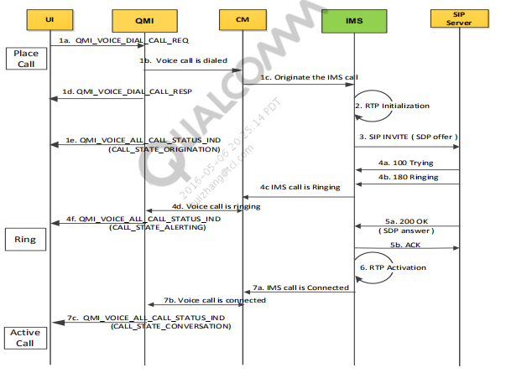

Search/Filter → MSG 0x156E

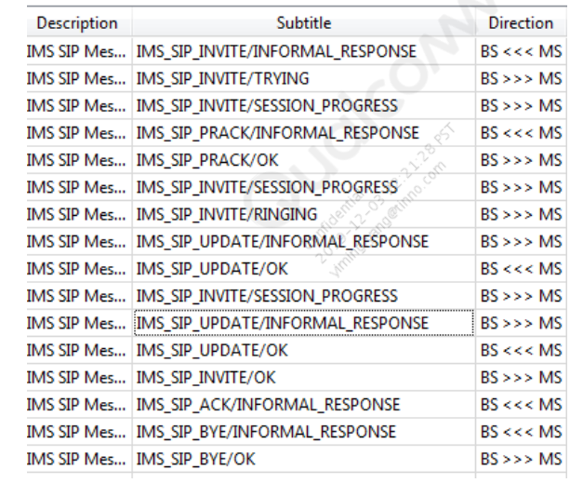

### 1. QMI receives a request to originate a VoLTE call.

2012 Dec 3 23:26:20.220 [00] 0x138E QMI Link 1 RX PDU

SduCtlFlags = REQ

MsgType = QMI_VOICE_DIAL_CALL_MSG

2012 Dec 3 23:26:20.315 [00] 0x138F QMI Link 1 TX PDU

SduCtlFlags = RSP

MsgType = QMI_VOICE_DIAL_CALL_MSG

ResultCode = QMI_RESULT_SUCCESS

ErrorCode = QMI_ERROR_NONE

2012 Dec 3 23:26:20.315 [00] 0x138F QMI Link 1 TX PDU

SduCtlFlags = IND

MsgType = QMI_VOICE_ALL_CALL_STATUS_IND

CallState = ORIGINATION

Direction = MO: Mobile Originated Call

### 2. RTP component is initialized within IMS.

MSG qipcallh.c 07002 Call id 3 moving to WAIT FOR RTP OPEN IMS/High 23:26:20.317

RTP initialization is successful

MSG qipcall.c 00725 qipcall_process_rtp_msg: QIPCALL_RTP_OPEN_DONE IMS/High 23:26:20.330

### 3. IMS creates an SDP offer based on the UE config and sends to IMS CN in a SIP INIVITE request.

MSG qipcallsdp.c 04718 Creating Offer | iface: 0 | call_id: 3 IMS/High 23:26:20.330

MSG qipcallsdp.c 04751 [is_offer: 1] IMS/High 23:26:20.330

If HD voice is enabled, then AMR-WB will be offered. Otherwise AMR-NB will be offered.

Note: configurable through NV 65964 ( 1=AMR-WB 0=AMR-NB )

MSG 00327 327|qipcall_get_nv_item qpDplIODeviceGetItem for /nv/item_files/ims/qipcall_enable_hd_voice IMS/Error 23:26:20.331

MSG qipcalliface.c 01169 qipcalliface_update_codec_based_on_hd_flag: HD enabled.. Enable WB-AMR IMS/High 23:26:20.331

**4.IMS creates an SDP offer based on the UE configuration and**

**sends to IMS CN in a SIP INIVITE request**

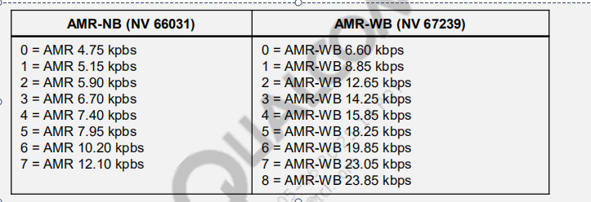

Note: mode set is configured by NV 66031 for AMR-NB and NV 67239 for AMR-WB. It is a bitmask ( 1 << n ) representation of the above values.

For example: 149 = 1001 0101 = 23.05 kbps, 15.85 kbps, 12.65 kbps, 6.60 kbps

Note: octet aligned / bandwidth efficient is configured by NV 67241 for AMR-NB and NV 67240 for AMR-WB

( 0 = bandwidth efficient 1 = octet aligned )

MSG IMS/High 23:26:20.332 qipcallsdp.c 03054 qipcallsdp_add_payld_fmt:WB-Amr mode is 149 Octet align 1

MSG IMS/High 23:26:20.333 qipcallsdp.c 03067 qipcallsdp_add_payld_fmt:NB-Amr mode is 1 Octet align 1

INVITE request with SDP payload is sent to IMS CN. This is routed to the far-end peer in order to begin VoLTE session establishment.

MSG 3209|EVENT_SIP_REQUEST_SEND: INVITE sip:+10000000001@test.3gpp.com;user=phone SIP/2.0 f: <tel:+112345 IMS/Error 23:26:20.395

### 4. 100 Trying is received, which indicates that the INVITE request was received by the IMS CN.

MSG IMS/Error 23:26:20.423 04418 4418|EVENT_SIP_MESSAGE_RECV:SIP/2.0 100 Trying Via: SIP/2.0/UDP [2001::21f:29ff:fe7c:8f52]:5060;b

**5.180 Ringing is received from far-end UE.**

MSG 04418 4418|EVENT_SIP_MESSAGE_RECV:SIP/2.0 180 Ringing Via: SIP/2.0/UDP [2001::21f:29ff:fe7c:8f52]:5060; IMS/Error 23:26:21.545

**6.IMS waits for 200 OK response to the INVITE request. This indicates that the far-end UE answered the VoLTE call.**

IMS starts the ringback timer

Note: This value is configurable through NV 67281 (in milliseconds). It is the amount of time which the UE waits for a final (non-1xx provisional) SIP

response before sending CANCEL to end the MO VoLTE session establishment attempt.

MSG qipcallh.c 01554 Start QIPCALL Ringback timer 35000 call id 3 IMS/High

**7.IMS sends indication to CM, which is propagated to UI through**

**QMI VOICE. Ringback tone is played to the user**

Note: a normal ringback indication is propagated to upper layers unless SIP header Alert-Info is set ( Alert-Info indicates call waiting )

MSG qipcallh.c 02275 Alert info present not present in 180, sending call ringback indication to upper layer for call id = 3 IMS/High

23:26:21.583

MSG IMS/High 23:26:21.585 qpDplCallCtrl.c 02972 qpDplCallCtrlReportInd: eIndication = 4

2012 Dec 3 23:26:21.586 [00] 0x138F QMI Link 1 TX PDU

MsgType = QMI_VOICE_ALL_CALL_STATUS_IND

CallState = ALERTING

Direction = MO: Mobile Originated Call

**8.IMS receives 200 OK (INVITE) response from IMS CN and sends ACK to IMS CN.**

MSG IMS/Error 23:26:21.757 4418|EVENT_SIP_MESSAGE_RECV:SIP/2.0 200 OK Via: SIP/2.0/UDP [2001::21f:29ff:fe7c:8f52]:5060;branc

MSG IMS/High23:26:21.768 qpSipSessionService.cpp 03331 EVENT_SIP_SESSION_ESTABLISHED:Response Code: 200

MSG IMS/High 23:26:21.770 qimfif_cbs.cpp 01515 Received event = 4

MSG IMS/Error 23:26:21.783 01637 1637|SIP Established. 200 ok rcved for dialog_id

3525262039_2367532956@2001::21f:29ff:fe7c:8f523525262

MSG IMS/Error 23:26:21.793 3209|EVENT_SIP_REQUEST_SEND: ACK sip:+10000000001@[2001::210:1ff:fe23:4567]:5081 SIP/2.0 Via: SIP/2.0

**9.IMS activates the media part of the VoLTE call via the RTP component that was initiated in step 2.**

MSG IMS/High 23:26:21.826 qpaudio.c 02285 qpAudioInitialize Start

MSG IMS/High 23:26:21.818 qipcallrtp.c 00875 qipcallrtp_resume_rtp_stream: success

**10.IMS informs upper layers that the call is connected.**

**Mobile-Originated Call Setup (cont.)**

IMS informs CM that call is connected

MSG IMS/High 23:26:21.818 qpDplCallCtrl.c 02972 qpDplCallCtrlReportInd: eIndication = 2

CM updates the state and passes on the information to the QMI layer

MSG [00005/02]Call Manager/High 23:26:21.818 cmipapp.c 02688 =CM= RPT name 604

MSG [00005/02]Call Manager/High 23:26:21.818 cmipcall.c 01795 =CM= RXD: CONNECTED

The QMI layer passes the call status to the AP side.

2012 Dec 3 23:26:21.821 [00] 0x138F QMI Link 1 TX PDU

MsgType = QMI_VOICE_ALL_CALL_STATUS_IND

CallState = CONVERSATION

Direction = MO: Mobile Originated Call

## Mobile-Originated Call Setup

## (with Precondition)

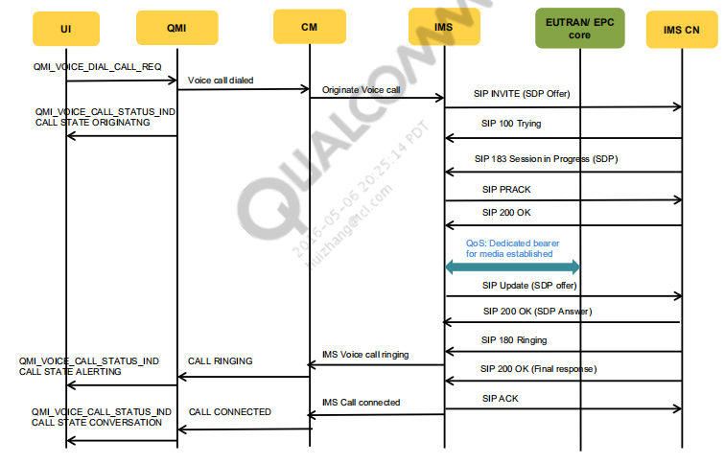

对于UE而言，简历PDP上下文的执行过程是相互独立的。这意味着在资源呗成功预留之前，根本无法保证所协商的媒体会话是否可以建立起来。因此，precondition作用主要是为了确认本地和主叫方的资源都以预留成功之前，被叫方不应该振铃，以最大程度减少被叫方振铃但是接听电话又失败的情况

MO call setup with precondition log analysis

Mobile-Originated Call Setup (with Precondition) (cont.)

The NV 65957 = qipcall_precondition_enable is used to enable/disable the precondition.

### 1. SIP INVITE is sent for an MO VoLTE call with a precondition.

00:00:41.418 /local/mnt/workspa 01288 1288|EVENT_SIP_SESSION_START: INVITE sip:+10123456789@one.att.net;user=phone

SIP/2.0

SIP INVITE snippet from pcap logs

INVITE sip:+10123456789@one.att.net;user=phone SIP/2.0

k: 100rel,replaces,precondition

o=root 5000 1000 IN IP6 fc01:abab:cdcd:efe0:b3e3:c776:8987:4b5f

a=curr:qos local none

a=curr:qos remote none

a=des:qos

mandatory local

sendrecv

a=des:qos optional remote sendrecv

### 2. Network responds with SIP 183 Session in Progress

[06054/02] IMS SIP/High 00:00:42.042 /local/mnt/workspa 04551 4551|EVENT_SIP_MESSAGE_RECV:SIP/2.0 183 Session in

Progress Allow: UPDATE Call-ID: 41399_1857307

SIP 183 response from NW supporting remote precondition

SIP/2.0 183 Session in Progress

Require: 100rel,precondition

Supported: precondition // Precondition supported by NW

a=curr:qos local none

a=curr:qos remote none

a=des:qos mandatory local sendrecv

a=des:qos

mandatory remote sendrecv // supports remote QoS precondition

### 3. After receiving SIP 183, QIPCALL registers for a QoS event with the data layer.

[00051/02] IMS/High 00:00:42.070 qipcalldialog.c 00865 qipcalldialog_process_incoming_session_progress_event: Call state = 11, precondition

enabled by remote = 1

[00051/02] IMS/High 00:00:42.070 qipcallqos.c 00343 qipcallqos_register_qos 0

[00051/02] IMS/High 00:00:42.071 qipcallqos.c 00446 qipcallqos_register_qos: Register successfully for N/W init QoS event

### 4. Network sets up the dedicated bearer for a media packet for VoLTE call.

1980 Jan 6 00:00:42.248 [00] 0xB0E2 LTE NAS ESM Plain OTA Incoming Message - Activate dedicated EPS bearer context request Msg

eps_bearer_id_or_skip_id = 6 (0x6)

msg_type = 197 (0xc5) (Activate dedicated EPS bearer context request)

1980 Jan 6 00:00:42.258 [00] 0xB0E3 LTE NAS ESM Plain OTA Outgoing Message - Activate dedicated EPS bearer context accept Msg

eps_bearer_id_or_skip_id = 6 (0x6)

### 5. After the dedicated bearer setup is accepted, the data layer informs IMS about QoS availability. QIPCALL checks the

**bandwidth allocation details and sends SIP UPDATE.**

[00051/01] IMS/Medium 00:00:42.266 qpDplQoS.c 00311 qpDplProcessQoSEvent: DPL_QOS_MSG_NW_INIT_AVAIL event occured

[00051/02] IMS/High 00:00:42.266 qipcallqos.c 00891 qipcallqos_process_qos_available_event: Received QoS Handle = 0x1, Instance Handle =

0x2e001b01

[00051/02] IMS/High 00:00:42.266 qipcalldialog.c 02408 qipcalldialog_update_qos_status Status = 0

[00051/02] IMS/High 00:00:42.266 qipcalldialog.c 02417 QIPCALLQOS_QOS_AVAILABLE Handle = 1, media_index = 0

[00051/02] IMS/High 00:00:42.267 qipcallqos.c 00727 qipcallqos_get_bandwidth_allocated: local_as:49, rr: 1837, rs:612

[00051/02] IMS/High 00:00:42.267 qipcallqos.c 00729 qipcallqos_get_bandwidth_allocated: local_as:49, as_from_mbr: 383

[00051/02] IMS/High 00:00:42.270 qipcalliface.c 04665 qipcalliface_get_AS_value_based_on_mode: bandwidth=38 for mode=2

[00051/02] IMS/High 00:00:42.270 qipcalldialog.c 02154 qipcalldialog_update_precondition_status: Updated local precondition met for call id

= 2, precondition supported = 1, stream id = 0

[00051/02] IMS/High 00:00:42.270 qipcallsdp.c 01363 qipcallsdp_is_local_pre_condition_met: local precondition met for index = 0

[00051/02] IMS/High 00:00:42.270 qipcallsdp.c 01522 qipcallsdp_is_local_pre_condition_met: local precondition status = 1 for call id = 2

[00051/02] IMS/High 00:00:42.270 qipcalldialog.c 01836 qipcalldialog_process_wait_for_200ok_of_update

[00051/02] IMS/High 00:00:42.270 qipcallsdp.c 06476 Creating Offer | iface: 0 | call_

[06054/02] IMS SIP/High 00:00:42.310 /local/mnt/workspa 03554 3554|EVENT_SIP_REQUEST_SEND: UPDATE

sip:+10123456789@[fc01:abab:cdcd:6fee::1] SIP/2.0 Call-ID: 41399_

SIP UPDATE snippet from pcap log

UPDATE sip:+10123456789@[fc01:abab:cdcd:6fee::1] SIP/2.0

m=audio 50010 RTP/AVP 104 0

b=AS:38 //Bandwidth allocated based on codec

b=RS:0

b=RR:0

a=curr:

qos local sendrecv // local QoS reserved

a=curr:qos remote none

a=des:qos mandatory local sendrecv

a=des:qos mandatory remote sendrecv

### 6. Network responds to SIP UPDATE with SIP 200 OK with SDP Answer.

[06054/02] IMS SIP/High 00:00:42.436 /local/mnt/workspa 04551 4551|EVENT_SIP_MESSAGE_RECV:SIP/2.0 200 OK

Call-ID: 41399_185730744@fc01:abab:cdcd:efe0:6634:7ddb

SIP/2.0 200 OK snippet from pcap log

m=audio 10000 RTP/AVP 104

b=AS:38

b=RS:0

b=RR:0

a=curr:qos

local sendrecv

a=curr:

qos remote sendrecv // remote QoS reserved

a=des:qos mandatory local sendrecv

a=des:qos mandatory remote sendrecv

### 7. Network sends SIP 180 Ringing.

[06054/02] IMS SIP/High 00:00:42.497 /local/mnt/workspa 04551 4551|EVENT_SIP_MESSAGE_RECV:SIP/2.0 180 Ringing

Call-ID: 41399_185730744@fc01:abab:cdcd:efe0:6634

8. Network sends SIP 200 OK final response for INVITE. At this point the call is established.

MSG [06054/02] IMS SIP/High 00:01:01.425 /local/mnt/workspa 04551 4551|EVENT_SIP_MESSAGE_RECV:SIP/2.0 200

OK

Call-ID: 41399_185730744@fc01:abab:cdcd:efe0:6634:7ddb

9. UE sends SIP ACK to SIP 200 OK.

MSG [06054/02] IMS SIP/High 00:01:01.467 /local/mnt/workspa 03554 3554|EVENT_SIP_REQUEST_SEND: ACK

sip:+10123456789@[fc01:abab:cdcd:6fee::1] SIP/2.0

Call-ID: 41399_185

## Mobile-Originated Call Setup Failure (with Precondition)

If a precondition is not met, i.e., a dedicated QoS bearer for media is not available or is incorrect, or it is not set by

the network, then the QoS timer expires. Upon timer expiration, IMS releases the MO call and sends SIP CANCEL.

The following NV must be configured based on the operation requirement:

NV 71572 = qipcall_qos_reservation_timer = 2000 msec

## 1. After receiving SIP 183, the QIPCALL registers for a QoS event with the data layer and starts the QoS timer.

MSG [00051/01] IMS/Medium 07:54:51.337 qpDplQoS.c 00448 qpDplQoSEventReg: Entry

MSG [00051/02] IMS/High 07:54:51.338 qipcallqos.c 00452 qipcallqos_register_qos: Register successfully for N/W init QoS

event

MSG [00051/01] IMS/Medium 07:54:51.338 qipcalltimer.cpp 00264 QipcallTimer::StartTimer - iDelay:2000 TimerID 0

## 2. Because the network did not set up a necessary dedicated bearer for QoS in 2000 msec, the QoS timer is expired. After that, QIPCALL releases the MO call and sends SIP CANCEL to the network.

MSG [00051/01] IMS/Medium 07:54:53.338 qipcalltimer.cpp 00164 QipcallTimer: Timer fired 0

MSG [00051/02] IMS/High 07:54:53.338 qipcallh.c 11965 qipcallh_wait_for_qos_reservation_timer_handler for call id = 2

MSG [00051/02] IMS/High 07:54:53.338 qipcallh.c 12031 qipcallh_wait_for_qos_reservation_timer_handler local

precondition not met, ending the call

MSG [00051/02] IMS/High 07:54:53.338 qipcallh.c 02779 qipcall_call_end_rpt_ind: Call Id=2, State=11,Cause=0

MSG [00051/02] IMS/High 07:54:53.348 qipcallh.c 08101 [qipcallh_chg_state_to_null] [call_id: 2]

MSG [06054/02] IMS SIP/High 07:54:53.382 sipConnection.cpp 03512 3512|EVENT_SIP_REQUEST_SEND: CANCEL

sip:+12234567890@one.att.net;user=phone SIP/2.0f: <tel:+14251234

## Mobile-Terminated Call Setup

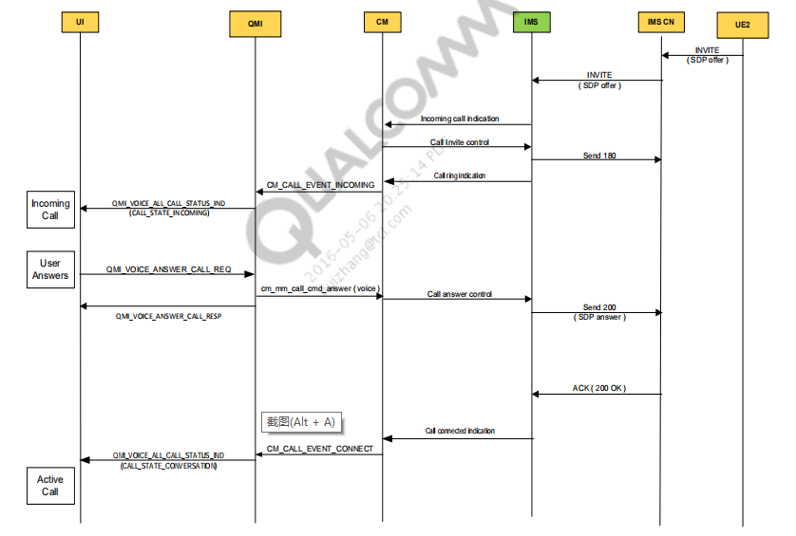

### 1. IMS receives INVITE request, responds with 100 Trying, and processes internally the incoming VoLTE call request.

MSG IMS/Error 00:58:33.880 04418 4418|EVENT_SIP_MESSAGE_RECV:INVITE sip:+11234567890@[2001::21f:29ff:fe7c:8f52]:5060 SIP/2.0

MSG IMS/Error 00:58:33.918 03192 3192|EVENT_SIP_RESPONSE_SEND: SIP/2.0 100 Trying Via: SIP/2.0/TCP

[2001::210:1ff:fe23:4567]:64326;bra

### IMS ensures it is able to accept the incoming VoLTE call.

### ▪ The following must be TRUE:

### ▪

Current RAT is LTE.

▪

CM domain selection has chosen IMS for VOICE (see [Q4]).

▪

There is no active 1X voice call.

▪

MO VoLTE call setup is not in progress.

▪

There is no or only one current active VoLTE call.

Hardcoded maximum of two concurrent VoLTE calls

▪

LTE signal strength (RSRP) is above configurable threshold (NV 70213)

[qipcall_signal_strength_threshold ] in dBm).

Optional based on IMS operation mode (NV 69673)

### 1.IMS stores and processes the dialog information (SIP headers and SDP).

MSG IMS/High 00:58:33.923 qipcalldialog.c 01957 [qipcalldialog_process_incoming_msg]

MSG IMS/High 00:58:33.923 qipcall.c 00502 Rxed SIP INCOMING

MSG IMS/High 00:58:33.925 qipcalldialog.c 01873 [qipcalldialog_update_sdp_received]

MSG IMS/High 00:58:33.945 qipcallh.c 11906 Preconditions is disabled

IMS will parse SDP offer from far-end and read the near-end NV config in order to formulate an SDP answer with commonly supported

media / attributes

MSG IMS/High 00:58:33.925 qipcalldialog.c 01873 [qipcalldialog_update_sdp_received]

MSG IMS/High 00:58:33.963 qipcallsdp.c 06010 [qipcallsdp_extract_info_from_peer_container]

### 2. IMS opens an RTP stream to ensure RTP resources are reserved for the incoming call (same as MO step 2).

IMS waits for RTP to be opened before proceeding to notify upper layers about the incoming call request.

RTP open process

▪ Memory allocation for audio stream

▪ RTP timer allocation (RTP/RTCP inactivity timers, RTP clock)

▪ Stream configuration/association with IMS internal call ID

MSG IMS/High 00:58:33.965 qipcallh.c 12034 Call id 4 moving to WAIT FOR RTP OPEN

MSG DS Real Time Transport Protocol/Medium00:58:33.965 qvp_rtp_api.c 00832 API qvp_rtp_open entered with appid 0

MSG IMS/High 00:58:33.990 qipcall.c 00725 qipcall_process_rtp_msg: QIPCALL_RTP_OPEN_DONE

### 3. IMS notifies CM about the incoming VoLTE call. The user is not alerted for this notification. This notification to upper layers is only performed to check if an incoming VoLTE call is allowed.

MSG IMS/High 00:58:33.991 qipcallh.c 02791 qipcall_call_incoming_rpt_ind for call_type = 1 eVideoAttrib = 0 eAudioAttrib = 3

MSG IMS/High 00:58:33.991 qipcallh.c 02834 qipcall_call_incoming_rpt_ind call id = 4

MSG IMS/High 00:58:33.991 qpDplCallCtrl.c 02972 qpDplCallCtrlReportInd: eIndication = 0

MSG IMS/High 00:58:33.991 qpDplCallCtrl.c 03037 qpDplCallCtrlReportInd: CallType = 1

MSG Call Manager/High 00:58:33.991 cmipcall.c 01516 =CM= RXD: MT_INVITE

MSG Call Manager/High 00:58:33.991 cmipcall.c 01585 =CM= is_volte is TRUE for MT

Note: qpDplCallCtrlReportInd will return TRUE when upper layers were successfully notified about the incoming VoLTE call

MSG IMS/High 00:58:33.991 qipcallh.c 01781 qipcall_rpt_ind ret from qpDplCallCtrlReportInd = 1

//IMS waits for response from CM to confirm the incoming VoLTE call is allowed

MSG IMS/High 00:58:33.991 qipcallh.c 06097 Call Id 4 state from 4 to WAIT_FOR_INVITE_RSP

▪

### CM informs IMS that the VoLTE call is allowed. A 180 Ringing response is sent to inform the MO UE that the MT UE is being notified about the incoming VoLTE call

Invite cb

MSG IMS/High 00:58:33.992 qipcallh.c 21562 qipcall_dpl_ctrl_cb: eCallCbType = 2

Wait for invite

MSG IMS/High 00:58:33.992 qipcallh.c 12881 Invite Res In State 6

IMS will check if there are currently any active voice calls in order to set SIP header “Alert-Info” appropriately for normal ringback

tone or call waiting tone. TRUE is returned if DPL is successfully able to query CM for the current call list.

Note: An active voice call is a call with call type CM_CALL_TYPE_VOICE in the “conversation” state

MSG IMS/High 00:58:33.995 qipcallh.c 12791 qipcallh_set_alert_info: qpDplGetCMCallList returned = 1, NumOfCalls =4

Note: Data calls are considered as “invalid” voice calls

MSG IMS/High 00:58:33.995 qipcallh.c 12814 qipcallh_set_alert_info: | Invalid Call id= 0 call-id = 0 is in state = 3

MSG IMS/High 00:58:33.995 qipcallh.c 12814 qipcallh_set_alert_info: | Invalid Call id= 1 call-id = 1 is in state = 3

MSG IMS/High 00:58:33.995 qipcallh.c 12814 qipcallh_set_alert_info: | Invalid Call id= 2 call-id = 2 is in state = 3

MSG IMS/High 00:58:33.995 qipcallh.c 12814 qipcallh_set_alert_info: | Invalid Call id= 3 call-id = 4 is in state = 2

Note: is_alert_info_set is a flag used to indicate if there are any other active voice calls in progress

( 0 = FALSE 1 = TRUE )

MSG IMS/High 00:58:33.995 qipcallh.c 12821 qipcallh_set_alert_info: Alert info set to = 0

IMS sends 180 Ringing response

MSG IMS/High 00:58:33.995 qipcall.c 01806 [qipcall_send_response] [response: 180]

MSG IMS/Error 00:58:34.006 03192 3192|EVENT_SIP_RESPONSE_SEND: SIP/2.0 180 Ringing Via: SIP/2.0/TCP

[2001::210:1ff:fe23:4567]:64326;br

## 5.IMS informs upper layers about the incoming VoLTE call to notify the MT UE user via the UI.

IMS starts the ringing timer

Note: the ringing timer value is configurable through NV 67280 ( in milliseconds ). This is the amount of time the MT UE will wait for the

user to answer or reject the call before ending the VoLTE session establishment with 486 “Busy Here” response to the MO UE.

MSG IMS/High 00:58:34.007 qipcallh.c 01528 Start QIPCALL Ringing timer 30000 call id 4

Ringing event notification is propagated to upper layers

MSG IMS/High 00:58:34.007 qipcallh.c 02896 qipcall_call_ring_cnf_ind call id = 4

MSG IMS/High 00:58:34.007 qpDplCallCtrl.c 02971 qpDplCallCtrlReportInd: Entry

Ringing

MSG IMS/High 00:58:34.007 qpDplCallCtrl.c 02972 qpDplCallCtrlReportInd: eIndication = 1

Incoming call

MSG Call Manager/High 00:58:34.007 cmdbg.c 02157 =CM= <<CM callevt=5 <4>

2012 Dec 4 00:58:34.013 [00] 0x138F QMI Link 1 TX PDU

MsgType = QMI_VOICE_ALL_CALL_STATUS_IND

CallState = INCOMING

Direction = MT: Mobile Terminated Call

If CM is successfully notified about this event, then TRUE is returned in the DPL call control report indication

MSG IMS/High 00:58:34.012 qipcallh.c 01781 qipcall_rpt_ind ret from qpDplCallCtrlReportInd = 1

MSG IMS/High 00:58:34.012 qipcallh.c 05513 Call Id 4 state from 6 to WAIT_FOR_ANSWER

### 6.The user answers the incoming VoLTE call. IMS creates an SDP answer and sends a 200 OK (INVITE) response.

2012 Dec 4 00:58:36.885 [00] 0x138E QMI Link 1 RX PDU

MsgType = QMI_VOICE_ANSWER_CALL_MSG

MSG Call Manager/High 00:58:36.885 cmdbg.c 02044 =CM= >>CM callcmd 1: 17

Wait for answer (1 accept or 0 reject)

MSG IMS/High 00:58:36.888 qipcallh.c 12571 Answer Cmd State 11 call id = 4, bAccept = 1

SDP state is QIPCALL_SDP_OFFER_RCVD ( from step 1 ), the below flag indicates this is an SDP answer to the SDP offer

MSG IMS/High 00:58:36.888 qipcallsdp.c 04718 Creating Offer | iface: 0 | call_id: 4

MSG IMS/High 00:58:36.888 qipcallsdp.c 04751 [is_offer: 0]

Received answer sent

MSG IMS/High 00:58:36.896 qipcalldialog.c 01834 [update SDP state] [from: 2] [sent]

MSG IMS/High 00:58:36.896 qipcall.c 01806 [qipcall_send_response] [response: 200]

MSG IMS/Error 00:58:36.908 3192|EVENT_SIP_RESPONSE_SEND: SIP/2.0 200 OK Via: SIP/2.0/TCP

[2001::210:1ff:fe23:4567]:64326;branch=

### 7. IMS “activates” the VoLTE (same as MO Call Setup steps 7 to 10).

MSG IMS/High 00:58:36.910 qipcallh.c 05426 [ activating call id: 4]

## Mobile-Terminated Call Setup (with Precondition)

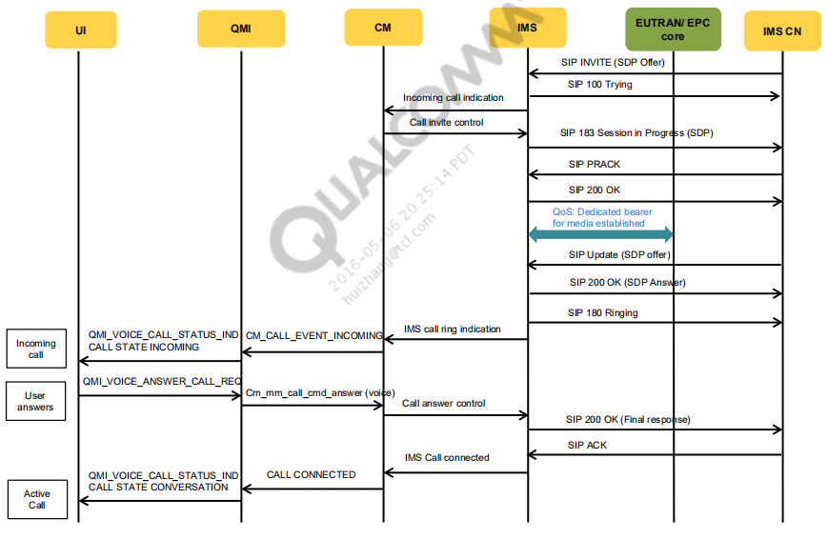

MT call setup with precondition log analysis

The NV 65957 = qipcall_precondition_enable is used to enable/disable the precondition.

### 1. SIP INVITE is received for an MT VoLTE call with a precondition.

MSG [06054/02] IMS SIP/High 00:09:00.441 /local/mnt/workspa 04624 4624|EVENT_SIP_MESSAGE_RECV:INVITE

sip:310410123456789@[fc01:abab:cdcd:efe0:a562:42a6:91d0:cb44]:8

SIP INVITE snippet from pcap logs

INVITE sip:310410123456789@[fc01:abab:cdcd:efe0:a562:42a6:91d0:cb44]:8902 SIP/2.0

Supported: 100rel,precondition

m=audio 10000 RTP/AVP 97 98 99 100 101

a=curr:qos local none

a=curr:qos

remote none

a=des:qos

mandatory local

sendrecv

a=des:qos optional remote sendrecv

### 2. UE responds with SIP 183 Session in Progress.

MSG [06054/02] IMS SIP/High 00:09:00.551 /local/mnt/workspa 03552 3552|EVENT_SIP_RESPONSE_SEND: SIP/2.0

183 Session Progress Call-ID: first_call Contact: <sip:+112345

SIP 183 response from UE supporting precondition

SIP/2.0 183 Session ProgressRequire: 100rel,precondition

Require: 100rel,precondition

k: 100rel,precondition //Precondition supported by UE

a=curr:qos local none

a=curr:qos remote none

a=des:qos mandatory local sendrecv

a=des:qos

mandatory remote sendrecv

### 3. After sending SIP 183, QIPCALL registers for a QoS event with the data layer.

MSG [00051/02] IMS/High 00:09:00.552 qipcallqos.c 00290 qipcallqos_register_qos

MSG [00051/02] IMS/High 00:09:00.552 qipcallqos.c 00357 qipcallqos_register_qos: Media Type = 0, port = 50010

### 4. Network sets up the dedicated bearer for a media packet for VoLTE call.

2014 May 13 00:09:00.985 [2F] 0xB0E2 LTE NAS ESM Plain OTA Incoming Message -- Activate dedicated EPS bearer context request Msg

eps_bearer_id_or_skip_id = 6 (0x6)

msg_type = 197 (0xc5) (Activate dedicated EPS bearer context request)

2014 May 13 00:09:00.997 [9F] 0xB0E3 LTE NAS ESM Plain OTA Outgoing Message -- Activate dedicated EPS bearer context accept Msg

eps_bearer_id_or_skip_id = 6 (0x6)

### 5. After the dedicated bearer setup is accepted, the data layer informs IMS about QoS availability. QIPCALL checks the

bandwidth allocation details and updates the precondition status.

MSG [00051/02] IMS/High 00:09:01.000 qipcallqos.c 00217 qipcallqos_process_qos_message: QoS Event 0

MSG [00051/02] IMS/High 00:09:01.000 qipcalldialog.c 02593 QIPCALLQOS_QOS_AVAILABLE Handle = 2, media_index =

0

MSG [00051/02] IMS/High 00:09:01.002 qipcallqos.c 00728 qipcallqos_get_bandwidth_allocated: local_as:38, rr: 1425,

rs:475

MSG [00051/02] IMS/High 00:09:01.002 qipcallqos.c 00730 qipcallqos_get_bandwidth_allocated: local_as:38,

as_from_mbr: 384

MSG [00051/02] IMS/High 00:09:01.002 qipcallsdp.c 01976 qipcallsdp_set_media_directionality: Set directionality of 0 to 3

MSG [00051/02] IMS/High 00:09:01.002 qipcallsdp.c 01384 qipcallsdp_is_local_pre_condition_met: local precondition met

for index = 0

MSG [00051/02] IMS/High 00:09:01.002 qipcallsdp.c 01543 qipcallsdp_is_local_pre_condition_met: local precondition

status = 1 for call id = 6

MSG [00051/02] IMS/High 00:09:01.003 qipcallsdp.c 01610 qipcallsdp_is_remote_pre_condition_met: Remote

precondition not met

### 6. MT UE sends SIP UPDATE indicating its precondition status.

MSG [06054/02] IMS SIP/High 00:09:01.172 /local/mnt/workspa 04624 4624|EVENT_SIP_MESSAGE_RECV:UPDATE

sip:+11234567890@[fc01:abab:cdcd:efe0:a562:42a6:91d0:cb44]:8902

SIP UPDATE snippet from pcap log

UPDATE sip:+11234567890@[fc01:abab:cdcd:efe0:a562:42a6:91d0:cb44]:8902;user=phone SIP/2.0

m=audio 10000 RTP/AVP 97 100

b=AS:38

b=RS:0

b=RR:0

a=curr:qos local sendrecv //MO UE QoS bandwidth reserved

a=curr:qos remote none

a=des:qos mandatory local sendrecv

a=des:qos mandatory remote sendrecv

[00051/02] IMS/High 00:09:01.195 qipcallsdp.c 01543 qipcallsdp_is_local_pre_condition_met: local precondition status = 1 for call id = 6

[00051/02] IMS/High 00:09:01.196 qipcallsdp.c 01605 qipcallsdp_is_remote_pre_condition_met: Remote precondition met

At this point both local (MT UE) and remote (MO UE) precondition is met

### 7. UE responds to SIP UPDATE with SIP 200 OK with SDP Answer and a local precondition status.

MSG [06054/02] IMS SIP/High 00:09:01.226 /local/mnt/workspa 03552 3552|EVENT_SIP_RESPONSE_SEND: SIP/2.0

200 OK Call-ID: first_call Contact: <sip:+11234567890@[fc01:ab

SIP/2.0 200 OK snippet from pcap log

m=audio 50010 RTP/AVP 97 100

b=AS:38

b=RS:0

b=RR:0

a=curr:qos local sendrecv

a=curr:qos

remote sendrecv // MT UE QoS reserved

a=des:qos mandatory local sendrecv

a=des:qos mandatory remote sendrecv

### 8. UE sends SIP 180 Ringing and indicates to the UI layer of the incoming call.

MSG [06054/02] IMS SIP/High 00:09:01.245 /local/mnt/workspa 03552 3552|EVENT_SIP_RESPONSE_SEND: SIP/2.0

180 Ringing Call-ID: first_call Contact: <sip:+11234567890@[fc

### 9. After the user accepts the incoming call, UE sends SIP 200 OK final response for INVITE. At this point the call is established.

MSG [06054/02] IMS SIP/High 00:09:04.179 /local/mnt/workspa 03552 3552|EVENT_SIP_RESPONSE_SEND: SIP/2.0

200 OK Call-ID: first_call Contact: <sip:+11234567890@[fc01:ab

### 10. UE receives SIP ACK for SIP 200 OK from the network.

MSG [06054/02] IMS SIP/High 00:09:04.279 /local/mnt/workspa 04624 4624|EVENT_SIP_MESSAGE_RECV:ACK

sip:+11234567890@[fc01:abab:cdcd:efe0:a562:42a6:91d0:cb44]:8902;us

## Mobile-Terminated Call Setup Failure

If a precondition is not met, i.e., a dedicated QoS bearer for media is not available or is incorrect, or it is not set by the network, then the QoS timer expires. Upon timer expiration, IMS releases the MT call and sends SIP 580 Precondition Failure.

The following NV must be configured based on the operation requirement:

NV 71572 = qipcall_qos_reservation_timer = 2000 msec

### 1. After sending SIP 183, the QIPCALL registers for a QoS event with the data layer and starts the QoS timer.

MSG

[00051/03] IMS/Error 00:22:09.848

/local/mnt/workspa 03341 3341|EVENT_SIP_RESPONSE_SEND: SIP/2.0 183 Session Progress

MSG

[00051/02] IMS/High

00:22:09.851

qipcallqos.c 00419 qipcallqos_register_qos: Register successfully for N/W init QoS event

MSG

[00051/02] IMS/High

00:22:09.851

qipcalltimer.cpp 00081 QipcallTimer::QipcallTimer CB - 42c2f54c, user data - 47e28a10

MSG

[00051/02] IMS/High

00:22:09.851

qipcalltimer.cpp 00151 QipcallTimer::StartTimer - iDelay:2000

### 2. Because the network did not set up a necessary dedicated bearer for QoS in 2000 msec, the QoS timer is expired. After

### that, QIPCALL releases the MT call and sends SIP 580 to the network.

MSG

[00051/02] IMS/High 00:22:17.852

qipcalltimer.cpp 00095 QipcallTimer: Timer fired 0

MSG

[00051/02] IMS/High

00:22:17.852

qipcallh.c 13413 qipcallh_wait_for_qos_reservation_timer_handler for call id = 2

MSG

[00051/02] IMS/High

00:22:17.852

qipcallsdp.c 01185 qipcallsdp_is_local_pre_condition_met: local precondition not met

MSG

[00051/02] IMS/High

00:22:17.852

qipcallh.c 13419 qipcallh_wait_for_qos_reservation_timer_handler local precondition not

met, ending the call

MSG

[00051/02] IMS/High

00:22:17.852

qipcallh.c 06358 qipcallh_chg_state_to_null called

MSG

[00051/02] IMS/High

00:22:17.852

qipcallh.c 06215 Releasing audio codec

MSG [00051/03] IMS/Error 00:22:17.885 /local/mnt/workspa 03341 3341|EVENT_SIP_RESPONSE_SEND: SIP/2.0 580

Precondition Failure Call-ID: alejandro.B@3gpp.org Content

## Call Termination (Near Side-Initiated)

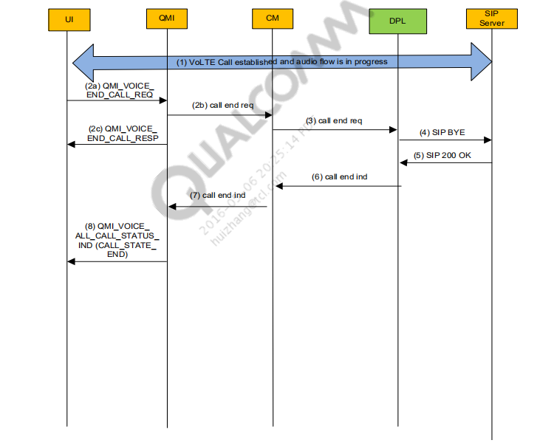

### 1. Call is established and audio flow is in progress

### 2. CM receives call end command from QMI

LOG Length: 0017 QMI Link

1 RX PDU 04:38:56.798

MsgType = QMI_VOICE_END_CALL_MSG

Call ID = 1

b) MSG qmi_voice_cm_if.c 04034 QMI VOICE qmi_voice_cm_if_end_call Data Services/Medium

04:38:56.800

c) LOG Length: 0024 QMI Link

1 TX PDU

04:38:56.810

ResultCode = QMI_RESULT_SUCCESS

ErrorCode = QMI_ERROR_NONE

### 3. CM requests IMS to end the VoLTE call

### 4. IMS internally cleans up the VoLTE call and sends BYE request

### 5. IMS receives 200 OK ( BYE )

### 6. Call end indication is propagated up to QMI VOICE

LOG Length: 0048 QMI Link 1 TX PDU 04:38:56.811

MsgType = QMI_VOICE_ALL_CALL_STATUS_IND

CallState = END

CallType = 2

Direction = MO, Mobile-Originated Call

## Call Termination (Far Side-Initiated)

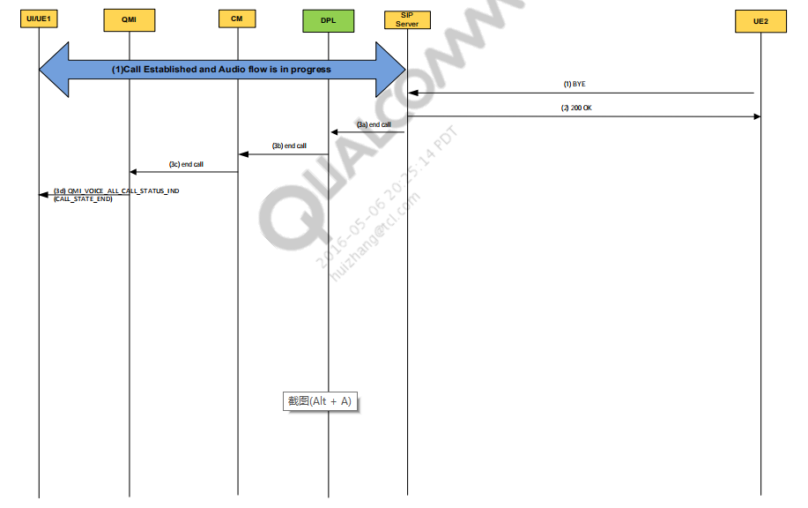

### 1. IMS receives BYE message and sends 200 OK.

MSG

IMS/Error

03:46:36.133

01424 1424|QimfSipActiveObj::ProcessMessage | Received Message is BYE

sip:2121@[2002:c023:9c17:591:398c:ce3d

MSG

IMS/Error

03:46:36.133 04428 4428|EVENT_SIP_MESSAGE_RECV:BYE

sip:2121@[2002:c023:9c17:591:398c:ce3d:777b:968f]:5060 SIP/2.0Re

### 2. SIP stack sends 200 OK.

MSG

IMS/Error

03:46:36.172

03196 3196|EVENT_SIP_RESPONSE_SEND: SIP/2.0 200 OK

### 3. IMS performs VoLTE call cleanup and “end call” indication is propagated to QMI VOICE.

MSG

Data Services/High [05000/02]

03:46:36.187

qmi_voice_cm_if.c 17743 CALL EVENT

RECEIVED from CM : id = 65539, name = CM_CALL_EVENT_END

[00] 0x138F QMI Link 1 TX PDU

MsgType = QMI_VOICE_ALL_CALL_STATUS_IND

CallState = END

Direction = MT: Mobile Terminated Call

## Call Hold

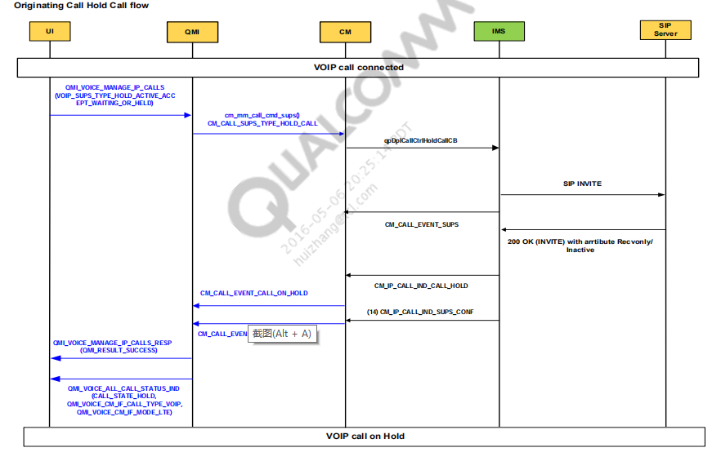

### 1. UI to QMI.

[00] 0x138F QMI Link 1 RX PDU

QmiType = VOICE

MsgType = QMI_VOICE_MANAGE_IP_CALLS

sups_type = HOLD_ACTIVE_ACCEPT_WAITING_OR_HELD

MSG [05000/01] Data Services/Medium 04:37:44.386 qmi_voice_cm_if.c 10678 Inside qmi_voice_cm_if_sups_manage_ip_calls(), found a call list entry mode=9:

MSG [05000/01] Data Services/Medium 04:37:44.386 qmi_voice_cm_if.c 10687 Inside qmi_voice_cm_if_sups_manage_ip_calls():

MSG [05000/01] Data Services/Medium 04:37:44.386 qmi_voice_cm_if.c 06647 Inside qmi_voice_cm_if_sups_hold_active_accept_waiting_or_held():

### 2. QMI sends hold call request to CM, CM_CALL_SUPS_TYPE_HOLD_CALL.

MSG [05000/01] Data Services/Medium 04:37:44.386 qmi_voice_cm_if.c 06729

cm_mm_call_cmd_sups(), CM_CALL_SUPS_TYPE_HOLD_CALL CallId =15

**3. CM to IMS through call back and IMS responds to CM with**

**CM_CALL_EVENT_SUPS.**

MSG [00051/02] IMS/High 04:37:44.386 qpDplCallCtrl.c 02010

qpDplSendCMIPAPPInfoEvent: Entry

MSG [05000/02] Data Services/High 04:37:44.388 qmi_voice_cm_if.c 17743 CALL EVENT RECEIVED from CM : id = 65540, name = CM_CALL_EVENT_SUPS

### 4. IMS sends INVITE with sendonly attribute set to SIP.

MSG [00051/03] IMS/Error 04:37:44.435 Z:/M8960AAAAATAAM4 03175 =2;max

red=0a=rtpmap:112 telephone-event/16000a=fmtp:112 0-15 a=sendonly a=maxptime:240 a=ptime

### 5. SIP forwards this INVITE to SIP server aka P-CSCF.

MSG [00051/03] IMS/Error 04:37:44.435 Z:/M8960AAAAATAAM4 03213

3213|EVENT_SIP_REQUEST_SEND: INVITE sip:1212@[2002:c023:9c17:589:785d:1e43:4a2d:a510]:5060 SIP/2.0

### 6. SIP server sends 200 OK to SIP stack.

MSG [00051/03] IMS/Error 04:37:44.572 Z:/M8960AAAAATAAM4 01424

1424|QimfSipActiveObj::ProcessMessage | Received Message is SIP/2.0 200 OK

### 7. SIP stack sends QPE_SIP_REINVITE_ESTABLISHED_EV message to IMS.

MSG [00051/02] IMS/High 04:37:44.612 qimfif_cbs.cpp 01834 Reinvite Established

**8. IMS also sends ack of reinvite to SIP statck.**

**9. IMS sends CM a CM_IP_CALL_IND_CALL_HOLD indication.**

MSG [00005/02] Call Manager/High 04:37:44.643 cmipapp.c 02690 =CM= RPT name

606/* 606 = CM_IP_CALL_IND_CALL_HOLD */ MSG [00005/01] Call Manager/Medium

04:37:44.643 Null 01929 `QSR MSG: Hash <CDB4B3AE> not found MSG [00005/02] Call

Manager/High 04:37:44.643 cmipcall.c 01967 =CM= RXD: CALL_HOLD

**10. CM sends QMI a CM_CALL_EVENT_CALL_ON_HOLD event.**

MSG [05000/02] Data Services/High 04:37:44.645 qmi_voice_cm_if.c 17743 CALL EVENT

RECEIVED from CM : id = 65582, name = CM_CALL_EVENT_CALL_ON_HOLD

**11. IMS sends CM a CM_IP_CALL_IND_SUPS_CONF indication.**

MSG [00005/02] Call Manager/High 04:37:44.645 cmipapp.c 02690 =CM= RPT name

609/* 609 = CM_IP_CALL_IND_SUPS_CONF */

**12. CM sends QMI a CM_CALL_EVENT_MNG_CALLS_CONF event.**

MSG [05000/02] Data Services/High 04:37:44.645 qmi_voice_cm_if.c 17743 CALL EVENT

RECEIVED from CM : id = 65579, name = CM_CALL_EVENT_MNG_CALLS_CONF

**13. QMI provides response to UI about its call hold request.**

MSG [05000/01] Data Services/Medium 04:37:44.646 qmi_voice.c 14265 QMI VOICE

qmi_voicei_sups_manage_ip_calls_resp

**14. QMI provides a status of call to UI.**

MSG 07035 Call information for call id 1 is:/* information of call id 1 */

MSG qmi_voice.c 07036 Call State =6, call type =2, direction 2/* call state = 6 =

QMI_VOICE_CM_IF_CALL_STATE_HOLD call type = 2 = VOIP call */

[00] 0x138F QMI Link 1 TX PDU

QmiType = VOICE

MsgType = QMI_VOICE_ALL_CALL_STATUS_IND

CallState = HOLD

Direction = MO: Mobile Originated Call

## Call Resume

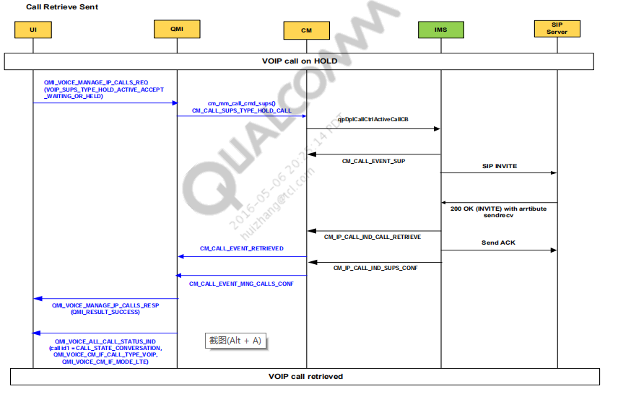

### 1. UI to QMI.

[00] 0x138F QMI Link 1 RX PDU

QmiType = VOICE

MsgType = QMI_VOICE_MANAGE_IP_CALLS

sups_type = HOLD_ACTIVE_ACCEPT_WAITING_OR_HELD

**2. QI to CM about CM_CALL_SUPS_TYPE_HOLD_CALL.**

MSG [05000/01] Data Services/Medium 04:37:50.465 qmi_voice_cm_if.c 06729 cm_mm_call_cmd_sups(), CM_CALL_SUPS_TYPE_HOLD_CALL CallId =15

**3. CM to IMS through qpDplCallCtrlActiveCallCB.**

MSG [00051/02] IMS/High 04:37:50.465 qpDplCallCtrl.c 02010 qpDplSendCMIPAPPInfoEvent: Entry //krunal (5 / new -3)

MSG [00051/02] IMS/High 04:37:50.465 qpDplCallCtrl.c 02052 qpDplSendCMIPAPPInfoEvent: Exit

**4. IMS will send INVITE to P-CSCF server aka SIP SERVER.**

MSG [00051/03] IMS/Error 04:37:50.512 Z:/M8960AAAAATAAM4 03213 3213|EVENT_SIP_REQUEST_SEND: INVITE

sip:1212@[2002:c023:9c17:589:785d:1e43:4a2d:a510]:5060 SIP/2.0

MSG [00051/03] IMS/Error 04:37:50.515 Z:/M8960AAAAATAAM4 04985 4985|EVENT_SIP_SESSION_START: INVITE

sip:1212@[2002:c023:9c17:589:785d:1e43:4a2d:a510]:5060 SIP/2.0

**5. IMS informs CM about CM_CALL_EVENT_SUPS.**

MSG [05000/02] Data Services/High 04:37:50.466 qmi_voice_cm_if.c 17743 CALL EVENT RECEIVED from CM : id =

65540, name = CM_CALL_EVENT_SUPS

**6. IMS receives 200 OK from SIP server aka P-CSCF.**

MSG [00051/03] IMS/Error 04:37:50.661 Z:/M8960AAAAATAAM4 01424 1424|QimfSipActiveObj::ProcessMessage |

Received Message is SIP/2.0 200 OK

**7. IMS sends ACK to SIP server.**

MSG [00051/03] IMS/Error 04:37:50.710 Z:/M8960AAAAATAAM4 03213 3213|EVENT_SIP_REQUEST_SEND: ACK

sip:1212@[2002:c023:9c17:589:785d:1e43:4a2d:a510]:5060 SIP/2.0 f: <s

**8. IMS to CM about CALL RETRIEVE event.**

/* 607 = CM_IP_CALL_IND_CALL_RETRIEVE */

MSG [00005/02] Call Manager/High 04:37:50.733 cmipapp.c 02690 =CM= RPT name 607

MSG [00005/02] Call Manager/High 04:37:50.733 cmipcall.c 02055 =CM= RXD: CALL_RETRIEVE

**9. CM to QMI about call_event_retrieved.**

MSG [05000/02] Data Services/High 04:37:50.735 qmi_voice_cm_if.c 17743 CALL EVENT RECEIVED from CM : id = 65583, name =

CM_CALL_EVENT_CALL_RETRIEVED

**10.IMS to CM about CM_IP_CALL_IND_SUPS_CONF = 609.**

MSG [00005/02] Call Manager/High 04:37:50.735 cmipapp.c 02690 =CM= RPT name 609 //KRUNAL (8.8)

MSG [00005/01] Call Manager/Medium 04:37:50.735 cmipcall.c 02203 =CM= RXD: SUPS_CONF, sups_type=3, num_part=0, participant=0x0

**11.CM to QMI about CM_CALL_EVENT_MNG_CALLS_CONF.**

MSG [05000/02] Data Services/High 04:37:50.736 qmi_voice_cm_if.c 17743 CALL EVENT RECEIVED from CM : id = 65579, name =

CM_CALL_EVENT_MNG_CALLS_CONF

### 12.QMI to UI.

MSG [05000/01] Data Services/Medium 04:37:50.737 qmi_voice.c 14265 QMI VOICE qmi_voicei_sups_manage_ip_calls_resp

MSG [05000/01] Data Services/Medium 04:37:50.737 qmi_voice.c 07035 Call information for call id 1 is:

MSG [05000/01] Data Services/Medium 04:37:50.737 qmi_voice.c 07036 Call State =3, call type =2, direction 2

/* Call State =3 = QMI_VOICE_CM_IF_CALL_STATE_CONV call type = 2= VOIP call */

[00] 0x138F QMI Link 1 TX PDU

QmiType = VOICE

MsgType = QMI_VOICE_ALL_CALL_STATUS_IND

CallState = CONVERSATION

Direction = MO: Mobile Orig

### Call Add

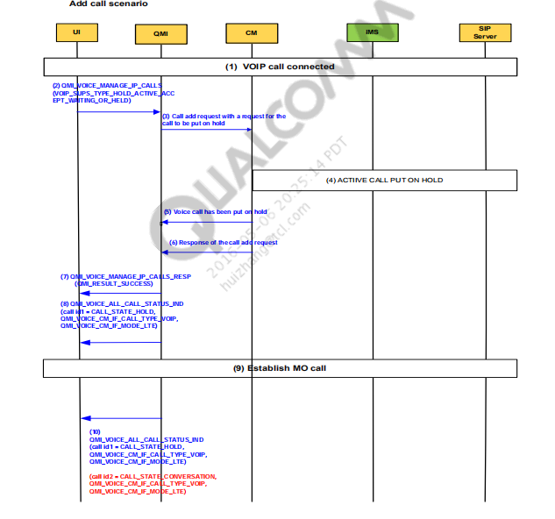

### 1. VoLTE call has been established. See MO or MT call flow for details.

### 2. UI requests that a call be added via QMI.

[00] 0x138E QMI Link 1 RX PDU

QmiType = VOICE

MsgType = QMI_VOICE_MANAGE_IP_CALLS

sups_type = HOLD_ACTIVE_ACCEPT_WAITING_OR_HELD

MSG [05000/01] Data Services/Medium 18:59:56.951 qmi_voice_cm_if.c 10610 Inside

qmi_voice_cm_if_sups_manage_ip_calls(), found a call list entry mode=9:

MSG [05000/01] Data Services/Medium 18:59:56.951 qmi_voice_cm_if.c 10619 Inside

qmi_voice_cm_if_sups_manage_ip_calls():

MSG [05000/01] Data Services/Medium 18:59:56.951 qmi_voice_cm_if.c 06591 Inside

qmi_voice_cm_if_sups_hold_active_accept_waiting_or_held():

### 3. QMI requests that a call would be added with a request to hold the call.

MSG [05000/01] Data Services/Medium 18:59:56.951 qmi_voice_cm_if.c 06673

cm_mm_call_cmd_sups(), CM_CALL_SUPS_TYPE_HOLD_CALL CallId =6

### 4. Call is put on HOLD see call hold call flow for more details

### 5. CM informs QMI about call on hold event received.

MSG [05000/02] Data Services/High 18:59:57.278 qmi_voice_cm_if.c 17450 CALL EVENT RECEIVED from CM : id = 65582, name = CM_CALL_EVENT_CALL_ON_HOLD

### 6. CM responds to the add call request.

MSG [05000/02] Data Services/High 18:59:57.278 qmi_voice_cm_if.c 17450 CALL EVENT

RECEIVED from CM : id = 65579, name = CM_CALL_EVENT_MNG_CALLS_CONF

### 7.QMI informs UI about QMI_VOICE_MANAGE_IP_CALL_RESP.

519272 163:MSG [05000/01] Data Services/Medium 18:59:57.280 qmi_voice.c 14040 QMI

VOICE qmi_voicei_sups_manage_ip_calls_resp

2014 Apr 11 23:42:56.055 [00] 0x138F QMI Link 1 TX PDU

QmiType = VOICE

MsgType = QMI_VOICE_MANAGE_IP_CALLS

QmiResult = QMI_RESULT_SUCCESS

### 8. The call status is relayed back up to QMI.

MSG [05000/01] Data Services/Medium 18:59:57.413 qmi_voice.c 07084 Call information

for call id 1 is:

// call id=1 first one

MSG [05000/01] Data Services/Medium 18:59:57.413 qmi_voice.c 07085 Call State =6, call

type =2, direction 2

// 6 = QMI_VOICE_CM_IF_CALL_STATE_HOLD

MSG [05000/01] Data Services/Medium 18:59:57.413 qmi_voice.c 07086 Call Mode =4, is

mpty =0, als =0

MSG [05000/01] Data Services/Medium 18:59:57.413 qmi_voice.c 07084 Call information

for call id 2 is:

// call id-2 second one

MSG [05000/01] Data Services/Medium 18:59:57.413 qmi_voice.c 07085 Call State =1, call

type =2, direction 1

//1=QMI_VOICE_CM_IF_CALL_STATE_ORIG

[00] 0x138F QMI Link 1 TX PDU

QmiType = VOICE

MsgType = QMI_VOICE_ALL_CALL_STATUS_IND

CallId = 1

CallState = HOLD

Direction = MO: Mobile Originated Call

### 9. MO call establishment; see MO call sequence.

[00] 0x138E QMI Link 1 RX PDU

QmiType = VOICE

MsgType = QMI_VOICE_DIAL_CALL_MSG

service_type = VOICE_DIAL_CALL_SRV_TYPE_AUTOMATIC

### 10. QMI informs UI about call status.

MSG [05000/01] Data Services/Medium 19:00:00.881 qmi_voice.c 07084 Call information

for call id 1 is:

//callid=1 is on hold as of now

MSG [05000/01] Data Services/Medium 19:00:00.881 qmi_voice.c 07085 Call State =6, call

type =2, direction 2

MSG [05000/01] Data Services/Medium 19:00:00.881 qmi_voice.c 07086 Call Mode =4, is

mpty =0, als =0

MSG [05000/01] Data Services/Medium 19:00:00.881 qmi_voice.c 07084 Call information

for call id 2 is:

MSG [05000/01] Data Services/Medium 19:00:00.881 qmi_voice.c 07085 Call State =3, call

type =2, direction 1

callid=2 is started conversation, 3=QMI_VOICE_CM_IF_CALL_STATE_CONV

call type=2 VOIP call

[00] 0x138F QMI Link 1 TX PDU

QmiType = VOICE

MsgType = QMI_VOICE_ALL_CALL_STATUS_IND

CallId = 2

CallState = CONVERSATION

Direction = MO: Mobile Originated Call

CallId = 1

CallState = HOLD

Direction = MO: Mobile Originated Call

## Call Waiting

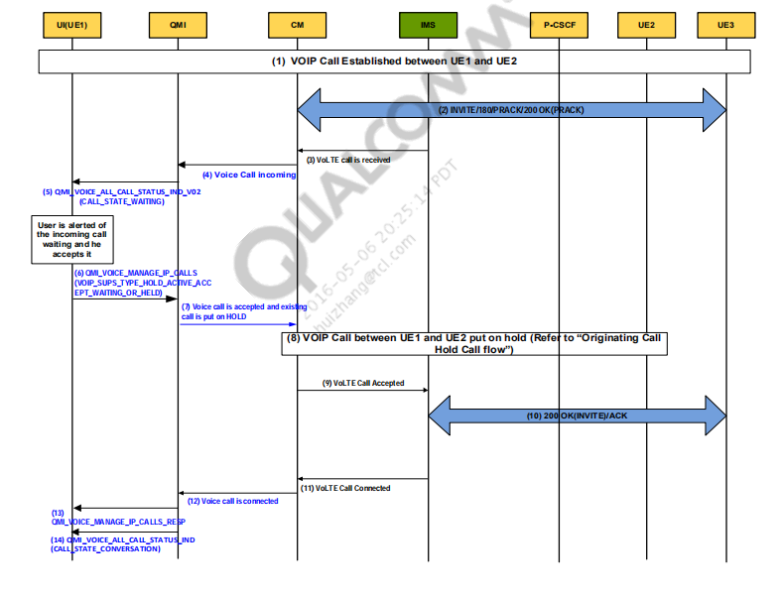

### 1. A call has been established between UE1 and UE2 and is ongoing.

MSG /local/mnt/workspa 04418 4418|

EVENT_SIP_MESSAGE_RECV:

INVITE sip:2121@[2002:c023:9c17:663:315a:8427:63fe:2bd2]:5060 SIP/2.0 IMS/Error 05:34:37.856

MSG /local/mnt/workspa 03187 3187|EVENT_SIP_RESPONSE_SEND: SIP/2.0 100 Trying

From: sip:anonymous@anonymous.invalid;tag=673324519 IMS/Error 05:34:37.893

MSG /local/mnt/workspa 03187 3187|EVENT_SIP_RESPONSE_SEND: SIP/2.0 180 Ringing

Record-Route: <sip:[2002:C023:9C17:51A:21B:21FF:FE2 IMS/Error 05:34:37.955

MSG /local/mnt/workspa 04418 4418|EVENT_SIP_MESSAGE_RECV:

PRACK sip:2121@[2002:c023:9c17:663:315a:8427:63fe:2bd2]:5060 SIP/2.0 IMS/Error 05:34:38.406

MSG /local/mnt/workspa 03187 3187|EVENT_SIP_RESPONSE_SEND: SIP/2.0 200 OK

Record-Route: <sip:[2002:C023:9C17:51A:21B:21FF:FE22:F8B IMS/Error 05:34:38.448

MSG /local/mnt/workspa 04418 4418|

EVENT_SIP_MESSAGE_RECV:ACK sip:2121@[2002:c023:9c17:663:315a:8427:63fe:2bd2]:5060 SIP/2.0

Re IMS/Error 05:34:44.968

### 2. A third UE, UE3, initiates a call with UE1 via the INVITE message (INVITE/180/PRACK/200 OK(PRACK)).

MSG /local/mnt/workspa 04418 4418|

EVENT_SIP_MESSAGE_RECV:

INVITE sip:2121@[2002:c023:9c17:663:315a:8427:63fe:2bd2]:5060 SIP/2.0 IMS/Error 05:35:20.990

MSG /local/mnt/workspa 03187 3187|EVENT_SIP_RESPONSE_SEND: SIP/2.0 100 Trying

From: "54321" <sip:54321@qctlabsip06.qualcomm.com>;t IMS/Error 05:35:21.028

MSG qpDplCallCtrl.c 02970 qpDplCallCtrlReportInd: eIndication = 0 IMS/High 05:35:21.085

### 3. IMS indicates to CM that a VoLTE call is received.

MSG /local/mnt/workspa 03187 3187|EVENT_SIP_RESPONSE_SEND: SIP/2.0 180 Ringing

Record-Route: <sip:[2002:C023:9C17:51A:21B:21FF:FE2 IMS/Error 05:35:21.100

MSG qpDplCallCtrl.c 02970 qpDplCallCtrlReportInd: eIndication = 1 IMS/High 05:35:21.622

MSG cmdbg.c 02170 =CM= <<CM callevt=5 <7> Call Manager/High

05:35:21.623

MSG qpCall.c 00516 qpDplCallEventCB: CallEvent : 5 IMS/High

05:35:21.623

1980 Jan 6 05:35:21.624 [00] 0x12C1 CM Call Event

Version = 3

Call Event = 5

### 4. CM indicates to QMI that a MT call has been received.

MSG qmi_voice_cm_if.c 17747 CALL EVENT RECEIVED from CM : id = 65541, name =

CM_CALL_EVENT_INCOMData Services/High 05:35:21.625

MSG qmi_voice_cm_if.c 11849 Inside qmi_voice_cm_if_call_event_incom(): Data Services/Medium

05:35:21.625

### QMI notifies UI that an MT call has been received.

05:35:21.626 [00] 0x138F QMI Link 1 TX PDU

QmiType = VOICE

MsgType =

QMI_VOICE_ALL_CALL_STATUS_IND

CallId = 2

CallState =

WAITING

CallType = 2

Direction =

MT: Mobile Terminated Call

Mode = 4

CallState = CONVERSATION

CallType = 2

Direction = MT: Mobile Terminated Call

Mode = 4

*** User is alerted of the incoming call waiting and he accepts it ***

### UI accepts the call and notifies the modem via QMI.

05:35:25.604 [00] 0x138E QMI Link 1 RX PDU

QmiType = VOICE

SduCtlFlags = REQ

MsgType = QMI_VOICE_MANAGE_IP_CALLS

QmiVoiceV1DefaultMsg {

Hex Dump = { 1, 1, 0, 3 }

MSG qmi_voice.c 14084 QMI VOICE qmi_voicei_sups_manage_ip_calls

Data Services/Medium

05:35:25.603

MSG qmi_voice_cm_if.c 06647 Inside qmi_voice_cm_if_sups_hold_active_accept_waiting_or_held():Data Services/Medium

### 7. QMI sends to the accept call response to CM

MSG qmi_voice_cm_if.c 06729 cm_mm_call_cmd_sups(), CM_CALL_SUPS_TYPE_HOLD_CALL CallId =6

Data Services/Medium 05:35:25.605

MSG cm.c 07569 =CM= cm_mm_call_cmd_sups() Call Manager/High 05:35:25.605

### 8. The existing call between UE1 and UE2 is put on HOLD. See HOLD call sequence for details.

### 9. CM notifies IMS that the call has been accepted.

### 10. Call is accepted and indicated to UE3. See MT call flow for more details.

**11. IMS indicates to CM that call is in connected state.**

MSG qpDplCallCtrl.c 02970 qpDplCallCtrlReportInd: eIndication = 2 IMS/High 05:35:25.675

MSG cmipcall.c 01795 =CM= RXD: CONNECTED

Call Manager/High 05:35:25.675

MSG cmdbg.c 02170 =CM= <<CM callevt=6 <7>

Call Manager/High 05:35:25.675

1980 Jan 6 05:35:25.675 [00] 0x12C1 CM Call Event

Version = 3

Call Event = 6 (CM_CALL_EVENT_CONNECT)

**12. CM indicates the call connected state to the UI via QMI message CM_CALL_EVENT_CONNECT.**

MSG qmi_voice_cm_if.c 17747 CALL EVENT RECEIVED from CM : id = 65542, name =

CM_CALL_EVENT_CONNECT Data Services/High 05:35:25.676

**13. QMI indicates via the message QIP_VOICE_MANAGE_IP_CALLS_RESP that**

**the request was received and processed by CM.**

**14. QMI indicates via the message QMI_VOICE_ALL_CALL_STATUS_IND**

**(CALL_STATE_CONVERSATION) that the second call is in the conversation state and the first call has been held.**

1980 Jan 6 05:35:25.680 [00] 0x138F QMI Link 1 TX PDU

QmiType = VOICE

SduCtlFlags = RSP

MsgType = QMI_VOICE_MANAGE_IP_CALLS

MsgLength = 7

QmiVoiceV1DefaultMsg {

Hex Dump = { 2, 4, 0, 0, 0, 0, 0 }

05:35:25.680 [00] 0x138F QMI Link 1 TX PDU

QmiType = VOICE

MsgType = QMI_VOICE_ALL_CALL_STATUS_IND

CallId = 2

CallState = CONVERSATION

CallType = 2

Direction = MT: Mobile Terminated Call

CallId = 1

CallState = HOLD

CallType = 2

Direction = MT: Mobile Terminated Call

### Call Conferencing

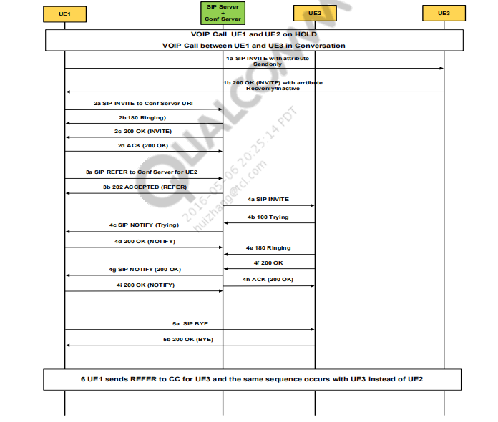

▪ Precondition – UE1 has UE2 on hold and is in an active call with UE3.

1. When UE1 receives the request to start a conference, it puts the active call with

UE3 on hold.

2. UE1 creates the conference via an INVITE sent to the conference URI.

3. UE1 sends a REFER to the conference server with the URI of the UE that is to be

added to the conference. In this case, it is UE2.

4. UE2 receives an INVITE from the conference server and UE1 receives NOTIFY

indications for the 100 Trying and the 200 OK messages received on the

conference server from UE2.

5. UE1 ends the call with UE2 after receiving the NOTIFY that UE2 has accepted the

call with the conference server.

6. Repeat steps 3a through 5b (of the call flow) for adding UE3 into the conference

call.

## Call Conference Subscribe Event Package

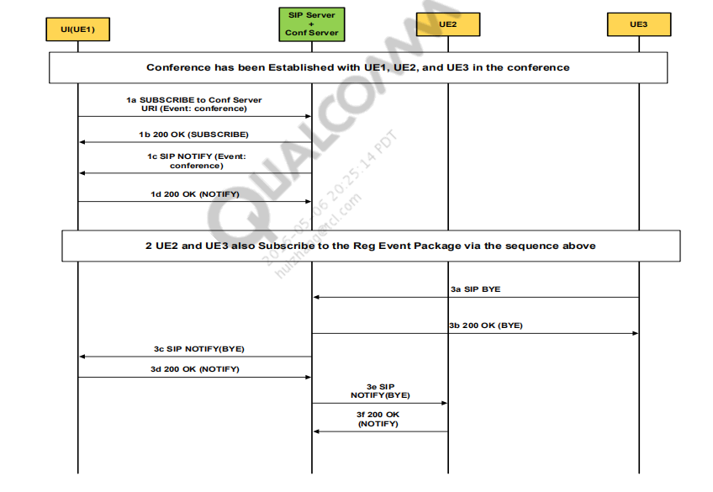

Precondition – UE1, UE2 and, UE3 have each established a call with the

conference server and are logically in the same conference.

1. UE1 subscribes to the conference event package and receives the full state of the conference.

2. UE2 and UE3 subsequently subscribe to the events of the server.

3. UE3 leaves the conference by sending a BYE. The other subscribed members of

the conference get a NOTIFY informing them of this BYE.

▪ Per [S1], the first NOTIFY that comes after the subscribe gives the full

state of the conference call. All subsequent NOTIFY updates are partial

states with changes of that initial conference state.

▪

### Precondition – VoIP call UE1 and UE2 on HOLD and there is an initiated VoIP call between UE1 and UE3 in conversation.

2014 Apr 11 23:43:13.170 [00] 0x138F QMI Link 1 TX PDU

QmiType = VOICE

MsgType = QMI_VOICE_ALL_CALL_STATUS_IND

CallId = 2

CallState =

HOLD

CallType = VOICE_IP

Direction = MO: Mobile Originated Call

CallId = 1

CallState =

CONVERSATION

CallType = VOICE_IP

Direction = MO: Mobile Originated Call

## . UI requests a call conference through QMI.

QmiType = VOICE

SduCtlFlags

= REQ

MsgType =

QMI_VOICE_MANAGE_IP_CALLS

sups_type = MAKE_CONFERENCE_CALL

### CM receives the request through QMI. CM informs IMS to put the call between UE1 and UE3 on hold.

MSG [00051/02] IMS/High 23:43:22.280 qipcallh.c 30617 qipcall_dpl_ctrl_cb: eCallCbType = 13

Once the SIP re-INVITE to put call with UE3 on hold succeeds, the indication is sent to CM.

MSG [00051/02] IMS/High 23:43:23.322 qipcallh.c 02971 call hold rpt ind. eCALL_IND_CALL_HOLD Call Id=13,

cause=0, remote=0

MSG [00051/02] IMS/High 23:43:23.322 qipcallh.c 02681 qipcall_rpt_ind ret from qfDplCallCtrlReportInd = 1

QmiType = VOICE

**QMI indicates to the UI that both calls are on hold.**

QmiType = VOICE

MsgType = QMI_VOICE_ALL_CALL_STATUS_IND

CallId = 2

CallState = HOLD

CallType = VOICE_IP

Direction = MO: Mobile Originated Call

CallId = 1

CallState = HOLD

CallType = VOICE_IP

Direction = MO: Mobile Originated Call

**IMS receives the request for a multiparty call.**

MSG qipcallh.c 21614 qipcall_dpl_ctrl_cb: eCallCbType = 0 IMS/High 20:12:39.641

**IMS via the framework sends out the INVITE message to connect to the conference server.**

MSG D:/Builds/MPCS_IOT 03213 3213|EVENT_SIP_REQUEST_SEND: INVITE sip:122@ice-ims-

02.qualcomm.com;user=phone SIP/2.0 From: "88888" IMS/Error 20:12:39.730

**The status of the conference call is indicated by CM to QMI to be sent to the UI.**

MSG qmi_voice_cm_if.c 17450 CALL EVENT RECEIVED from CM : id = 65542, name = CM_CALL_EVENT_CONNECT

Data Services/High 20:12:43.097

**QMI sends the indication to the UI.**

QmiType = VOICE

MsgType = QMI_VOICE_ALL_CALL_STATUS_IND

CallId = 3

CallState = CONVERSATION // Conference call

CallType = VOICE_IP

Direction = MO: Mobile Originated Call

CallId = 2

CallState = HOLD

CallType = VOICE_IP

Direction = MO: Mobile Originated Call

CallId = 1

CallState = HOLD

CallType = VOICE_IP

Direction = MO: Mobile Originated Call

## Once the call with conference server is established, the UE sends a REFER to add UE2 to

## the conference call.

MSG [06054/02] IMS SIP/High 23:43:24.238 /local/mnt/workspa 03592 3592|EVENT_SIP_REQUEST_SEND: REFER

sip:n-way_voice@[2001:1890:1f8:2000::7:2]:5000;transport=tcp SIP/2.

Once UE1 terminates the call to UE2 via a BYE, a message sent via the SIP stack.

MSG D:/Builds/ABCD_IOT 03213 3213|EVENT_SIP_REQUEST_SEND: BYE sip:5222@10.42.189.113:5060 SIP/2.0

To: <sip:5222@ice-ims-02.qualcom

IMS/Error 20:12:59.557

### Call End status of UE1 to UE2 is indicated to QMI to be notified to the UI.

MSG qmi_voice_cm_if.c 17450 CALL EVENT RECEIVED from CM : id = 65539, name = CM_CALL_EVENT_END

Data Services/High 20:12:59.566

### The status of the UE1 to UE2 call is indicated to the UI via QMI.

LOG Length: 0055 QMI Link 1 TX PDU

20:12:59.571

QmiType = VOICE

MsgType = QMI_VOICE_ALL_CALL_STATUS_IND

CallId = 3

CallState = CONVERSATION

CallType = VOICE_IP

Direction = MO: Mobile Originated Call

CallId = 2

CallState = HOLD

CallType = VOICE_IP

Direction = MO: Mobile Originated Call

CallId = 1

CallState = END

CallType = VOICE_IP

Direction = MO: Mobile Originated Call

**UE sends a REFER to add UE3 to the conference call.**

MSG [06054/02] IMS SIP/High /local/mnt/workspa 03592 3592|EVENT_SIP_REQUEST_SEND: REFER sip:n

way_voice@[2001:1890:1f8:2000::7:2]:5000;transport=tcp SIP/2.

**After UE3 is added to the conference, IMS sends a SIP BYE to end the call with UE3.**

MSG [06054/02] IMS SIP/High /local/mnt/workspa 03592 3592|EVENT_SIP_REQUEST_SEND: BYE

**Call End status of UE1 to UE3 is indicated to QMI to be notified to the UI.**

MSG qmi_voice_cm_if.c 17450 CALL EVENT RECEIVED from CM : id = 65539, name = CM_CALL_EVENT_END

Data Services/High 20:13:03.140

**The status of the UE1 to UE3 call is indicated to the UI via QMI.**

LOG Length: 0041 QMI Link 1 TX PDU

20:13:03.145

MsgType = QMI_VOICE_ALL_CALL_STATUS_IND

CallId = 2

CallState = END

**IMS receives a success for the conference call.**

Call event 43 is CM_CALL_EVENT_MNG_CALLS_CONF MSG qpCall.c 00797 qpDplCallEventCB: CallEvent : 43

IMS/High 20:12:39.510

QmiType = VOICE

MsgType = QMI_VOICE_ALL_CALL_STATUS_IND

CallId = 3

CallState = CONVERSATION

CallType = VOICE_IP

Direction = MO: Mobile Originated Call

CallId = 2

CallState = END

CallType = VOICE_IP

Direction = MO: Mobile Originated Call

### IMS sends an indication of the conference call status to CM.

MSG [00051/02] IMS/High 19:54:17.638 qpDplCallCtrl.c 02953 qpDplCallCtrlReportInd: Entry

### CM receives an indication of the conference call and sends to QMI to inform the UI.

MSG [05000/02] Data Services/High 19:54:17.640 qmi_voice_cm_if.c 17141 CALL EVENT RECEIVED from CM : id = 65579, name = CM_CALL_EVENT_MNG_CALLS_CONF

**QMI indicates the result of the manage call to the UI.**

LOG [0x138F] QMI Link 1 TX PDU 19:54:17.641 Length: 0024

MsgType = QMI_VOICE_MANAGE_IP_CALLS

QmiResult = QMI_RESULT_SUCCESS

## DTMF

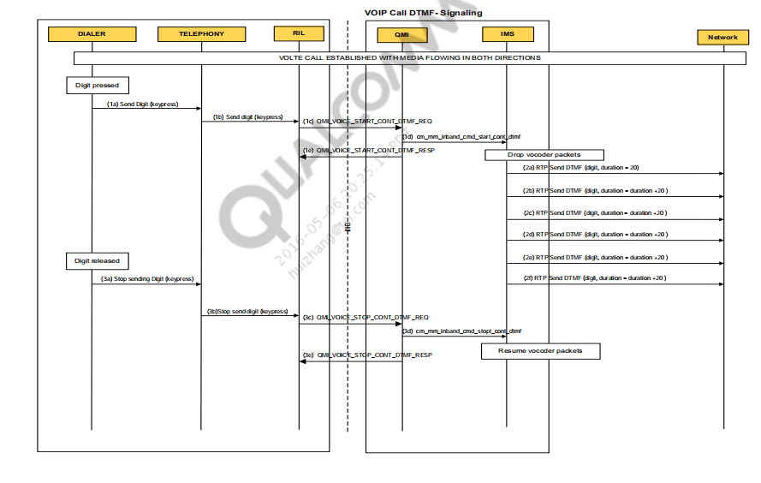

### Precondition – VoIP call UE1 and UE2 on VoIP call in conversation.

### 1. Digit is pressed.

2013 Feb 21 02:19:39.090 [00] 0x138E QMI Link 1 RX PDU

QmiType = VOICE

SduCtlFlags = REQ

MsgType = QMI_VOICE_START_CONT_DTMF_MSG

Continuous DTMF Information Tlv {

digit = 49

Data Services/Medium02:19:39.091 qmi_voice_cmd_list.c 00454 Command CM IF START CONT DTMF (7) pending

receipt of CM_INBAND_EVENT_REV_START_CONT_DTMF_CONF

Call Manager/Medium02:19:39.091 cmipapp.c 03915 =CM= CMIPAPP: Send start inband DTMF for call 6

2013 Feb 21 02:19:39.095 [00] 0x138F QMI Link 1 TX PDU

QmiType = VOICE

SduCtlFlags = RSP

MsgType = QMI_VOICE_START_CONT_DTMF_MSG

### DTMF is sent over RTP.

IMS/High 02:19:39.113 qipcallh.c 15230 -----> Sending dtmf for digit 49 duration :20

IMS/High 02:19:39.133 qipcallh.c 15230 -----> Sending dtmf for digit 49 duration :40

IMS/High 02:19:39.155 qipcallh.c 15230 -----> Sending dtmf for digit 49 duration :60

IMS/High 02:19:39.175 qipcallh.c 15230 -----> Sending dtmf for digit 49 duration :80

IMS/High 02:19:39.195 qipcallh.c 15230 -----> Sending dtmf for digit 49 duration :100

IMS/High 02:19:39.216 qipcallh.c 15230 -----> Sending dtmf for digit 49 duration :120

### Digit is released.

2013 Feb 21 02:19:39.220 [00] 0x138E QMI Link 1 RX PDU

QmiType = VOICE

SduCtlFlags = REQ

MsgType = QMI_VOICE_STOP_CONT_DTMF_MSG

IMS/High 02:19:39.222 qipcallh.c 15040 Stop DTMF event: 0x31 Duration :120

IMS/High 02:19:39.225 qipcallh.c 14892 qipcall_stop_dtmf_rpt_conf: call modify rpt ind.

eCALL_IND_STOP_DTMF_CNF Call Id=6, status = 1

2013 Feb 21 02:19:39.225 [00] 0x138F QMI Link 1 TX PDU

QmiType = VOICE

SduCtlFlags = RSP

MsgType = QMI_VOICE_STOP_CONT_DTMF_MSG

VT call check for Video port in SIP invite SDP+

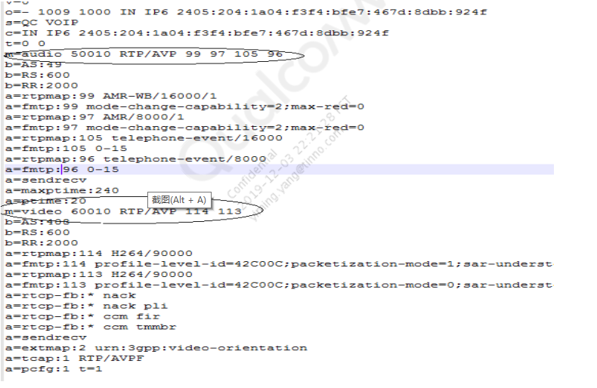

Dedicated bearers are established to call voice and video data

▪ QCI 1: for Audio

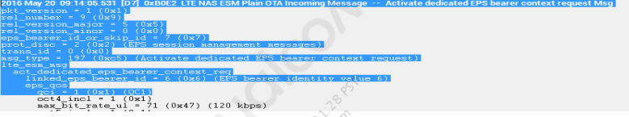

▪ QCI 2: for Video

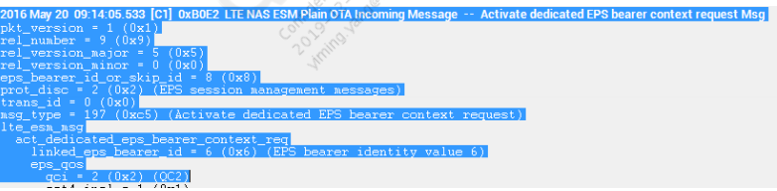

## VT Call Upgrade

Once the VoLTE voice call is established, a user can upgrade the voice

call to video call by pressing the upgrade option from UI

UE sends SIP Invite message for the VT upgrade request with the video

port, and supported codecs

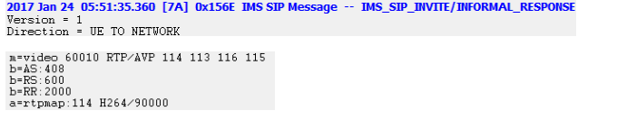

Network responds with the message ‘100 trying’. Dedicated bearer

establishment request for video with QCI 2 is established.

▪ Once the MT side UE accepts the VT call, 200 ok is sent to the UE. The

UE then replies to ACK.

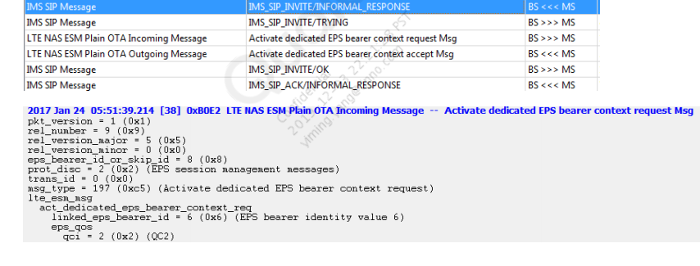

## VT Call to Voice Call Downgrade

For downgrading the call from video to voice call, press the following

option from the UI:

UE sends a SIP invite message for downgrading the VT call to voice with

video port as 0.

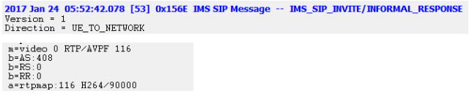

Network responds with the message “100 trying” and deactivates the

dedicated bearer that was established for video transmission.

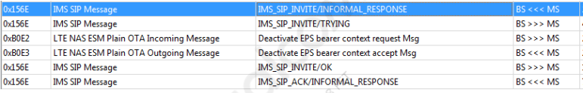

UE responds with ACK after receiving 200 ok from network for the

successful downgrade of the VT call to voice.

# Emergency Call Over IMS

▪ Both UE and network should support emergency service, for successful

emergency call.

▪ ECC calls over IMS are supported from Release 9 onwards

▪ System information block type 1 specifies whether the network supports

IMS Emergency call or not

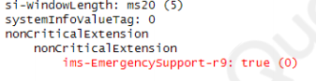

In addition, in the attach accept message, the network indicates its

supports for an ECC call:

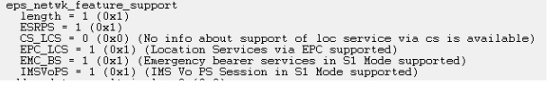

In addition, in the attach accept message, the network indicates its

supports for an ECC call:

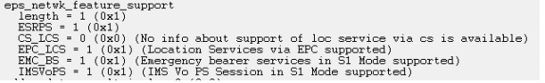

UE matches digits dialed by the user with a list of known emergency

numbers

▪ Emergency number list in the UE is common for CS and PS domain use

▪ If there is a match, the UE shall initiate the call as an emergency call.

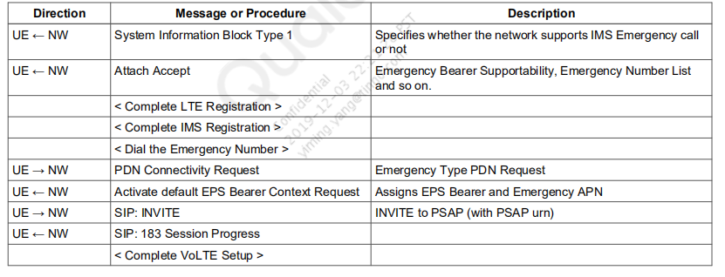

PDN Connectivity Request message with Reg type emergency

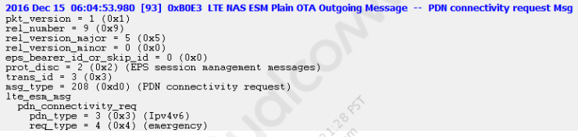

Network establishes EPS bearer with QCI 5 and APN as EMERGENCY

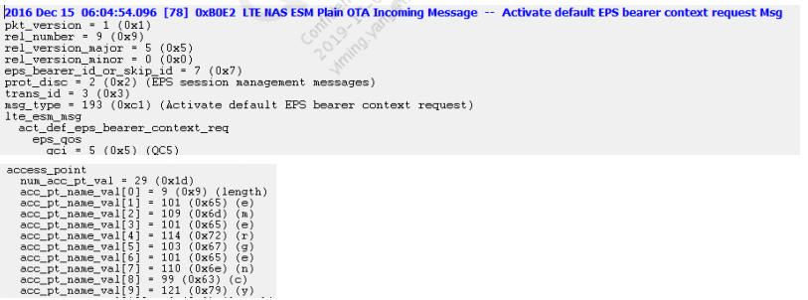

UE does the SIP Registration again for the emergency call and sends an

invite message with the “to” field as SOS

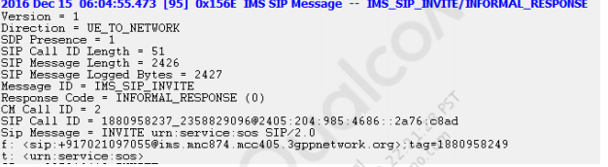

Network sends 183 session progress, and dedicated bearer request

for the call to be established.

▪ If there is any error response from network like 500 internal server,

then UE tries to establish the call over CS by falling back to CS

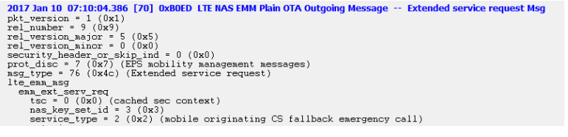

# CSFB and SRVCC

CSFB：CS FallBack，是一种单卡单待方案，同一时刻终端只能驻留于一种网络中（LTE或2/3G）。支持CSFB的终端开机后若有LTE覆盖，则驻留于​LTE网络中，当有MT呼叫时，寻呼消息通过MSC Server传递给MME进而寻呼UE，UE回落到2/3G网络接听CS呼叫，呼叫结束后又回到LTE网络。UE发起语音呼叫时，UE先回落到2/3G网络（通过发起ESR过程），呼叫结束后再回到LTE网络。​

SRVCC：Single Radio Voice Call Continuity。SRVCC是VoLTE不完全覆盖前的解决方案，也是一种单卡单待方案。与SGLTE/SVLTE的区别在于一个是单待，一个是双待。由于终端同一时刻只驻留于一种网络中，当在两种网络中切换并保持连续性时，需要CS域、LTE PS域和IMS域共同完成承载和会话层的切换。当LTE基站发现终端有正在进行的语音通话（存在QCI=1的承载）且需要切换，且目标小区是2G/3G小区时，通知MME进行SRVCC切换。MME向MSC Server发送切换请求，MSC Server先建立好CS承载，然后向作为会话锚点的IMS域发送通知消息，通知进行会话层的切换。

（note SGLTE/SVLTE）​

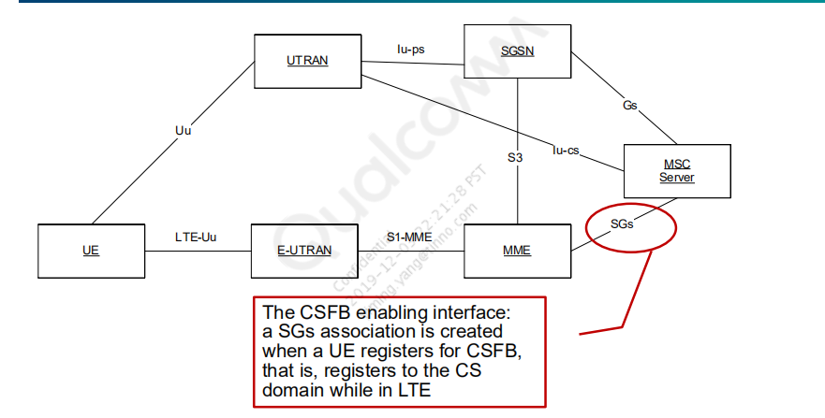

Note: SGs Protocol Stack is SGsAP/SCTP/IP; SGsAP is based on BSSAP+ (TS 44.008)

### CSFB to UMTS – Network Architecture

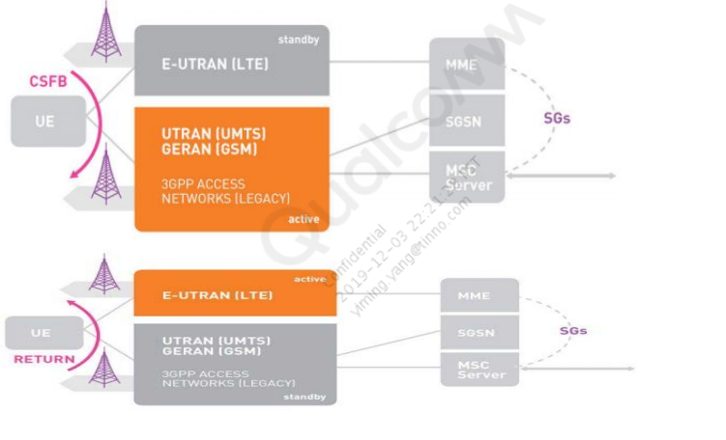

CSFB UE modes

▪ A UE configured to use CS fallback, shall operate in

CS/PS mode 1 or CS/PS mode 2

▪ CS/PS mode 1/2 of operation: the UE registers to both EPS and non-EPS

services, and UE's usage setting is "voice/data centric"

▪ To register for CSFB over UMTS, the UE performs:

▪ A combined EPS/IMSI Attach and/or combined TA/LA Update*

▪ ATTACH or TAU type indicates “combined registration”.

▪ No indication of CSFB support or other parameters from EPC and eNB

are required for CSFB registration

▪ UE tries the combined registration (that is, it performs a combined CS and PS

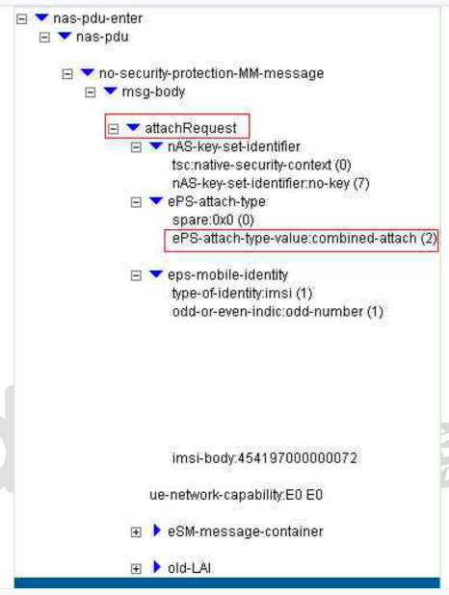

**CSFB主叫流程**

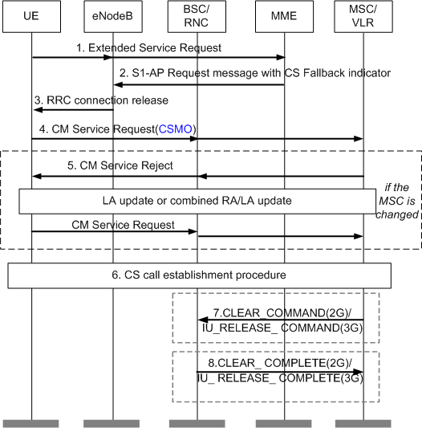

**主叫CSFB流程说明**

1. UE发起CS Fallback语音业务请求。UE语音拨打时，会发一条extended service request，消息里会携带CSFB信息。其中service-type信元指示业务类型为始发CSFB语音业务，同时携带该UE在联合附着过程中CS域给它分配的TMSI。之后会在基站的辅助下回落到2G/3G

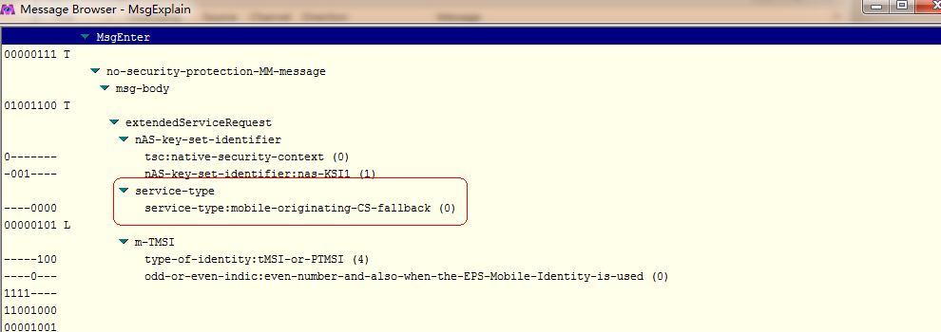

2） MME发送Initial Context Setup Request消息给eNodeB，包含CS Fallback Indicator。该消息指示eNodeB，UE因CS Fallback业务需要回落到UTRAN/GERAN。

3） eNodeB要求UE开始系统的小区测量，并获得UE上报的测量报告，确定重定向的目标系统小区。然后向UE发送目标系统具体的无线配置信息，并释放连接。LTE网络通过RIM流程（无线消息管理流程）提前获取2G目标小区广播信息，将2G网络的广播信息一并填充至RRC Release消息中下发，省去终端读取2G广播信息的时间

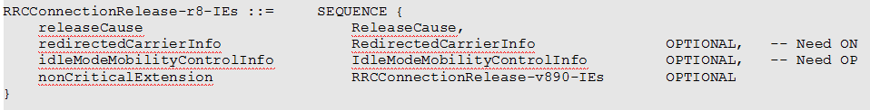

76127, 11902, 6274156, 17:48:17:393 2019/11/07, MOD_ERRC_CONN, , TRACE_PEER, [NW->MS] ERRC_RRCConnectionRelease(EARFCN[66886], PCI[1])(cause:[ReleaseCause_other], redirectInfo:[1])

rrcConnectionRelease

rrcConnectionRelease-r8

releaseCause: other (1)

redirectedCarrierInfo: utra-FDD (2) // Redirection 信息, 包含Redirect的频点

utra-FDD: 9888

nonCriticalExtension

cellInfoList-r9: utra-FDD-r9 (1) // 这是扩展的信息, 网络预先给了具体的小区PSC以及系统广播, 加快搜索过程.

utra-FDD-r9: 1 item

Item 0

CellInfoUTRA-FDD-r9

physCellId-r9: 100

System-Information-Container

4） UE接入目标系统小区，发起CS域的业务请求CM Service Request。如果CM业务请求消息中携带“CSMO”标志，则MSC Server记录本次呼叫是移动始端CSFB呼叫。

5） 如果目标系统小区归属的MSC Server与UE附着EPS网络时登记的MSC Server不同，则该MSC Server收到UE的业务请求时，由于没有该UE的信息，可以采取隐式位置更新流程，接受用户请求。如果MSC Server不支持隐式位置更新，且MSC Server没有用户数据，则拒绝该用户的业务请求。如果MSC Server拒绝用户的业务请求会导致UE发起一个CS域位置更新流程。终端发起位置更新请求，且位置更新请求消息中的Additional update parameters信元中携带CSMO标识，同时该标识有效，则MSC Server会记录本次呼叫是CSFB呼叫。（CS fallback紧急呼叫流程中，CM_SERVICE_REQUEST消息前无需位置更新。）

6）完成位置更新后UE再次在 CS域建立语音呼叫流程。

7） 通话结束后，MSC Server向主叫回落到的BSC发送的拆线消息CLEAR_COMMAND消息中携带CSFB Indication信元，指示BSC拆除空口连接并指示UE回到LTE网络。 或者MSC Server向主叫回落到的RNC发送IU_RELEASE_COMMAND消息，携带End Of CSFB信元，指示RNC拆除空口连接并指示UE回到LTE网络。

8） MSC收到BSC的CLEAR_COMPLETE消息/RNC的IU_RELEASE_COMPLETE消息表示呼叫结束，A口拆链完成。接入侧在指示终端重选网络时只针对CSFB用户通话前携带LTE频点，实现CSFB终端快速返回LTE，快速回落过程也称为FastReturn（用户不可及时间可缩短为1-2秒。）。

**2.6.2 CSFB被叫流程**

MSC Server收到对UE的被叫语音请求，通过存在的SGs关联和MME信息，向该MME发起寻呼请求。MME通过eNodeB在空口寻呼该UE，并指示UE回落到目标GERAN/UTRAN网络。UE接入到目标网络后，在电路域继续进行语音呼叫。

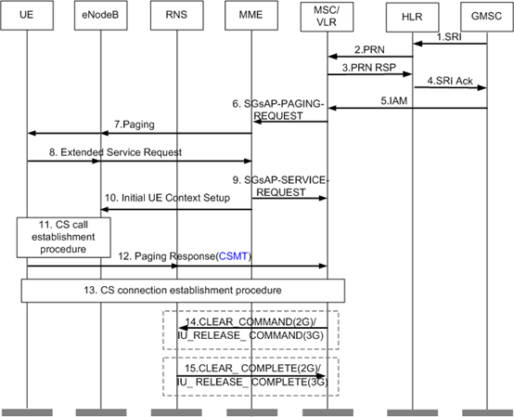

**被叫CSFB流程说明**

1） GMSC Server向被叫用户归属HLR发送取路由信息请求。

2） HLR收到该SRI消息后，向被叫用户当前附着到的old MSC Server获取漫游号码。

3） old MSC Server为该次呼叫分配漫游号码MSRN1，并返回给HLR。

4） HLR将该漫游号码发送给GMSC。

5） GMSC收到该漫游号码后，进行号码分析，根据分析结果将呼叫路由到old MSC Server。

6） MSC Server收到IAM入局（例如中继ISUP入局）消息后，根据存在的SGs关联和MME信息，发送SGsAP-PAGING-REQUEST(携带IMSI，TMSI，Service indicator ，CLI，LAC)消息给MME。

7） MME发送Paging消息给eNodeB。eNodeB发起空口的Paging流程。

8） UE建立连接并发送Extended Service Request消息给MME（消息中携带“CSMT”移动终端标识）。

9） MME发送SGsAP-SERVICE-REQUEST消息给MSC Server。MSC Server收到此消息，不再向MME重发寻呼请求消息。为避免呼叫接续过程中，主叫等待时间过长，MSC Server收到包含空闲态指

示的SGs Service Request消息，先通知主叫，呼叫正在接续过程中。

10） MME发送Initial UE Context Setup消息给eNodeB，包含CS Fallback Indicator。该消息指示eNodeB，UE因CSFB业务需要回落到UTRAN/GERAN。

11） UE回落到CS域之后，UE检测到当前的位置区信息和存储的位置区不同，将发起位置更新。MSC Server收到UE发送的LOCATION_UPDATE_REQUEST消息。这种情况下，UE不需要回Paging Response给MSC Server，UE直接发送SETUP消息建立呼叫。如果位置更新消息中携带“CSMT”标志，则MSC Server记录本次呼叫是CSFB呼叫。

12） 伴随着空口、A/Iu-CS接口连接的建立，UE回Paging Response消息给MSC Server，该消息中携带CSMT标识，即使BSC/RNC没有向该UE发起过寻呼请求，也需要能处理UE的寻呼响应。如果寻呼响应消息中的位置区信息和VLR中保存的不一致，则VLR在业务接入成功之后将SGs关联置为非关联。

13） 建立CS呼叫。

14） 通话结束后，指示BSC/RNC拆除空口连接并指示UE回到LTE网络。

15） MSC收到BSC的CLEAR_COMPLETE消息/RNC的IU_RELEASE_COMPLETE消息表示呼叫结束。接入侧在指示终端重选网络时只针对CSFB用户携带LTE频点，实现CSFB终端快速返回E-UTRAN。FastReturn方案也需要网络的支持，如果网络不支持，则通过网络优先级的方式返回LTE（一般为最高优先级）。

# Srvcc 流程

Esrvcc 通话过程中发生

Asrvcc ringing 后

Bsrvcc ringing 前（主叫）

* Single Radio Voice Call Continuity (SRVCC) provides the ability to

transition a voice call from a VoIP/IMS domain to the legacy circuit switch

domain.

* UE can be either voice centric or data centric: CS Voice preferred, IMS PS

Voice secondary (CS_PREF)

* IMS PS Voice preferred, CS Voice secondary (PS_PREF)

Whenever a voice call is initiated using the PS domain, SRVCC may be

required to transfer the call to the CS domain in the following scenario: IMS PS voice is preferred and the UE is in the E-UTRAN domain when the call is

initiated.

* CS voice is preferred and the UE is in an E-UTRAN coverage area, but CSFB

registration has failed; in this case, a VoIP/IMS-capable device can make and

accept calls using VoIP/IMS.

* From a UE perspective, the SRVCC process involves: SR-VCC capability
* negotiation – UE and MME should agree on the capabilities and whether
* SR-VCC should be supported. This negotiation is performed in different

stages using RRC and NAS signaling.

* Initiating a voice call – For SRVCC purposes, the voice call is anchored at

the VCC app.

* Channel measurements and reporting – When on the LTE network, the UE shall

perform the normal channel measurements on E-UTRAN: If the channel quality

with the current eNodeB falls below a certain level, UE notifies eNodeB.

* UE shall report the measurements based on the triggers specified by eNodeB.

The appropriate target could be EUTRAN or UTRAN/GERAN.

* Handover to UMTS and Derivation of keys upon SRVCC HO
* UE uses the CS path to continue the voice call

From a network perspective, the following process is involved: SR-VCC

capability negotiation between UE and MME

* Network configures channel measurements and reporting thresholds
* Handover – E-UTRAN detects that a handover is required. It informs MME

that UE needs to handover to UTRAN/GERAN

* MME detects that this is SRVCC. It informs MSC server that a PS to CS

handover is required.

* MSC server also informs the target RAN to prepare for handover.
* A new bearer path is set up for the UE in UTRAN/GERAN and UE is

directed to the new network. This process depends on the target network

1）手机向EnodeB 发送测量报告  
2） EnodeB 判定进行向GSM 进行SRVCC 切换  
3） EnodeB 发送切换请求  
4） MME 进行语音承载与数据承载的分离，对QCI=1 的GBR 语音承载进行到CS 域的切换  
5） MME 向MSC Server 发送PS 到CS 的切换请求（内含IMSI 和STN-SR 号码）  
6） MSC Server 与目标MSC Server 和BSC 协商完成GSM 无线系统切换电路的建立  
7） MSC Server 向IMS MMTel 发起语音会话转移传送信息（含STN-SR 号码）  
8） IMS MMTel 进行语音会话的更新和用户面的承载更新  
9） MSC Server 向MME 发送PS 到CS 的切换响应消息  
10） MME 向EnodeB 发送切换命令消息  
11） EnodeB 向用户终端发送切换命令消息  
12）用户终端切换到GSM，用户终端通过BSC 发送PS 业务挂起， SGSN 与MME 互通PS 挂起消息  
13） BSC 向目标MSC Server 发送切换完成消息  
14） MSC Server 向MME 发送切换完成消息  
15）根据规范流程MME 与SGw/PGw 互通进行相应的LTE 承载处理和挂起

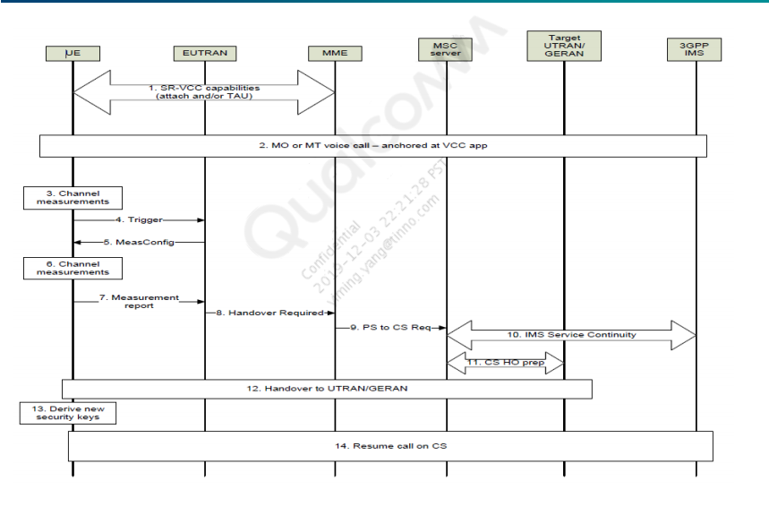

Negotiating SRVCC/UE capabilities

▪ SRVCC capability has to be negotiated between the UE and MME in the

following scenarios: During the attach procedure, the UE specifies that it is

SRVCC-capable and MME lets eNodeB know that SRVCC is possible.

▪ Tracking area update – The UE specifies that it is SRVCC-capable and MME

notifies eNodeB that SRVCC is possible.

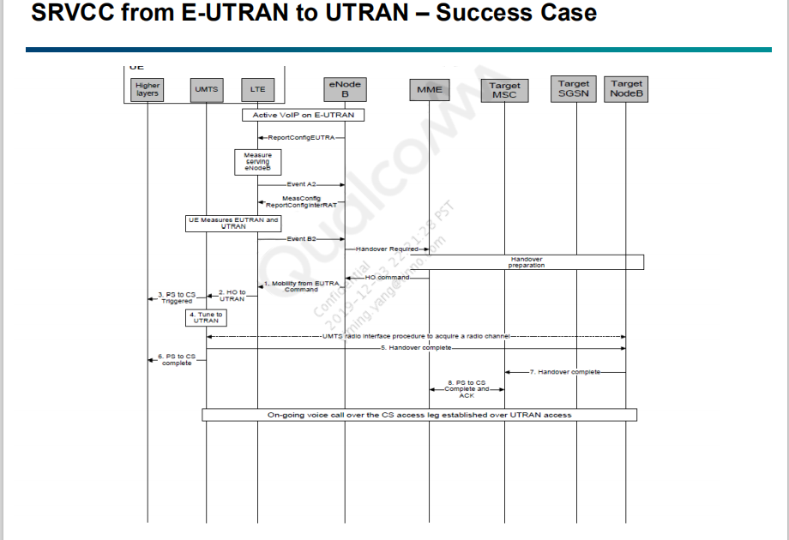

A VoIP call is ongoing on E-UTRAN.

An inter-RAT handover trigger condition has been met (event B1 or B2).

eNodeB sends the Mobility from the E-UTRA command and the UE

moves to the new RAT. 4.

The UE receives the handover from the E-UTRA command. LTE

forwards the handover to the UTRAN command to the UMTS protocol.

A notification is sent to the higher layers that SRVCC handover has

started.

The UE tunes to the UTRAN frequency as specified in the HO to

UTRAN command.

After the radio interface procedure for acquiring a new channel has

been completed, the UE sends a “Handover Complete” message to

NodeB

Higher layers are notified that handover is complete (voice call over CS

can be resumed after this step). .

Target NodeB notifies MSC that handover is complete.

MSC notifies MME that handover is complete.

关键log

017 Jan 12 12:33:12.291 [0B] 0xB0ED LTE NAS EMM Plain OTA Outgoing Message -- Attach request Msg

pkt_version = 1 (0x1)

rel_number = 9 (0x9)

rel_version_major = 5 (0x5)

rel_version_minor = 0 (0x0)

security_header_or_skip_ind = 0 (0x0)

prot_disc = 7 (0x7) (EPS mobility management messages)

msg_type = 65 (0x41) (Attach request)

lte_emm_msg

emm_attach_request

tsc = 0 (0x0) (cached sec context)

nas_key_set_id = 4 (0x4)

att_type = 2 (0x2) (combined EPS/IMSI attach)

.

.

.

.

.

SRVCC to GERAN/UTRAN capability = 1 (0x1)

EPC capability = 1 (0x1)

voice_domain_pref_incl = 1 (0x1)

voice_domain_pref

length = 1 (0x1)

UE_usage_setting = 0 (0x0) (Voice centric)

voice_domain_pref_for_EUTRAN = 3 (0x3) (IMS PS Voice preferred, CS Voice as secondary)

dev_properties_incl = 0 (0x0)

old_guti_incl = 1 (0x1)

old_guti

guti_type = 0 (0x0) (Native GUTI)

ms_network_feature_incl = 1 (0x1)

ms_network_feature_support

ext_periodic_timers = 1 (0x1)

network_resource_id_container_incl = 0 (0x0)

t3324_incl = 0 (0x0)

t3412_ext_incl = 0 (0x0)

ext_drx_par_incl = 0 (0x0)

2017 Jan 12 12:38:47.907 [AD] 0xB0C0 LTE RRC OTA Packet -- UL_DCCH / MeasurementReport

Pkt Version = 12

RRC Release Number.Major.minor = 11.7.4

Radio Bearer ID = 1, Physical Cell ID = 2

Freq = 1374

SysFrameNum = N/A, SubFrameNum = 0

PDU Number = Invalid Channel Message, Msg Length = 8

SIB Mask in SI = 0x00

}

}

Interpreted PDU:

value UL-DCCH-Message ::=

{

message c1 : measurementReport :

{

criticalExtensions c1 : measurementReport-r8 :

{

measResults

{

measId 14,

measResultPCell

{

rsrpResult 50,

rsrqResult 33

},

measResultNeighCells measResultListUTRA :

{

{

physCellId fdd : 395,

measResult

{

utra-RSCP 85,

utra-EcN0 30

}

}

}

}

}

2017 Jan 12 12:38:48.484 [69] 0x412F WCDMA Signaling Messages -- UL_DCCH Handover To UTRAN Complete

Subscription ID = 2

Channel Type = UL_DCCH, Radio Bearer ID = 2, Uarfcn = N/A, Psc = N/A, Message Length = 8

Interpreted PDU:

value UL-DCCH-Message ::=

{

message handoverToUTRANComplete :

{

startList

{

{

cn-DomainIdentity cs-domain,

start-Value '00000000 00000000 0010'B

},

{

cn-DomainIdentity ps-domain,

start-Value '00000000 00000001 0110'B

}

},

count-C-ActivationTime 96

}

}

2017 Jan 12 12:38:48.273 [4A] 0xB0C0 LTE RRC OTA Packet -- DL_DCCH / MobilityFromEUTRACommand

Pkt Version = 12

RRC Release Number.Major.minor = 11.7.4

Radio Bearer ID = 1, Physical Cell ID = 2

Freq = 1374

SysFrameNum = N/A, SubFrameNum = 9

PDU Number = Invalid Channel Message, Msg Length = 225

SIB Mask in SI = 0x00

Interpreted PDU:

value DL-DCCH-Message ::=

{

message c1 : mobilityFromEUTRACommand :

{

rrc-TransactionIdentifier 0,

criticalExtensions c1 : mobilityFromEUTRACommand-r8 :

{

cs-FallbackIndicator FALSE,

purpose handover :

{

targetRAT-Type utra,

targetRAT-MessageContainer nas-SecurityParamFromEUTRA '09'H

}

}

}

}

## EVS

Enhanced Voice Services (EVS) is a super wideband speech audio

coding standard. It offers up to 20 kHz audio bandwidth and has high

robustness to delay jitter and packet losses.

▪ EVS has been developed by 3GPP and is described in 3GPP TS 26.441.

▪ EVS can be used to enhance telephony and teleconferencing, audiovisual

conferencing services, and streaming audio.

The following table depicts how EVS compares with other audio codecs.

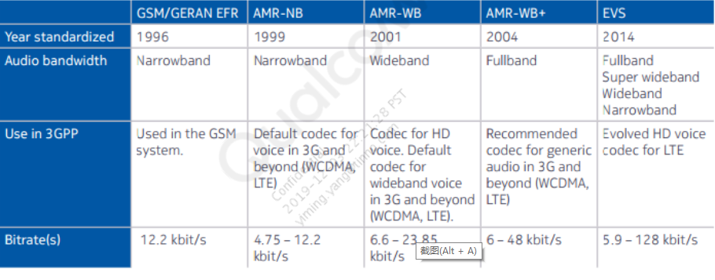

3GPP has standardized a new codec for EVS. The EVS codec is the

successor to the HD mobile voice codec AMR-WB.

▪ EVS provides full interoperability with HD voice.

▪ EVS offers cutting-edge performance that exceeds the capabilities of

other codec standards from ITU-T, IETF, and 3GPP.

▪ EVS excels with high audio quality for speech and music, outstanding

compression efficiency, and superior robustness against transmission

impairments.

▪ All of these characteristics are essential for mobile operators seeking to

deliver cost-effective mobile services and achieve long-term business

success. Compared to HD voice, the EVS codec provides substantially

improved quality at similar bit rates, and unprecedented quality at higher

bit rates.

▪ EVS significantly improves network capacity while maintaining the same

quality as HD voice.

▪ MO Invite for EVS

EVS Log Analysis

2017 Jul 21 06:02:51.240 [89] 0x156E IMS SIP Message --

IMS_SIP_INVITE/INFORMAL_RESPONSE

Version = 1

Direction = UE_TO_NETWORK

SDP Presence = 1

SIP Call ID Length = 35

SIP Message Length = 2551

SIP Message Logged Bytes = 2552

Message ID = IMS_SIP_INVITE

……………………….

m=audio 50056 RTP/AVP 126 104 102 105 96

b=AS:50

b=RS:600

b=RR:2000

a=rtpmap:126 EVS/16000/1

a=fmtp:126 evs-mode-switch=1;br=9.6-24.4;bw=swb;ch-aw-recv=1;max-red=0

2017 Jul 13 05:26:33.640 [7E] 0x156E IMS SIP Message --

IMS_SIP_INVITE/SESSION_PROGRESS

Version = 1

Direction = NETWORK_TO_UE

SDP Presence = 1

SIP Call ID Length = 57

SIP Message Length = 1298

SIP Message Logged Bytes = 1299

Message ID = IMS_SIP_INVITE

Response Code = SESSION_PROGRESS (183)

……

a=rtpmap:126 EVS/16000/1

a=fmtp:126 evs-mode-switch=1; br=9.6-24.4; bw=swb; ch-aw-recv=1; max-red=0

a=rtpmap:105 telephone-event/16000

a=fmtp:105 0-15

a=sendrecv

a=maxptime:240

a=ptime:20

# Wi-Fi Calling

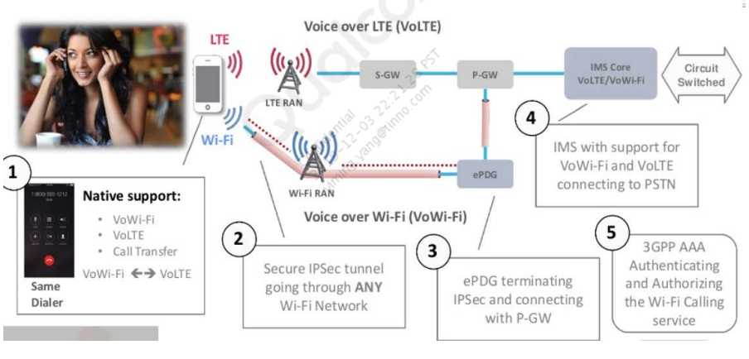

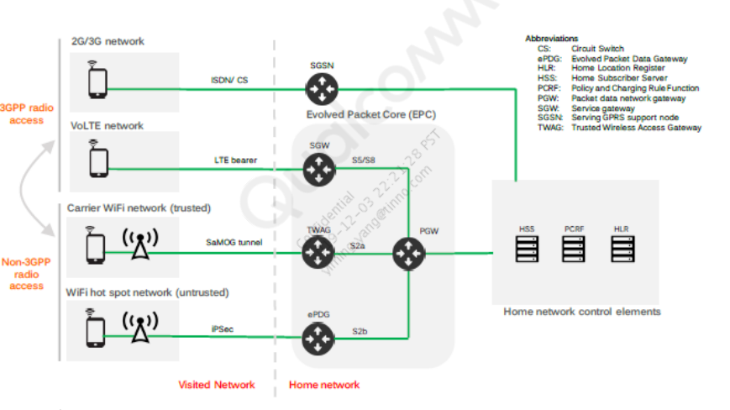

▪ Wi-Fi is referred to as Non 3GPP Access. There are two types of Non

3GPP Access Networks:

▪ Trusted: Access Network was introduced along with the LTE standard in 3GPP

Release 8 (2008). The AN is connected directly to the Packet Gateway (PGW).

The access network is controlled directly by the operator and the devices

(actual Wi-Fi hotspots) can be trusted from the security point of view.

▪ Untrusted: Access Network is even older – described in the Release 6 (2006).

In this case, the WLAN is not under control of the operator or it is not

considered to be secure enough. Such a network is connected via Evolved

Packet Data Gateway (ePDG) which provides extra security.

▪ It is up to the operator to classify what ANs are trusted. There are

operators who treat all the Wi-Fi communication as Untrusted, even when

it originates from their own hotspots.

▪ The role of ePDG is to create an IPSec tunnel between the UE and the

ePC network

▪ Once the IPSec tunnel is established, the data goes directly to the PGW.

# IMS Registration and Call Over Wi-Fi

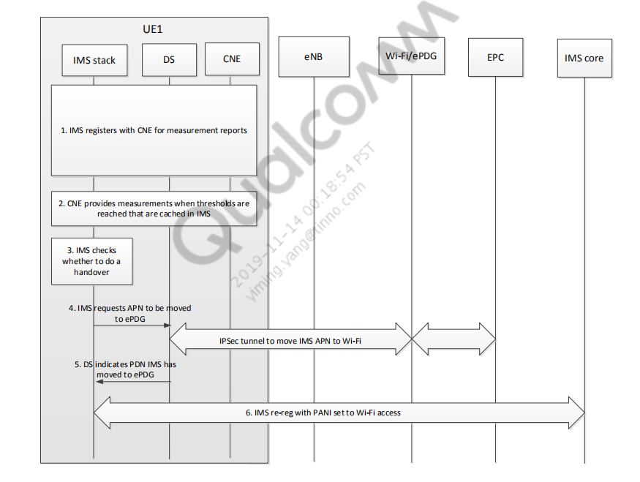

### **1. Wi-Fi available indication in DS is observed by filtering Messages > Data Services.**

[5006/0002] DS Protocol Services/High [ ds_mppm_cmd_hdlr.c 11492]

ds_mppm_cmd_process_mppm_dsd_event: Old DSD Preferred System Mask is

0x10000 Current DSD Preferred System Mask is 0x10010 wifi_avail 1

#### 2. IWLAN available indication comes to IMS- looked at by DPL.

[0051/0002] IMS/High [qpDcm.c 8296] qpDplProcessDSSysEvent: Iterating

DS Sys Info, pDSSysEvStruct->avail_sys[0].tech = 0, rat_value = 5,

so_mask = 400

//if we do not see 5 and only see c9, IWLAN might not have been enabled

using adb property

adb shell setprop persist.data.iwlan.enable true

#### 3. WFC and Wi-Fi preference per UE settings

[0051/0002] IMS/High PDPManager.cpp 2756] Initial GetPreferredRAT

preferredRAT[6], n_eRATMaskNew[82] OperatorMode[2] WFC[1]

Callmodepref[1]

[0051/0002] IMS/High [PDPHandler.cpp 1779]

CPDPHandler::HandleRatNotification - rat Mask[82] | This Instance

Value[1], wFCStatus[1],callModePreference[1]

[0051/0002] IMS/High [PDPManager.cpp 2800] GetPreferredRAT Preferred

RAT 6

// WFC and network preference taken into account to decide on which RAT

Registration is needed

**4. DPL informs all IMS registered clients about RAT availability (RM, PM, QIPcall, and so on).**

**5. RM decides if RAT is valid for IMS registration.**

**6. DPL reports Wi-Fi quality, and based on it, states if registration is possible on IWLAN.**

[0051/0001] IMS/Medium [ qpDplHandOver.c 5678]

qpDplWiFiMeasurementsSetParamEx: Received START Command

[0051/0002] IMS/High [ PDPManager.cpp 3360] StartRATMeasurements

Current HO state 1 New Src Rat 0 Target Rat 6

[10371/0000] QCNEA WQE CQE/Low [ CQEngine.cpp 627]

alpha:0.000000 avgRSSI:-24.000000 currRSSI:-24

[10371/0001] QCNEA WQE CQE/Medium [ CQEngine.cpp 1798] Notify

CQE Result (BAD:false/GOOD:true) : true, Reason = CQ_CC_MAC_METRICS,

Current Avg RSSI(dbm): -24.000000 and Prev Avg RSSI(dbm): -24.000000

[0051/0003] IMS/Error [ qpDplHandOver.c 5970]

DplHOConvertReportToQuality -- [Debug] iWiFiQual GOOD

[0051/0002] IMS/High [ qpDplHandOver.c 2257] IsHandOverPossible:

TRAT is GOOD, SRAT is BAD but TRAT NOT Preferred: Override PrefRAT:

HandOver is POSSIBLE.. notifying APP

//Registration will be triggered over IWLAN only if WIFI is Good

quality. If WiFI is BAD quality IWLAN will not be considered valid RAT

for Registration

#### 7. PDP is triggered to be activated on IWLAN.

[0051/0002] IMS/High [qpDcm.c 7515] qpDcmEstablishPDPConnection |

pDcmProfile=834ea440 dsAppID=54

[6052/0002] IMS DPL/High [qpDcm.c 7538] qpDcmEstablishPDPConnection -

APNName --> ims, Resolved APN -->

#### 8. ePDG tunnel is established.

Data Services logs

[5000/0001] Data Services/Medium [DSS_NetDSAPI.cpp 563]

dss_pppopen(): app_id 54

[5006/0002] DS Protocol Services/High [ds_iwlan_s2b_pdn_sm.c 193]

1364 SM 0. Processing DS_IWLAN_S2B_PDN_SM_WLAN_PROXY_IFACE_UP_EV in

state DS_IWLAN_S2B_PDN_SM_TRANSPORT_C

[5006/0002] DS Protocol Services/High [ds_iwlan_s2b_pdn_sm.c 193]

1971 SM 0. Processing DS_IWLAN_S2B_PDN_SM_TUNNEL_PRE_CONFIG_COMPLETE_EV

in state DS_IWLAN_S2B_PDN_SM_TUNN

[5006/0002] DS Protocol Services/High [ds_iwlan_s2b_pdn_sm.c 193]

2279 SM 0. Processing DS_IWLAN_S2B_PDN_SM_TUNNEL_UP_EV in state

DS_IWLAN_S2B_PDN_SM_TUNNEL_CONFIGURING_ST

[5006/0002] DS Protocol Services/High [ds_iwlan_s2b_pdn_sm.c 193]

2920 SM 0. Processing DS_IWLAN_S2B_PDN_SM_SIO_CONFIG_COMPLETE_EV in

state DS_IWLAN_S2B_PDN_SM_SIO_CONFIGU

[5006/0002] DS Protocol Services/High [ds_iwlan_s2b_pdn_sm.c 193]

3247 SM 0. Processing DS_IWLAN_S2B_PDN_SM_RM_UP_EV in state

DS_IWLAN_S2B_PDN_SM_RM_CONFIGURING_STATE.

[5006/0002] DS Protocol Services/High [ds_iwlan_s2b_pdn_sm.c 193] 680

SM 0. Entering DS_IWLAN_S2B_PDN_SM_NET_UP_STATE state from state

DS_IWLAN_S2B_PDN_SM_RM_CONFIGURING_S

Filter: iwlan_s2b

Security logs [Message Packets -> Security]

[5503/0002] Security/Internet Protocol Security/High

[ secips_ikesainit.c 916] Sending IKESAINIT Req msg1

[5503/0002] Security/Internet Protocol Security/High

[ secips.c 2188] IPSEC SA ESTABLISHED

// SA establishes will indicate tunnel successful establishment

**1. IMS registers with CNE for measurement reports.**

20:01:21.603 qpDplHandOver.c 04695 qpDplWiFiMeasurementsSetParamEx: Received START Command

20:01:21.603 qpDplHandOver.c 04628 DplHandOverSetCNEProfileForMetrics - Profile Mask set by

IMS --> 0x000000000000000f | DS mask --> 0x4f646e61486c704

**2. CNE provides measurements when thresholds are reached that are cached in IMS. ▪**

**The CNE event comes via DS Sys events.**

20:01:31.604 qpDcm.c 11242 qpDplProcessCommonDSSysEvents: CNE_PROFILE_MET Mask --> 0x0

▪

HOAlgoFlavor represents the algorithm type that is in use.

▪

1 – VzW

▪

0 – Other

20:01:31.605 qpDplHandOver.c 04928 DplHandOverProcessCNEReport - HOAlgoFlavor -->1

**3.The UE checks whether a handover is possible. In the example below, handover is**

**not possible, as indicated by HO possible = 0.**

srat = source rat trat = target rat

▪

LTE – 10

▪

iWLAN – 6

20:01:31.605 qpDplHandOver.c 03641 IsHandOverPossible: current srat = 10 trat= 6 prefrat = 10

20:01:31.605 qipcalliface_ho_mgr.c 03417 qipcalliface_process_handover_measurement_cb: SRAT = 10, TRAT = 6, pHOStatus-

>bIsHOPossible 0 ===>

20:01:31.607 qipcalliface_ho_mgr.c 02271 qipcalliface_is_wwan_iwlan_handover_required: current system = 1, HO possible = 0,

**IMS checks whether to do a handover.**

**Here a RAT change triggers IMS to check**

**SRAT 0 => source RAT indicates no RAT, meaning LTE is lost**

20:03:04.463 qipcalliface_ho_mgr.c 03172 qipcalliface_is_wwan_iwlan_measurement_params_changed: HO params changed

SRAT 0, TRAT 6, PrefRAT = 10

20:03:04.464 qpDplHandOver.c 03641 IsHandOverPossible: current srat = 0 trat= 6 prefrat = 10

**IMS determines handover is possible and the preferred system to handover to based on the**

**metrics.**

HO possible = 1 => handover is possible

▪

pref system 2 => preferred system is iWLAN

20:03:04.465 qipcalliface_ho_mgr.c 02271 qipcalliface_is_wwan_iwlan_handover_required: current system = 1, HO possible

= 1, pref system 2

**4. IMS requests the APN to be moved to ePDG.**

Preferred sys:

▪

0 – WWAN

2 – IWLAN

20:03:04.465 qipcalliface_ho_mgr.c 00374 qipcalliface_set_APN_pref_sys: Handover requested to preffered sys 2

20:03:04.465 qipcalliface_ho_mgr.c 00920 qipcalliface_perform_handover_management : HO

conditions changed. Initiate HO to sys 2

HO conditions changed. Initiate HO to sys 2

**5. IPSec Tunnel to move IMS PDN to Wi-Fi**

// SNI or PPPOPEN

01:43:20.009 ps_route.c 3032 ps_route_bring_up_iface_by_policy_ex(): DEBUG POLICY: flag=0 lookup_only=0 bring_up=1

01:43:20.009 ps_route.c 3037 ps_route_bring_up_iface_by_policy_ex(): DEBUG POLICY: family=4 iface.kind=1

iface.id/name=0x00000001

// MPPM decides the pref rat RADIO per APN request

01:43:20.065 ds_mppm.c 3479 ds_mppm_get_pref_rat_and_lte_attach_cap_for_apn_string: MPPM calculated pref_rat

RADIO_IWLAN, is_lte_attach_allowed 0 for apn_string vzwadmin

01:43:20.065 ds_mppm.c 4600 ds_mppm_get_pref_rat_for_apn_string: MPPM calculated pref_rat RADIO_IWLAN,

is_lte_attach_allowed 0 for apn_string vzwadmin

// reverse ip transport (0x8021) configuration on wlan proxy interface

01:43:20.669 ds_wlan_proxy_mode_hdlr.c 82 ds_wlan_proxy_get_cb_ptr_from_iface_ptr from iface: 0x8020::0

01:43:20.669 ds_wlan_proxy_rev_ip_xport_if.c 262 rev IP transport wds onfig complete for IFACE 0x8020:0, Posting Rev IP

xport wds config complete cmd to DS

01:43:20.669 ds_wlan_proxy_mode_hdlr.c 575 ds_wlan_proxy_process_rev_ip_xport_wds_config_complete for

instance_id:0

// WLAN proxy (0x8020::0) interface is up

01:43:20.669 ds_wlan_proxy_mh_sm.c 1054 DS_WLAN_PROXY_SM: SM id:0 proc_rm_config_complete_ev_in_rm_config

01:43:20.669 ds_wlan_proxy_mh_sm.c 1058 Processing WLAN_PROXY_RM_CONFIG_COMPLETE_EV event in state

WLAN_PROXY_SM_STATE_RM_CONFIG

01:43:20.669 ds_wlan_proxy_mh_sm.c 1063 Moving to state WLAN_PROXY_SM_STATE_NET_UP

01:43:20.669 ds_wlan_proxy_mh_sm.c 1299 DS_WLAN_PROXY_SM: SM id:0 Entering NET_UP state

01:43:20.669 ds_wlan_proxy_mh_sm.c 1303 Entering WLAN_PROXY_SM_STATE_NET_UP state from state

WLAN_PROXY_SM_STATE_RM_CONFIG

// IKEv2 tunnel configuration

01:43:20.670 ds_iwlan_s2b_pdn_sm.c 593

SM 0. Processing

DS_IWLAN_S2B_PDN_SM_WLAN_PROXY_IFACE_UP_EV in state DS_IWLAN_S2B_PDN_SM_CLOSED_STATE.

01:43:20.670 ds_iwlan_s2b_pdn_sm.c 458

Entering DS_IWLAN_S2B_PDN_SM_TUNNEL_CONFIGURING_STATE

state from state DS_IWLAN_S2B_PDN_SM_CLOSED_STATE

01:43:20.671 ds_iwlan_s2b_pdn_sm.c 797

In ds_iwlan_s2b_pdn_sm_enter_tunnel_configuring_state: pdn_cb_ptr

0x8b70c748, ikev2_cb_ptr 0x8b7156a0.

// secips_bring_up_tunnel

01:43:20.674 secips.c

534

secips_bring_up_tunnel: ENTER

01:43:20.674 secips.c

600

secips_bring_up_tunnel:Running switch SECIPSSP_KEY_MGMT_IKEV2

01:43:20.679 ds_iwlan_s2b_ikev2_hdlr.c 2248 secips_bring_up_tunnel returned 0

01:43:21.949 secips.c 1889 IKEv2 SA established

// IKEv2 tunnel is up

01:43:23.130 ds_iwlan_s2b_pdn_sm.c 856

SM 0. Processing DS_IWLAN_S2B_PDN_SM_TUNNEL_UP_EV in state

DS_IWLAN_S2B_PDN_SM_TUNNEL_CONFIGURING_STATE.

01:43:23.130 ds_iwlan_s2b_pdn_sm.c 458

Entering DS_IWLAN_S2B_PDN_SM_SIO_CONFIGURING_STATE state

from state DS_IWLAN_S2B_PDN_SM_TUNNEL_CONFIGURING_STATE

// reverse ip transport (0x8021) configuration completed

01:43:23.130 ds_iwlan_s2b_rev_ip_xport.c

234

rev_ip_transport_bringup for iface 0x8c172360 returned 0

01:43:23.130 ds_iwlan_s2b_rev_ip_xport.c

234

rev_ip_transport_bringup for iface 0x8c172360 returned 0

01:43:23.130 ds_iwlan_s2b_pdn_sm.c 1122

SM 0. Processing

DS_IWLAN_S2B_PDN_SM_SIO_CONFIG_COMPLETE_EV in state DS_IWLAN_S2B_PDN_SM_SIO_CONFIGURING_STATE

// PDN connection is up on s2b/epdg interface

01:43:26.428 ds_iwlan_s2b_pdn_sm.c 1364

SM 0. Processing DS_IWLAN_S2B_PDN_SM_RM_UP_EV in state

DS_IWLAN_S2B_PDN_SM_RM_CONFIGURING_STATE.

01:43:26.428 ds_iwlan_s2b_pdn_sm.c 458

Entering DS_IWLAN_S2B_PDN_SM_NET_UP_STATE state from state

DS_IWLAN_S2B_PDN_SM_RM_CONFIGURING_STATE

01:43:26.428 ds_iwlan_s2b_iface_hdlr.c 1120

ds_iwlan_s2b_iface_is_in_use. iface ptr 0x8c172360 is valid: 1 pdn cb

ptr 0x8b70c748

01:43:26.428 ds_iwlan_s2b_pdn_sm.c 1532

ds_iwlan_s2b_pdn_sm_enter_net_up_state.v4 iface in use. move iface

and phys link to up

// IPv4 interface is up

01:43:26.428 ds_iwlan_s2b_pdn_sm.c 1532

ds_iwlan_s2b_pdn_sm_enter_net_up_state.v4 iface in use. move iface

and phys link to up

01:43:26.428 ps_phys_linki_event.c

1007

ps_phys_link_up_ind_ex(): PHYS LINK UP IND 0x8C1730D8, state 64

01:43:26.429 ps_ifacei_event.c

2243

ps_iface_up_ind(): IFACE UP IND 0x8021:0, state 8

// IPv6 interface is up

01:43:26.429 ds_iwlan_s2b_pdn_sm.c 1551

In ds_iwlan_s2b_pdn_sm_enter_net_up_state: v6 iface in use. move

iface and phys link to up

01:43:26.429 ps_phys_linki_event.c

1007

ps_phys_link_up_ind_ex(): PHYS LINK UP IND 0x8C174000, state 64

01:43:26.430 ps_ifacei_event.c

2243

ps_iface_up_ind(): IFACE UP IND 0x8021:1, state 8

**6. DS indicates to IMS that the handover is complete and successful.**

20:03:07.697 PDPRATHandlerVoLTE.cpp 01981 EventHOSuccess HORat:6 currRAT:10 RegType[0]

20:03:07.697 PDPRATHandlerVoLTE.cpp 01988 EventHOSuccess raise event RegType[0]

**7. IMS initiates REGISTRATION with the PANI header set to Wi-Fi access.**

20:03:07.741 sipConnection.cpp 03067 EVENT_SIP_REG_REQ_SENT: 43 Code = 0 RAT = 6

20:03:07.742 sipConnection.cpp 03823 EVENT_SIP_REQUEST_SEND: REGISTER sip:test.3gpp.com SIP/2.0

f: <sip:+11234567890@test.3gpp.com>;tag=41

P-Access-Network-Info: IEEE-802.11; i-wlan-node-id=000102030405 <= PANI header from PCAP

20:03:07.855 qimfsiplib.cpp 04727 EVENT_SIP_MESSAGE_RECV:SIP/2.0 200 OK

Call-ID: 4150057853_1511000824@fc01:bbbb:cdcd:efe0:d867:adb

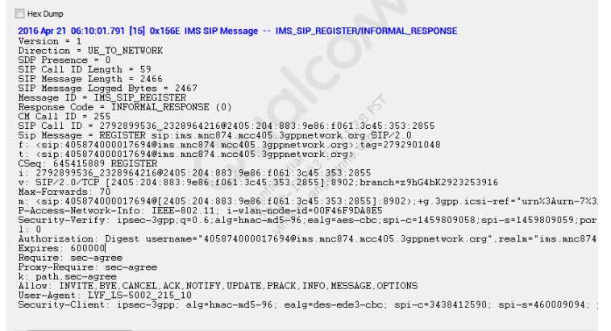

## Handover During Active Call

### 1618477562(1)

Steps 1 and 2 are identical to the Handover During Idle Call scenario in that CNE must be configured for the measurements to take, and periodically IMS gets measurement results via DS Sys events.

**3. MO/MT VT call is established.**

**4. IMS determines whether to do a handover after the call is connected.**

InCall = 1 → Call is ongoing.

CallType 2 → VT call.

20:00:51.712 qipcalliface_ho_mgr.c 03171 qipcalliface_is_wwan_iwlan_measurement_params_changed: HO params

changed SRAT 10, TRAT 6, PrefRAT = 10

20:00:51.713 qpDplHandOver.c 04406 qpDplHandOverParamsSet: Old Pref RAT = 10 New Pref RAT = 10

20:00:51.713 qpDplHandOver.c 04407 qpDplHandOverParamsSet: Old InCall = 0 New Incall = 1

20:00:51.714 qpDplHandOver.c 04430 qpDplHandOverParamsSet: InCall --> 1

20:00:51.714 qpDplHandOver.c 04431 qpDplHandOverParamsSet: CallType --> 2

20:00:51.715 qipcalliface_ho_mgr.c 03416 qipcalliface_process_handover_measurement_cb: SRAT = 10,

TRAT = 6, pHOStatus->bIsHOPossible 1

IMS determines handover is possible and the preferred system to handover to based on measurements.

HO possible = 1 and pref system 2 = iWLAN

20:00:52.012 qipcalliface_ho_mgr.c 02270 qipcalliface_is_wwan_iwlan_handover_required: current system = 1,

HO possible = 1, pref system 2

20:00:52.012 qipcalliface_ho_mgr.c 00373 qipcalliface_set_APN_pref_sys:

Handover requested to preferred sys 2

20:00:52.012 qipcalliface_ho_mgr.c 00919 qipcalliface_perform_handover_management :

HO conditions changed. Initiate HO to sys 2

Steps 5 – 7 are the same as steps 4 – 6 of Handover During Idle State, with the following additional step sequence which involves the RTP stream for video being handed over.

RTP handover is initiated to sys 2, which is iWLAN

20:00:52.014 qipcalliface_ho_mgr.c 00373 qipcalliface_set_APN_pref_sys: Handover requested to preffered sys 2

20:00:52.014 qipcalliface_ho_mgr.c 00919 qipcalliface_perform_handover_management : HO conditions changed. Initiate HO to sys 2

20:00:34.375 [IMS_AP] qpDplVideo.c 03940 | 1408 |DPL qpRTPVideoHandoverStatusInfo : 1

20:00:34.375 [IMS_AP] qpDplVideo.c 03964 | 1408 |DPL qpRTPVideoHandoverStatusInfo sent to qvpRTPIPCMessageToApp- SUCCESS

▪

#### RTP handover is successful

20:00:38.685 [IMS_AP] qpDplVideo.c 03940 | 1408 |DPL qpRTPVideoHandoverStatusInfo : 2

20:00:38.685 [IMS_AP] qpDplVideo.c 03964 | 1408 |DPL qpRTPVideoHandoverStatusInfo sent to qvpRTPIPCMessageToApp- SUCCESS

8. Handover to LTE takes place upon loss of Wi-Fi or poor Wi-Fi conditions.

Handover determination in this case is triggered by a RAT change.

SRAT 0 => source RAT indicates no RAT, which means Wi-Fi is lost.

20:02:42.485 qipcalliface_ho_mgr.c 03171 qipcalliface_is_wwan_iwlan_measurement_params_changed: HO params changed SRAT 0, TRAT 10, PrefRAT = 10

20:02:42.485 qipcalliface_ho_mgr.c 03416 qipcalliface_process_handover_measurement_cb: SRAT = 0, TRAT = 10, pHOStatus->bIsHOPossible 1 ===>

20:02:42.486 qipcalliface_ho_mgr.c 02270 qipcalliface_is_wwan_iwlan_handover_required: current system = 3, HO possible = 1, pref system 0

20:02:42.486 qipcalliface_ho_mgr.c 00373 qipcalliface_set_APN_pref_sys: Handover requested to preffered sys 0

20:02:42.486 qipcalliface_ho_mgr.c 00919 qipcalliface_perform_handover_management : HO conditions changed. Initiate HO to sys 0

▪

RTP handover is initiated to RAT 10, which is LTE.

20:02:24.981 [IMS_AP] qvp_rtp_app_cmd.c 12363 | 1408 |qvp_rtp_set_handoff_status_cmd rat_type = 10 HO_status: 1

20:02:24.981 [IMS_AP] qvp_rtp_app_cmd.c 12368 | 1408 |QVP_RTP_HO_INIT in app cmd sending 1

20:02:24.981 [IMS_AP] qpDplVideo.c 03940 | 1408 |DPL qpRTPVideoHandoverStatusInfo : 1

20:02:24.981 [IMS_AP] qpDplVideo.c 03945 | 1408 |DPL QVP_RTP_HO_INIT

▪

#### RTP handover is successful

20:02:26.726 [IMS_AP] qpDplVideo.c 03940 | 1408 |DPL qpRTPVideoHandoverStatusInfo : 2

20:02:26.727 [IMS_AP] qpDplVideo.c 03964 | 1408 |DPL qpRTPVideoHandoverStatusInfo sent to qvpRTPIPCMessageToApp- SUCCESS

9. DS indicates that handover is successful.

20:02:44.393 PDPRATHandlerVoLTE.cpp 01971 EventHOSuccess HORat:10 currRAT:6 RegType[0]

20:02:44.393 PDPRATHandlerVoLTE.cpp 01978 EventHOSuccess raise event RegType[0]

▪

RTP handover is successful

20:02:26.726 [IMS_AP] qpDplVideo.c 03940 | 1408 |DPL qpRTPVideoHandoverStatusInfo : 2

20:02:26.727 [IMS_AP] qpDplVideo.c 03964 | 1408 |DPL qpRTPVideoHandoverStatusInfo sent to qvpRTPIPCMessageToApp- SUCCESS

10. IMS initiates REGISTRATION with the PANI header set to LTE access.

20:02:44.432 sipConnection.cpp 03063 EVENT_SIP_REG_REQ_SENT: 43 Code = 0 RAT = 10

20:02:44.433 sipConnection.cpp 03823 EVENT_SIP_REQUEST_SEND: REGISTER sip:test.3gpp.com SIP/2.0

f: <sip:+11234567890@test.3gpp.com>;tag=16

P-Access-Network-Info: 3GPP-E-UTRAN-FDD; utran-cell-id-3gpp=311480000B0038000 <= PANI from PCAP

20:02:44.541 qimfsiplib.cpp 04736 EVENT_SIP_MESSAGE_RECV:SIP/2.0 200 OK

Call-ID: 1644419514_2865829720@fc01:bbbb:cdcd:efe0:7ce8:750

## Vowifi issue

#### ▪ IWLAN is not configured as valid IMS RAT.

To check the issue from the logs, apply log filter: EventChangeRAT

As shown in following sample prints, 0x40 should be present in ServiceOnRatMask bitmask. (0x400 – LTE, 0x40 – IWLAN)

▪

Failure case:

PDPManager.cpp 1145

EventChangeRat

-

ServiceOnRatMask = 0x00000400, new RAT mask = 0x00000040:

PDPManager.cpp 1146

EventChangeRat

- New RAT is 6 and is valid: 0

▪

Pass case:

PDPManager.cpp 1145

EventChangeRat

-

ServiceOnRatMask

= 0x00000440, new RAT mask = 0x00000040:

PDPManager.cpp 1146

EventChangeRat

- New RAT is 6 and is valid: 1

PDPManager.cpp 00356 CPDPManager::EventChangeRat - ServiceOnRatMask = 0x00000640, new RAT mask = 0x00000440:

PDPManager.cpp 00357 CPDPManager::EventChangeRat - New RAT is valid: 1

▪

Checkpoint: See KBA_for_wifi_configuration_from_AP_setting_mode_preference (KBA-180123010432) for VoWiFi configuration

and use QTI provided carrier MBN (if available).

#### ▪ Wi-Fi calling is OFF.

▪

To check the issue from the logs, apply log filter: Wi-Fi settings WFC status

(WFC status: 2 = OFF, 1 = ON) (callmodePreference: 1 = Wi-Fi preferred, 3 = cellular preferred)

▪

Failure case:

PDPManager.cpp 2373 GetPreferredRAT Wifi settings WFC status[2] callmodePreference[3] performMeasurements[1]

▪

Pass case:

PDPManager.cpp 2373 GetPreferredRAT Wifi settings WFC status[1] callmodePreference[1] performMeasurements[1]

▪

Checkpoint: See KBA_for_wifi_configuration_from_AP_setting_mode_preference (KBA-180123010432) for VoWiFi configuration.

#### WLAN offload NV is not enabled.

To check the issue from the logs, apply filter: qpDcmGetServingSystem, ds_mppm_update_wifi_and_iwlan_availability

▪

If this NV is not set to 2, IMS does not receive IWLAN RAT (5) indication, which results in VoWiFi not being registered.

rat_value = IWLAN(5), LTE (3), WLAN srv_status: 2 (enable)

▪

//In this example, IMS is receiving IWLAN (5) and LTE (3) RAT indications

12:53:58.597 qpDcm.c 8959 H qpDcmGetServingSystem: Iterating DS Sys Info, rat_value = 3, so_mask = 1000

12:53:58.597 qpDcm.c 8959 H qpDcmGetServingSystem: Iterating DS Sys Info, rat_value = c9, so_mask = 0

12:53:58.597 qpDcm.c 8959 H qpDcmGetServingSystem: Iterating DS Sys Info, rat_value = 5, so_mask = 400

▪

//In this example, iwlan_s2b_usability_mask 0x123 means DS_MPPM_WLAN_OFFLOAD_NV_MASK is not set .

ds_mppm_cmd_hdlr.c 03046 ds_mppm_update_wifi_and_iwlan_availability: subs id 1 dsd_mask before update = 0x0

WLAN srv_status = 2 iwlan_s2b_usability_mask 0x123

▪

Checkpoint: Ensure that NV70315 is set to 2 and appropriate MBN is used. For other ePDG parameter usage, see WLAN Offload Via S2B Provisioning (80-NP263-1).

#### AP/UI setting WFC OFF and changing Wi-Fi calling settings.

To check the issue from the logs, apply filter QMI log packet 0x1544

▪

As shown in the following sample prints, modem receives Wi-Fi calling settings.

▪

Wi-Fi calling disabled:

[0x1544] LOG 14:36:01.938 MCS QCSI Payload Packet Length: 0117

ims_settings_ims_service_enable_config_indTlvs[0] {

ims_settings_ims_service_enable_config_indTlvs[4] {

Type = 0x14

Length = 1

wifi_calling_enabled {

wifi_calling_enabled = false

}

▪

Setting call mode preference:

Call mode preference can be Wi-Fi only, cellular only, Wi-Fi preferred and cellular preferred.

ims_settings_get_ims_service_enable_config_rspTlvs

[6] {

Type = 0x16

Length = 4

call_mode_preference

} call_mode_preference { = IMS_SETTINGS_CALL_MODE_PREFERRED_CELLULAR

#### ▪ IWLAN system property is disabled.

▪ The following property should be enabled for VoWiFi registration.

▪

To check from logs, check whether the value is True or False in the following sample print in adb logs:

09:04:25.859 Linux Data/Medium [ netmgr_main.c 1269] property

[persist.vendor.data.iwlan.enable] value[false]

▪ Checkpoint: Ensure that the “persist.vendor.data.iwlan.enable” system property is enabled.

#### Wi-Fi RSSI threshold is not-met.

To check the issue from the logs, apply log filter: DplHOConvertReportToQuality|IsHandOverPossible:Final SRAT Quality

▪

Sample log snippets

//In this example, RSSI is not met for profile 2 and profile 3

MSG 02:30:22.150 IMS DPL/High [

qpDplHandOver

.

c

6362

]

qpDplConvertWQEStatusToMask

: [profile_1]

--

> [met][

error_none

]

MSG 02:30:22.150 IMS DPL/High [

qpDplHandOver

.

c

6362

]

qpDplConvertWQEStatusToMask

: [profile_2]

--

> [not

-

met][

cq_fail_rsi

] //<<

--

rssi

not met

MSG 02:30:22.150 IMS DPL/High [

qpDplHandOver

.

c

6362

]

qpDplConvertWQEStatusToMask

: [profile_3]

--

> [not

-

met][

cq_fail_rsi

] //<<

--

rssi

not met

MSG 02:30:22.150 IMS DPL/High [

qpDplHandOver

.

c

6362

]

qpDplConvertWQEStatusToMask

: [profile_4]

--

> [met][

error_none

]

▪

Checkpoint: These failures are seen when the configured RSSI threshold is not met. Ensure that the device is in good Wi-Fi conditions.

▪

#### MAC failures

▪

To check the issue from the logs, check the following MAC failure events for CNE profiles.

▪

Sample log snippets

MSG IMS DPL/High 11:45:04.690

[

qpDplHandOver

.c

6726]

qpDplConvertWQEStatusToMask

: [profile_1]

--

> [not

-

met][

cq_fail_mac

]

MSG IMS DPL/High 11:45:04.690

[

qpDplHandOver

.

c

6726]

qpDplConvertWQEStatusToMask

: [profile_2]

--

> [not

-

met][

cq_fail_mac

]

MSG IMS DPL/High 11:45:04.690

[

qpDplHandOver

.

c

6726]

qpDplConvertWQEStatusToMask

: [profile_3]

--

> [not

-

met][

cq_fail_mac

]

MSG IMS DPL/High 11:45:04.690

[

qpDplHandOver

.

c

6726]

qpDplConvertWQEStatusToMask

: [profile_4]

--

> [not

-

met][

cq_fail_mac

]

MSG IMS/Medium 11:45:04.690

[

qpDplHandOver

.c

5817]

DplHandOverProcessCNEReport

--

[Debug] iWiFiQual

BAD

▪

Checkpoint: MAC failures are seen when the local Wi-Fi environment is not good. Check for any congestion in the Wi-Fi setup/environment being

used.

Note: : SRAT means Source RAT. TRAT means Target RAT

#### DPD timeout

▪ To check the issue from the logs, look for the following error code in call end reason (720917 =

IKEV2_DPD_FAILURE)

▪ Sample log snippets

qpDcm.c 4916 H qpDcmProcessNetEvent - [202] event occurred for AppId [109] iFaceid [0x0]

qpDcm.c 6339 H qpDcmGetLastNetDownReason - Call end reason: 720917

▪ Checkpoint: DPD timeout is triggered when backhaul Internet connectivity is lost. Check if Wi-Fi AP backhaul is connected to Internet.  
  
**▪ The following are the frequently seen IWLAN IKEV2 failures while triggering VoWiFi registration.**

**▪ IKEV2 timeout (IKEV2_MSG_TIMEOUT = 720902)**

▪

This reason is returned when data call bringup fails in IKEV2 setup due to a timeout.

▪

To check the issue from the logs, apply log filter: qpDcmGetLastNetDownReason - Call end reason

▪

Sample prints:

IMS/High 22:21:25.398 qpDcm.c 05402 qpDcmGetLastNetDownReason - Call end reason: 720902

▪

Checkpoint: Check if you are able to browse Internet data.

▪ IKEV2 authorization failure (IKEV2_AUTH_FAILURE = 720901)

▪

This reason is returned when data call bringup fails in IKEV2 setup due to authentication failure configuration.

▪

To check the issue from the logs, apply log filter: qpDcmGetLastNetDownReason - Call end reason

▪

Sample prints:

IMS/High 22:21:25.398 qpDcm.c 05402 qpDcmGetLastNetDownReason - Call end reason: 720901

▪

**DNS resolution name failure (DNS_RESOLUTION_NAME_FAILURE = 720915)**

This reason is returned when data call bringup fails in retrieving the address from DNS.

▪

To check the issue from the logs, apply log filter: qpDcmGetLastNetDownReason - Call end reason

▪

Sample prints:

IMS/High 22:21:25.398 qpDcm.c 05402 qpDcmGetLastNetDownReason - Call end reason: 720915

▪

Checkpoint: Check if you are able to browse Internet data.

▪

**DNS resolution name failure** ▪

This reason is returned when data call bringup fails because there are multiple PDNs that are trying to come up on IWLAN on one ePDG

address and we have already received one or more IKEV2 failures.

To check the issue from the logs, apply log filter: qpDcmGetLastNetDownReason - Call end reason

Sample prints:

IMS/High 22:21:25.398 qpDcm.c 05402 qpDcmGetLastNetDownReason - Call end reason: 720911

MSG

[05000/01] Data

Services/Medium

02:08:19.748

ds_iwlan_s2b_pdn_sm.c 00703 ds_iwlan_s2b_pdn_sm_bri

ng_up_ev_in_closed_state: Block flag is set

MSG

[05000/01] Data

Services/Medium

02:08:19.748

ds_iwlan_s2b_iface_hdlr.c 01656 ds_iwlan_s2b_iface_

hdlr_move_iface_down: PS NET down reason : 0xb000f

▪

**Hysteresis timer running**

▪

To check the issue from the logs, apply log filter: bIsHOPossible|qipcalliface_override_pref_system_on_hysteresis_timers

▪

Sample log snippets

[0051/0002] | MSG | 07:43:36.247 | IMS/High | [

qipcalliface_ho_mgr.c 5828]

qipcalliface_process_handover_measurement_cb

: SRAT = 10, TRAT = 6,

pHOStatus->bIsHOPossible 1 ===>

|

[0051/0002] | MSG | 07:43:40.413 | IMS/High | [

qipcalliface_ho_mgr.c

3434]

qipcalliface_override_pref_system_on_hysteresis_timers

: epdg_wifi timer is running, stay on rat 2

|

[0051/0002] | MSG | 07:43:40.414 | IMS/High | [

qipcalliface_ho_mgr.c

3434]

qipcalliface_override_pref_system_on_hysteresis_timers

: epdg_wifi timer is running, stay on rat 2

|

▪

Back-off timer running

▪

To check the issue from the logs, apply log filter: qipcalliface_set_wwan_iwlan_handover_measurement_params|backoff

▪

Sample log snippets

[0051/0001] | MSG | 12:04:28.349 | IMS/Medium | 255 | RegInfo.cpp |

01942 | StartBackOffTimer -

Start iwlan back off timer |

[0051/0002] | MSG | 12:04:28.349 | IMS/High | 255 | RegInfo.cpp |

01936 | IsIwlanBackoffTimerRunning

- bRet = 1 |

[0051/0001] | MSG | 12:04:30.534 | IMS/Medium | 255 |

qipcalliface_ho_mgr.c

| 03681 |

qipcalliface_set_wwan_iwlan_handover_measurement_params

: backoff failure override

▪

Checkpoint: Both the timers mentioned are maintained to avoid the UE ping pong between the IWLAN and cellular RATs. Such

behavior is expected from the UE side. Customers are recommended to check why there is frequent RAT change.

**Source RAT is reported bad due to drop in signal strength.**

▪

To check the issue from the logs, apply log filter: DplHOConvertReportToQuality|IsHandOverPossible:|Final SRAT Quality

//LTE Quality RSRQ measurements reported to IMS. RSRQ is Bad here

MSG 08:27:07.130 IMS DPL/High [qpDplHandOver.c

929] Calculated New SNR value is 71.212502, RSRQ value is -179.957504

//SRAT Quality is BAD, TRAT Quality is GOOD. So HO is possible.

MSG 08:27:07.630 IMS/High [qpDplHandOver.c

2884] qpDplMetricReport: Final SRAT Quality --> 0 Final TRAT Quality

--> 1

//WiFi Quality GOOD

MSG 08:27:08.815 IMS/Error [qpDplHandOver.c

5884] DplHOConvertReportToQuality -- [Debug] iWiFiQual GOOD

//HO Triggered to preferred sys 2 means Wi-Fi.

MSG 08:27:13.687 IMS/High [qipcalliface_ho_mgr.c

1739] qipcalliface_set_APN_pref_sys:Handover requested to

preferred sys 2

//HO Success to RAT 6 means Wi-Fi

MSG 08:27:19.033 IMS/Error [PDPRATHandlerVoLTE.cpp 2579] EventHOSuccess HORat:6 currRAT:10 RegType[0] //<<-

-HORat:6

//HO Success

MSG 08:27:19.034 IMS/High [qipcalliface_ho_mgr.c

1542] qipcalliface_process_handover_events: eDcmRat = 6, eSRat

= 10, eTRat = 6

▪

Checkpoint: These failures are seen when configured SRAT thresholds are not met. Ensure that the device is in good signal conditions.

**Media metrics are reported bad**

▪

UE monitors media quality (TX/RX RTP stream) and declares that the media metrics are bad when jitter or packet loss is seen.

▪

To check the issue from the logs, look for the following failure prints

▪

Sample log snippets:

MSG 23:03:46.374 DS Real Time Transport Protocol/Error [qvp_rtp_app_cmd_svs.c 1612] metric kpi:computed metric -

jitter95pThr = 11 jitter95pAccpt = 14 jitter95pGood = 155

//Media Quality BAD due to jitter

MSG 23:03:46.374 DS Real Time Transport Protocol/High [qvp_rtp_app_cmd_svs.c 1615] metric

kpi:compute_metrics BAD due to 95p=14

//(walkaway+media)=bad. HO:1 means HO Possible

MSG 23:03:46.375 IMS/Medium [ qpDplHandOver.c 6707] IsHandOverPossible_ATT:

[srat=wifi,trat=lte,call_type=audio] [qual_srat(walkaway+media)=bad, qual_trat=good] [HO:1]

//Media DL Quality BAD

MSG 23:03:46.375 IMS DPL/High [ qpDplHandOver.c

5285] qpDplMetricReport_ex: Module-->[MEDIA-DL]

Quality-->[bad]

▪

Checkpoint: Media metrics are reported bad when the Wi-Fi backhaul quality is bad or when Wi-Fi AP is loaded. Ensure that the UE is in a good Wi-Fi signal area

**Signal quality is reported bad for some measurement samples.**

▪

The UE may see RSSI thresholds not meeting after VoWiFi registration is done. In this case, the UE falls back on the next preferred RAT.

▪

To check the issue from the logs, look for the following failure prints:

//In this example, RSSI is not met for profile 2 and profile 3

MSG 02:30:22.150 IMS DPL/High [qpDplHandOver.c

6362] qpDplConvertWQEStatusToMask: [profile_1] -->

[met][error_none]

MSG 02:30:22.150 IMS DPL/High [qpDplHandOver.c

6362] qpDplConvertWQEStatusToMask: [profile_2] --> [not

met][cq_fail_rsi] //<<--rssi not met

MSG 02:30:22.150 IMS DPL/High [qpDplHandOver.c

6362] qpDplConvertWQEStatusToMask: [profile_3] --> [not

met][cq_fail_rsi] //<<--rssi not met

MSG 02:30:22.150 IMS DPL/High [qpDplHandOver.c

6362] qpDplConvertWQEStatusToMask: [profile_4] --> [met][error_none

▪

Checkpoint: These failures are seen when configured RSSI thresholds are not met. Ensure that the device is in good Wi-Fi

conditions

**IMS logging:**

▪

Logs with the default log mask are sufficient from the IMS perspective.

▪

Along with the default log mask, ensure that following logs are enabled:

▪

Qtraces > IMS

▪

Logs masks mentioned on Slide Data Services Logging

▪

Sometimes, analysis might be required from the IMS data daemon perspective, which runs on the HLOS side. The

following adb properties must be set to enable the HLOS-side IMS debugging:

▪

adb root

▪

adb wait-for-device

▪

adb remount

▪

For Android O and later versions:

▪

adb shell setprop persist.vendor.ims.disableADBLogs 0

▪

adb shell setprop persist.vendor.ims.disableDebugLogs 0

▪

adb shell setprop persist.vendor.ims.disableQXDMLogs 0

▪

adb shell setprop persist.vendor.ims.disableIMSLogs 0

▪

For Android O and earlier versions:

▪

adb shell setprop persist.ims.disableADBLogs 0

▪

adb shell setprop persist.ims.disableDebugLogs 0

▪

adb shell setprop persist.ims.disableQXDMLogs 0

▪

adb shell setprop persist.ims.disableIMSLogs 0

▪

adb shell sync

▪

adb reboot

**Decoding ESP Packets on the ePDG Tunnel**

The following ADB commands are used to capture ePDG tunnel keys:

▪ adb shell date >> ip_xfrm_state_dump

▪ adb shell ip xfrm state >> ip_xfrm_state_dump

▪ adb shell ip xfrm policy >> ip_xfrm_state_dump

▪ Example ip_xfrm_state_dump file:

Wed Jul 15 15:07:49 PDT 2015

src 208.54.77.252 dst 192.168.0.194

proto esp spi 0x71a0c012 reqid 0 mode tunnel

replay-window 0 flag af-unspec

auth-trunc xcbc(aes) 0x5a4525ec7ddd5b8c29fc568652086dee 96

enc cbc(aes) 0x465ba88c7fe8deb6c50451f0a9d8a6a4e34f43f6245f8cf7db3845cae4fd8a94

encap type espinudp sport 4500 dport 32012 addr 0.0.0.0 ‘

src 192.168.0.194 dst 208.54.77.252

proto esp spi 0x07326552 reqid 0 mode tunnel

replay-window 0 flag af-unspec

auth-trunc xcbc(aes) 0x91a8cb7800a8bdd713b0c011ad98d14d 96

enc cbc(aes) 0x797cd41d396d94e73020ecba278aea515065807c01807c7c8915053c4e23928a

encap type espinudp sport 32012 dport 4500 addr 0.0.0.0

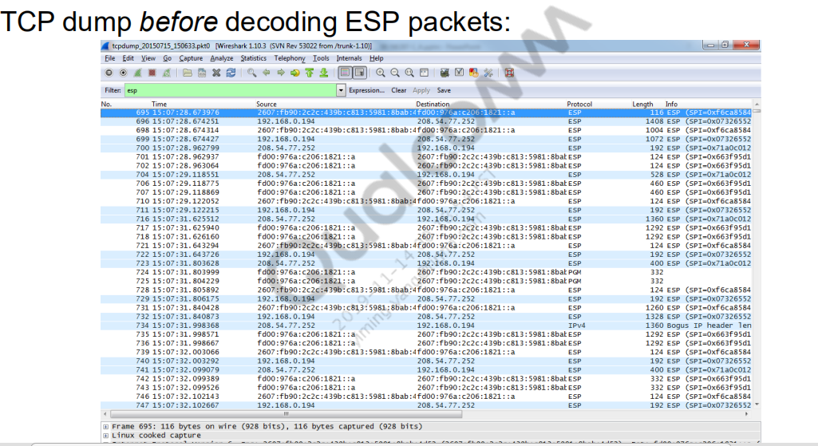

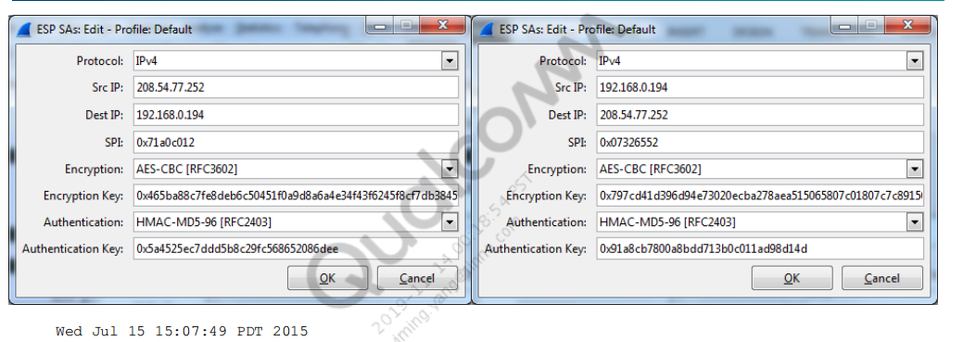

Wed Jul 15 15:07:49 PDT 2015

src 208.54.77.252 dst 192.168.0.194

proto esp spi 0x71a0c012 reqid 0 mode tunnel

replay-window 0 flag af-unspec

auth-trunc xcbc(aes) 0x5a4525ec7ddd5b8c29fc568652086dee 96

enc cbc(aes) 0x465ba88c7fe8deb6c50451f0a9d8a6a4e34f43f6245f8cf7db3845cae4fd8a94

encap type espinudp sport 4500 dport 32012 addr 0.0.0.0

src 192.168.0.194 dst 208.54.77.252

proto esp spi 0x07326552 reqid 0 mode tunnel

replay-window 0 flag af-unspec

auth-trunc xcbc(aes) 0x91a8cb7800a8bdd713b0c011ad98d14d 96

enc cbc(aes) 0x797cd41d396d94e73020ecba278aea515065807c01807c7c8915053c4e23928a

encap type espinudp sport 32012 dport 4500 addr 0.0.0.0

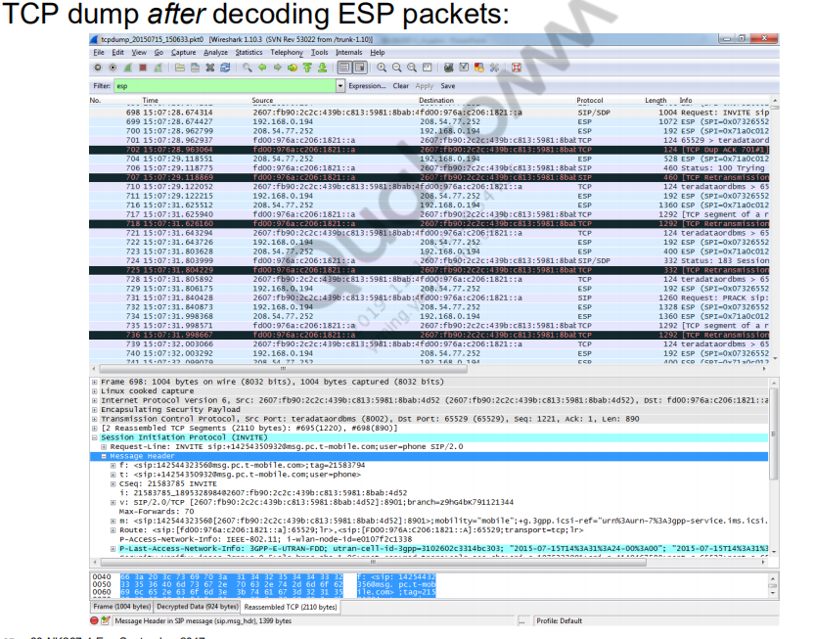

## Common IMS registration failures

### IMS PDN disconnection/failure

// IMS PDN failure from Data layer

M [5000/0001] Data Services/Medium [ ds_Net_Network.cpp 768]

Network::GetLastNetDownReason(): Reason 720902, obj 0xB7EC11A8

[0051/0002] IMS/High [ qpDcm.c 5371]

DPL_M#>>#IMS_APP#1#qpDcmProcessNetEvent-DS_ENETNONET event sent for

pDcmProfile (b788d3c0), eReason = 380

[0051/0002] IMS/High [PDPRATHandlerVoLTE.cpp 1433] PDPFailure state (1):

RegType[0]

[0051/0002] IMS/High [ qpDcm.c 15390] GetMappingDCMFailureMsg

- 720902 return 380

[0051/0002] IMS/High [PDPRATHandlerVoLTE.cpp 1450] EventPdpFailure:

RegType[0]

### Error/no response for register message/re-register message

Description: Network sends Error/No response for register requests. Registration is

failed and calls/sms is routed to CS.

If the network does not give any response for register or re-register message, then

IMS registration is failed and the next initiated calls/SMS are routed to CS till it

registers again.

Log filter: “HandleRegistrationFailureStatus err code”

Sample log snippet:

Check PCAP for this issue.

09:30:14.380 RegistrationHandlerVoLTE.cpp 11491 H Sub-ID:1

HandleRegFailureDefault - m_eFailureNotificationType 1

09:30:14.380 RegistrationHandlerVoLTE.cpp 6254 H Sub-ID:1

LogRegFailureOperation regFailureAction 0, intitalRegRequired 1

selectNextPCSCF 2, timer 0 sameloop 0, sameerroccurence 0

[0051/0002] | MSG | 13:11:49.621 | IMS/High | [RegistrationHandler.cpp

1547] HandleRegistrationFailureStatus err code 500: RegType[0] |

### No PCSCF from the network

Description: In this case, the network does not send pcscf address in response of

PDN connectivity request.

Log filter: HandlePCSCFUnavailableCase

Sample log snippet:

19974 MSG [00051/03] IMS/Error 22:27:36.902 PCSCFListHandler.cpp 00725

DoDnsQuery - No Address to search

19979 MSG [00051/02] IMS/High 22:27:36.902 RegistrationHandlerVoLTE.cpp

07476 HandlePCSCFUnavailableCase: RegType[0] Oprt mode[2]

### Due to the network sending 200OK directly for REG even though IPSec is enabled.

Description: In this case, the network directly sends 200OK without 401 for register

message. Even though sec-agree is in require and supported headers. These

scenarios are treated as failure at DUT side as sec-agree is there is Require header.

So, the network should support IPSec or should give 421 response for Register

request.

Log filter: “Security-Server validation failed”

Sample log snippet:

QXDM Professional™ logs→Refilter→Log

packets→Common→IMS→Signalling→IMS SIP message→Check register response

codes or PCAP.

[6054/0002] | MSG | 02:01:34.053 | IMS SIP/High | [sipConnection.cpp

12242] SipConnection::GetSplitSipHeaders | Header = Security-Server not

present | |

[0051/0003] | MSG | 02:01:34.053 | IMS/Error | [qpRegisterService.cpp

3450] RegisterService::NotifyResponse | Security-Server validation

failed. REG_FAILURE | |

**No VoPS in LTE attach**

Description: In these kind of issues, if the network does not support VoPS, the

network does not send VoPS which is set to 1, it sends VoPS field as zero in attach

accept.

Impact is IMS does not register for voice capability or it does not register if VoPS is

not configured in PM.

Log filter: OTA log needs to be checked (QXDM Professional logs→Refilter→Log

packets(OTA)→LTE→NAS layer)

Sample log snippet:

2017 Dec 9 07:06:03.722 [A4] 0xB0EC LTE NAS EMM Plain OTA Incoming

Message -- Attach accept Msg

pkt_version = 1 (0x1)

rel_number = 9 (0x9)

rel_version_major = 5 (0x5)

rel_version_minor = 0 (0x0)

security_header_or_skip_ind = 0 (0x0)

prot_disc = 7 (0x7) (EPS mobility management messages)

msg_type = 66 (0x42) (Attach accept)

IMSVoPS = 0 (0x0) (IMS Vo PS Session in S1 Mode not supported)

There could be another reason for this, where device does not ask for PS Services

for voice in LTE attach request.

Ensure to set NV 66048 to 3.

Voice Domain Preference (0 - CS, 1 - PS, 2 - CS Pref, 3 - PS Pref)

Sample log snippet:

The request should be similar to the following code:

[0xB0ED] OTA LOG 07:48:28.705 LTE NAS EMM Plain OTA Outgoing

MessageAttach request Msg

voice_domain_pref_for_EUTRAN = 3 (0x3) (IMS PS Voice preferred, CS Voice

as secondary)

### No response from CnE for IMS APN bringup on AP side

// Modem request IMS APN data call on AP

[6052/0002] IMS DPL/High [[IMS_DataD] imsdatad.c 3635] | 1063

|QCSI#>>#DATAD#1# REQ:MSGID:32 from MODEM

[6052/0002] IMS DPL/High [[IMS_DataD] imsdatad.c 1653] | 1063

|QCSI#>>#DATAD#6# QMI_IMS_DCM_PDP_ACTIVATE_REQ_V01--->

// Data call bring up request is successful

[6052/0003] IMS DPL/Error [[IMS_DataD] imsdatad.c 1050] | 1063 |ims-dcm

daemon process_indication_for_pdp_activate

[6052/0002] IMS DPL/High [[IMS_DataD] qpDplConnectionManager.cpp 1777] |

1063 |cs_startService : Connection to IMS service Success - its in

connecting state for pConnServDb [0x3176fe188], dsi_net_handle

[0x7d164dfa00]

// Data call is setup successfully

[6052/0002] IMS DPL/High [[IMS_DataD] qpDplConnectionManager.cpp 1117] |

1174 |qpDsiNetCtrlCB : DATAD_KPI dsi event is DSI_EVT_NET_IS_CONN for

dsi_net_handle [0x7d164dfa00]

// IMS request CNE to bring IMS APN

[6052/0002] IMS DPL/High [[IMS_DataD] qpDplConnectionManager.cpp 745] |

1063 |qpDsiNetCtrlThreadProc : calling qpdplSetupCNERoute. Updating NetID

to 0 as initial value

[6052/0002] IMS DPL/High [[IMS_DataD] qpdplCnERoutingNotifier.cpp 315] |

1063 |qpdplSetupCNERoute...calling getNetConfig for this APN type

[6052/0002] IMS DPL/High [[IMS_DataD] qpdplCnERoutingNotifier.cpp 331] |

1063 |qpdplSetupCNERoute...calling bringup for apn type 0

[6052/0002] IMS DPL/High [[IMS_DataD] qpdplCnERoutingNotifier.cpp 333] |

1063 |qpdplSetupCNERoute..bringup returned 0 ⬅ Any non-zero value is an

issue need to be checked with CNE team

// If you do not see any success response as below from CNE, issue needs to

be checked from CNE perspective

// Success response from CNE

[6052/0002] IMS DPL/High [[IMS_DataD] qpdplCnERoutingNotifier.cpp 127] |

6245 |======= onNetConfigChange : NetConfig Called ========

[6052/0002] IMS DPL/High [[IMS_DataD] qpdplCnERoutingNotifier.cpp 134] |

6245 |======= onNetConfigChange : DATAD_KPI : Connected for IMS apn .

ConnSrvDB [0x3176fe188], Netid:

[6052/0002] IMS DPL/High [[IMS_DataD] qpDplConnectionManager.cpp 991] |

6245 |qpDplCneRouteMsg : Current PDN Status 2

[6052/0002] IMS DPL/High [[IMS_DataD] qpDplConnectionManager.cpp 1000] |

6245 |qpDplCneRouteMsg : Connected event from CNE. Updating NetID

### SIM related failures

//Please check if SIM card has all ISIM and all required parameters

[0051/0003] IMS/Error [ImsRegManagerCardModule.cpp 187] IsCardReady()

returning QP_FALSE

[0051/0001] IMS/High [ RegisterManager.cpp 5654] CheckRegistrationNeeded

- ISIM not ok

### Handover failures

// IMS requests HO to iWLAN

[0051/0002] IMS/High [ qpDcm.c 12360]

qpDplIsSetPrefSysDuplicate: passed prefsys => 2 stored prefsys => 0

[6060/0002] IMS HOM/High [ ICSCore.cpp 2219]

ICSCore::set_APN_pref_sys: Handover requested to DCM_APN_PREF_SYS_IWLAN,

state:0

// HO to iWLAN is initiated at DS layer

[0051/0002] IMS/High [PDPRATHandlerVoLTE.cpp 2673] EventHOInit RegType[0]

m_iOprtMode[9]

// HO failure to iWLAN reported by DS layer.

[5006/0001] DS Protocol Services/Medium [ds_iwlan_s2b_iface_hdlr.c 1844]

ds_iwlan_s2b_iface_hdlr_move_iface_down: PS NET down reason : 0xb0006

[0051/0002] IMS/High [qpDcm.c 15390] GetMappingDCMFailureMsg - 720902

return 380

(0xB0006 = 0xB and 0x0006 = (11,6) meaning of failure can be found in

ps_iface_defs.h

PS_NET_DOWN_REASON_IWLAN_S2B_IKEV2_MSG_TIMEOUT =

TYPE_REASON_VAL(11,6)

[0051/0002] IMS/High [PDPRATHandlerVoLTE.cpp 1074] DcmCallback (21):

RegType[0]

[0051/0001] IMS/Medium [PDPRATHandlerVoLTE.cpp 2825]

CPDPRATHandlerVoLTE:EventHOFail HORat:10 oprt mode:9 RegType[0]

[0051/0001] IMS/Medium [ ICSCore.cpp 8572]

ICSCore::process_handover_events: Handover Failed. Curr RAT 10, src RAT 10,

Tgt RAT 6

## DCM profile creation failure

// DCM profile creation is initiated during bootup for normal REG and in

case of emergency call when call is initiated

[00051/02] IMS/High qpDcm.c 03437 qpDcmCreateProfile - New

profile[fb40e860] -> RAT:12 -> APN:3 shareable: 0

[06052/02] IMS DPL/High qpDcm.c 04037 SearchDSProfiles:

pApnName=

[00051/02] IMS/High qpDcm.c 04036 SearchDSProfiles: IMS

eTechType=0, eIPAddrType=2, eAPNType=3, pProfileNumber=fb40e860

[00051/02] IMS/High qpDcm.c 04036 SearchDSProfiles: IMS

eTechType=0, eIPAddrType=1, eAPNType=3, pProfileNumber=fb40e860

// Below error point out that valid emergency data profile is not

configured in the device. If you use MBN (wherever available), this error

can be avoided.

[00051/03] IMS/Error qpDcm.c 03593 qpDcmCreateProfile -

Valid 3GPP EMERGENCY profile not found

[00051/03] IMS/Error PDPRATHandlerVoLTE.cpp 00888 InitPDP

- DCM create Profile failed

[00051/03] IMS/Error PDPManager.cpp 02029

CreateEmergencyProfile | emergency profile creation failed

[00051/02] IMS/High PDPRATHandlerVoLTE.cpp 2530 PdpActivate

enter, pdp state:0 RegType[3]

[00051/02] IMS/High PDPRATHandlerVoLTE.cpp 2628 PdpActivate

m_pDcmProfile NULL RegType[3]

## Call drop/failure

###  Due to the network sending BYE/Cancel

Description: In these cases, the network sends BYE/CANCEL to the

existing/establishing call.

The call is disconnected.

Log filter: See IMS SIP message or PCAP for signaling flow.

(QXDM Professional logs→Refilter→Log

packets→Common→IMS→Signalling→IMS SIP message)

Sample log snippet:

2017 Dec 15 06:08:51.050 [8F] 0x156E IMS SIP Message --

IMS_SIP_BYE/INFORMAL_RESPONSE

Version = 1

Direction = NETWORK_TO_UE

### Audio/Video dedicated bearer not established

### Description: In these cases, the network deletes or removes dedicated bearers for Audio/Video. Or No dedicated bearer is established for audio/Video call. In this case also, BYE is

**received from/ sent to the network. This is expected behavior from device.**

Log filter: Local precondition not met| MidCall QoS timer timeout| Audio bearer

unavailable

Sample log snippet:

QXDM Professional logs→Refilter→Log packets(OTA)→LTE→NAS layer

2017 Dec 28 02:02:06.660 [87] 0xB0E2 LTE NAS ESM Plain OTA Incoming

Message -- Deactivate EPS bearer context request Msg

[0xB0E2] | OTA LOG | 20:01:40.109 | LTE NAS ESM Plain OTA Incoming

Message | Modify EPS bearer context request Msg | | | | |

tft_op_code = 5 (0x5) (Delete packet filters from existing TFT)

QXDM Professional logs→Refilter→Message packets→IMS

The following are some of the debugs if dedicated bearer is not established/removed

cases:

[0051/0002] | MSG | 00:20:10.073 | IMS/High | [qipcallh.c 15509]

qipcallh_handle_qos_timer_expiry for call id = 2

[0051/0002] | MSG | 16:02:46.363 | IMS/High | [qipcallh.c 17704]

qipcallh_wait_for_qos_reservation_timer_handler local precondition not

met, ending the call

[0051/0002] | MSG | 01:41:28.495 | IMS/High | [qipcalldialog.c 4277]

qipcalldialog_wait_for_qos_grant_timer_handler: MidCall QoS timer

timeout! |

[0051/0002] | MSG | 01:41:28.495 | IMS/High | [qipcalldialog.c 4655]

qipcalldialog_handle_qos_unavailable_for_voip_call: Audio bearer

unavailable. Ending the call, send BYE

###  Due to RTP/RTCP timeout

Description: If there are no RTP/RTCP packets from the network for some time

(Configurable) then call is dropped by sending BYE with reason RTP/RTCP timeout.

Log filter: qipcallrtp_process_rtp_inactivity_timeout

Sample log snippet:

06:29:37.665 qipcallrtp.c 1438 H Sub-ID:1

qipcallrtp_process_rtp_inactivity_timeout: Both RTP/RTCP for Audio

stream [0] timedout, Ending call

### Network does not forward INVITE/INVITE responses/INVITE methods to another end

Description: In these scenarios, the network does not forward INVITE/INVITE responses/INVITE methods to another end. Impact is call will not be connected.

Log filter: See SIP message logs or SIP packets in PCAP for signaling

QXDM Professional logs→Refilter→Log packets→Common→IMS→Signalling→IMS

SIP message

Check SIP packets.

Sample log snippet: NA

### Error response for INVITE/Emergency/INVITE/Other INVITE methods

Description: In these cases, the network sends an error response to INVITE/other

INVITE methods resulting in call disconnection.

Log filter: qimfif_handle_message_errors

Sample log snippet:

QXDM Professional logs→Refilter→Log packets→Common→IMS→Signaling→IMS

SIP message

SIP packets flow is seen here.

Or

QXDM Professional logs→Refilter→Message packets→IMS

[6067/0002] | MSG | 15:22:09.579 | IMS QIPCALL/High | [qimfif.cpp 8056]

qimfif_handle_message_errors: Method = INVITE |

[0051/0002] | MSG | 15:22:09.573 | IMS/High | [qpSipSessionService.cpp

4168] EVENT_SIP_SESSION_FAILURE:Response Code: 403 |

**Invalid SDP from the network**

Description: There are many cases where the SDP is invalid.

◻ Wrong version number sequence

◻ Invalid AS value

◻ ETC

In these cases, SDP parsing fails at UE and the call is disconnected by sending

CANCEL/BYE/488 response from UE.

Log filter: “failed to parse sip body”

Sample log snippet:

[0051/0002] MSG 16:16:30.197 IMS/High [qipcalldialog.c 4740]

[Retransmitted SDP] [sess_version: 2]

[0051/0003] | MSG | 07:23:13.320 | IMS/Error | [qipcallsdp.c 14524]

Failed to find supported codec in SDP!!

[0051/0003] | MSG | 07:23:13.320 | IMS/Error | [qipcallh.c 27229] failed

to parse sip body

### Network does not send the page to MT side.

Description: In this case, the network does not send any paging(CS/PS) to MT, So

There is no incoming call at MT. These cases not related to IMS.

###  NO response for INVITE/Emergency INVITE

Description: In this case, the network does not respond to INVITE/Emergency

INVITE messages.

Log filter: “Outgoing call Terminated (timeout)”

Sample log snippet: Check SIP messages in QXDM Professional or SIP packets in

PCAP.

QXDM Professional logs→Refilter→Log packets→Common→IMS→Signalling→IMS

SIP message.

Debug:

[0051/0003] | MSG | 08:41:21.946 | IMS/Error | [qimfif_cbs.cpp 3021]

qimfif_cbs_update: Outgoing call Terminated (timeout)

### VT call got connected as VoLTE

Description: In these scenarios, the network sends video port as zero in SDP of any

INVITE methods ((183 / UPDATE/200OK of UPDATE/ INVITE/200OK of INVITE),

irrespective of SDP already negotiated or not.

Then the call is downgraded/connected as audio call

Log filter: See SIP messages in QXDM Professional or SIP packets in PCAP

Sample log snippet:

QXDM Professional logs→Refilter→Log packets→Common→IMS→Signalling→IMS

SIP message

2017 Dec 11 07:28:57.813 [C0] 0x156E IMS SIP Message --

IMS_SIP_UPDATE/INFORMAL_RESPONSE

Direction = NETWORK_TO_UE

a=sendrecv

m=audio 45256 RTP/AVP 104 8 0 18 101 105 125

m=video 0 RTP/AVP 114 113

a=inactive

### Video call accepted as Video share call, video direction to "sendonly"

Description: In video conference/video call, PRACK/other requests or response SDP

has Video direction sendonly after proper direction exchanged in INVITE and 183.

Then video call is in one direction.

See SDP directions in SIP messages for these kinds of issues.

Log filter: See SIP messages in QXDM Professional or SIP packets in pcap

Sample log snippet:

2017 Dec 26 08:04:53.460 [53] 0x156E IMS SIP Message --

IMS_SIP_PRACK/INFORMAL_RESPONSE

Direction = NETWORK_TO_UE

m=audio 57634 RTP/AVP 104 102 96

m=video 48020 RTP/AVP 114 113

a=sendonly

### DTMF failures

■ DTMF is not heard on MT, the network does not forward DTMF to MT.

Description: In this case, DTMF requests are sent from the MO but these requests

are not forwarded to MT as the network is not forwarding it.

Sample log snippet: Check PCAP for this

//MO side PCAP

14:22:49.221187 2409:8800:8611:560f:c11a:5e3f:16a1:c257

2409:8010:9210:1:1002:1002:0:4 RTP EVENT 50010 64 Payload type=RTP

Event, DTMF One 1 58068

14:22:49.241250 2409:8800:8611:560f:c11a:5e3f:16a1:c257

2409:8010:9210:1:1002:1002:0:4 RTP EVENT 50010 64 Payload type=RTP

Event, DTMF One 1 58068

//MT side

No DTMF observed in PCAP

### Network does not give DTMF stop event

Description: In these cases, DTMF start only is received at MT but receive RTP

event for DTMF STOP (end bit is 1) is not received.

Log Filter: See PCAP for sequence

Sample log snippet:

07:19:17.102 qvp_rtp_app_cmd_svs.c 8170 M qvp_rtp_handle_nw_packet dtmf

packet received seq = 5, time 800

07:19:17.102 qvp_rtp_app_cmd_svs.c 8208 M dtmf send to app digit_count 1

end bit 0